**Stay Connected to St Ignatius**

[www.stignatiuscatholicprimary.co.uk](http://www.stignatiuscatholicprimary.co.uk/)

**‘Safe in God’s hands, we share our PEARL values’** 15th May 2020

|  |
| --- |
| Dear Parents and Carers,  I hope you and your families are keeping safe and well.  If you have not yet read my letter, sent on 12th May, regarding the reopening of schools, please do go to the letter tab under ‘News’. https://stignatiuscatholicprimary.co.uk/our-news/letters  We are currently awaiting further guidance and will let you know when we have more information.  Well done to all of those children who have been awarded an achievement certificate this week and it has been great to see so many of you getting involved in the new weekly challenges.  Mr C J Bonner |

|  |  |
| --- | --- |
| **Communication between home and school**  It has been 8 weeks since school closed.  The most effective, fun and interactive way to keep in touch with us is through our  Class Dojo **C:\Users\teacher\Desktop\Home Learning Ideas\download.jpg** See below and **please download this free app to get connected.**  We have also been speaking with many of you on the phone or by email.  For some of you, we see you every week when we deliver food to you.  If you have not yet made contact with us, in any of these ways, we ask that you do so as soon as you can, even just to update us on how things are for you and your child(ren).  If you have any specific questions or concerns or would like some advice, we would be very happy to help you.  We have already made telephone calls, left voicemail messages and sent emails to many of you.  Please can you respond to these if you have not already. Thank you.  If you need to update us on any of your details – phone numbers, email address, home address, please contact us via our email below. | |
| School Office line (Mon – Fri) 0208 800 2771  Miss Taylor : 07593 927514  Miss Curran : 07593 926806  Contact page at: <https://stignatiuscatholicprimary.co.uk/contact> | keep in touch myspace orkut friendster comments |

|  |  |  |
| --- | --- | --- |
| **Achievement Certificate** |  | **Class Dojo system**  To connect with your class teacher please download the **‘Class Dojo’** app and use the code sent via text to add yourself as a parent. If you have more than one child just ‘add child’ and use the additional code.  **C:\Users\teacher\Desktop\Home Learning Ideas\download.jpg**  We have most children connected, but if you have not connected yet please contact Miss Taylor on 07593 927514 and she will give you your unique P code so you can log on. The teachers will be sharing little videos and the children will be able to share photos of what they are doing at home.  [Shout Outs - WorkflowMax | Trenchant Business Evolution](https://www.google.com/url?sa=i&url=https://trenchantbe.ca/shoutouts-testimonials/shout-outs-workflowmax/&psig=AOvVaw1WD6McV3qOTgrclSHcSU2m&ust=1588970190613000&source=images&cd=vfe&ved=0CAIQjRxqFwoTCJivlcDNoukCFQAAAAAdAAAAABAD)  Nigel 2W  We would love to see what you are up to at home. Please share photos of the activities you are doing at home on your portfolio.  Nigel in 2W completed the Science Challenge this week- great job! |
| This week the following children have been awarded an online certificate. Please see our achievement page@ <https://www.stignatiuscatholicprimary.co.uk/key-information/online-learning/achievements>  **Sumdog:**  1H- Donates 1J- Noah Reception- Megan  2A- Monika 2W- Romeo Reception- Emilia  3F-Akachukwu 3A- Aleks  4C- Gabriel 4R- Gabriel  5C- La’Shawn 5Q- Natalie  6D- Cordell 6M- Beatriz  **Creativity Award:**  1H- Aoibhin 1J- Elena  2A- Zuzanna 2W- Victoria  3F- Elena 3A- Eoin  4C- Rebecca 4R- Otaine  5C- Agata 5Q- Melanie  6D- Julia 6M- Giovanni  Reception- Kevin Nursery- Michal  **C:\Users\James\AppData\Local\Microsoft\Windows\INetCache\Content.MSO\E91C09F4.tmp** Well done Children!  Log into Sumdog **@**<https://www.sumdog.com/user/sign_in> |

|  |
| --- |
| **Home Learning – Calling all children!**  Please continue to look at the Online Learning pages on the school website.  Next week we will be on Week 7 (18th May). Planning will be uploaded on Sunday.    Please look at our English page:  <https://www.stignatiuscatholicprimary.co.uk/key-information/online-learning/english>  We have lots of links to find free e-books, audio books and stories to help explain about the coronavirus to the children. |

|  |  |
| --- | --- |
| **Handwashing and Hygiene**  **Pepper experiment**  This experiment is an excellent way to explain to children the importance of using anti-bacterial hand gel when washing hands.  <https://www.youtube.com/watch?v=_KirHm_sYfI> | **Weekly Challenges!**    This week we launched our new **Weekly Challenge** page!  We have been delighted with the response and thank you for sharing your photos with us. Each week we will put up new challenges for you to try with your whole family.  If you have a look at the page, you will see a photo gallery of children and staff who have tried the challenges. |

|  |  |
| --- | --- |
| **Food parcel and prepared meals deliveries**  [Pasta Takeaway Stock Photos & Pasta Takeaway Stock Images - Alamy](https://www.google.com/url?sa=i&url=https://www.alamy.com/stock-photo/pasta-takeaway.html&psig=AOvVaw26uvYXqlhJwWNCUgI5woSK&ust=1588973130928000&source=images&cd=vfe&ved=0CAIQjRxqFwoTCNCvt7LYoukCFQAAAAAdAAAAABAD) [17 Parcel Clipart food parcel Free Clip Art stock illustrations ...](https://www.google.com/url?sa=i&url=https://clip.cookdiary.net/parcel-clipart/parcel-clipart-food-parcel&psig=AOvVaw3LJenEZiIpChQ2ncW4_eT5&ust=1588972917439000&source=images&cd=vfe&ved=0CAIQjRxqFwoTCLiTjcfXoukCFQAAAAAdAAAAABAD)  If any of our families, wherever you live, would like to receive prepared meals or if you live in Haringey and you would like a food parcel delivery, please contact Ms Curran on:  07593 926806 | **OnLine Safety**  https://www.stignatiuscatholicprimary.co.uk/images/WebsiteOnlineLearning/unnamed.jpg  With the increased expectations for children to be working online, never has Online safety been more important.  To help support parents and give you advice on safeguarding your children, please visit:  <https://bit.ly/2QT3Yvs-> our online safety page.  **thinkuknow** have produced some home learning packs for online safety for different age groups-see page! |

|  |  |
| --- | --- |
| **Families North London**  Welcome to Families North London’s first digital "lockdown" issue providing support in the areas of education, entertainment, parenting, health and well-being **during this time.** The magazine gathers together resources and advice to help parents manage home learning and pre-school play, and includes hundreds of ideas for indoor activities and entertainment.   We hope parents find the content of this magazine helpful to them. **Please copy this link** [https://bit.ly/35TRgDd](http://clt989395.bmetrack.com/c/l?u=A583515&e=105B13E&c=F18D3&t=0&l=4188ED33&email=FDMrhO3qvfhQWnoW9%2BccSiAuphNLo3%2FESk4kug6gi5E%3D&seq=1) | C:\Users\user\AppData\Local\Packages\Microsoft.MicrosoftEdge_8wekyb3d8bbwe\TempState\Downloads\Front_cover_capture (1).jpg |

|  |  |
| --- | --- |
|  | **Devices**  Concept of responsive navigation application for desktop computer ...  If your child does not have a device to do their Online Learning work at home – either a PC, laptop, tablet, parent mobile phone - let us know so that we can help you with other ways of supporting your child**.** |

|  |  |
| --- | --- |
| [Use Constructive Imaginative Play to Get Your Children Talking](http://nowpressplay.co.uk/imaginative-play-for-developing-discussion-skills/) [Why we created ‘now>press>play At Home’](http://nowpressplay.co.uk/creating-home-schooling-package/)    C:\Users\user\Desktop\DESKTOP  Sep 2019\School Closure\Stay Connected  newsletters\untitled.png  https://campaign-image.eu/zohocampaigns/43181000000393910_zc_v36_girlwaving.jpg | **now>press>play At Home**  **now>press>play** is an immersive audio resource that engages primary school children in the curriculum through emotion, imagination and movement.  <https://youtu.be/-PnGrkGZ2Hs>  https://youtu.be/YzcHr4NvzRQ  We have been given free access to their home package.  <http://nowpressplay.co.uk/learn-at-home/>  **Password:** nowpressplay |

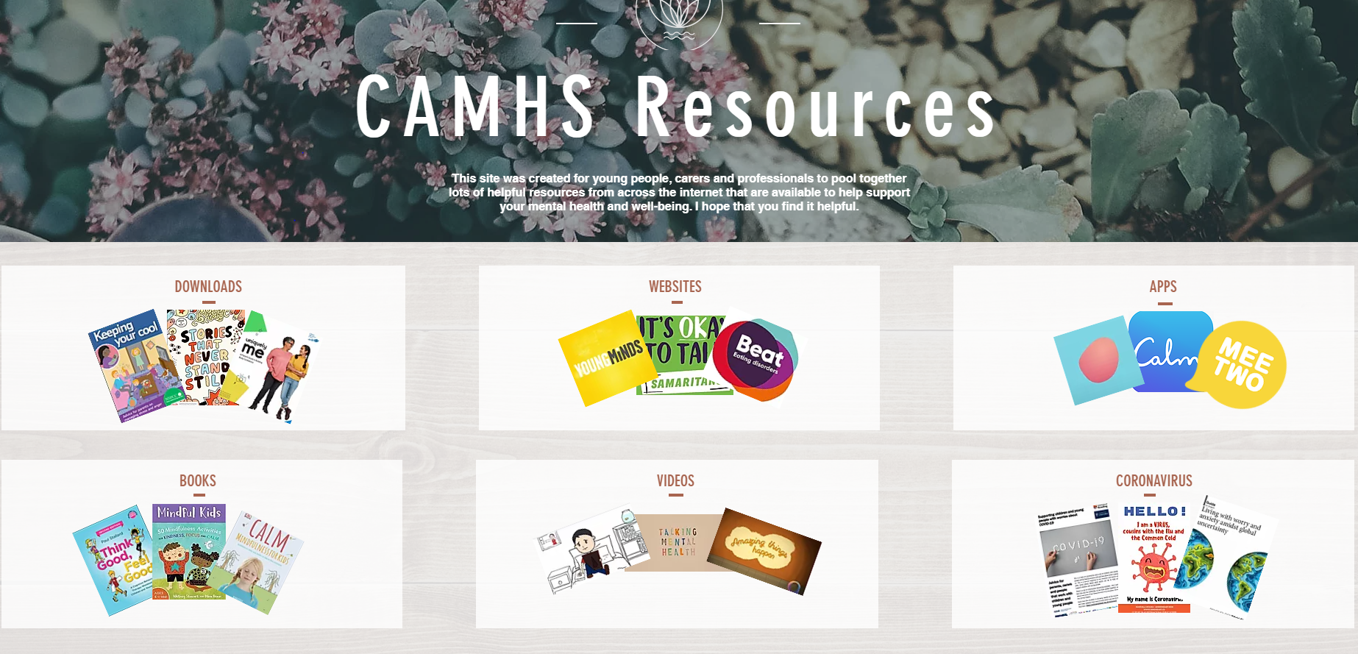

<https://www.camhs-resources.co.uk/>

This site was created for young people, carers and professionals to pool together lots of helpful resources from across the internet that support the mental health and wellbeing of young people.

