**Stay Connected to St Ignatius**

[www.stignatiuscatholicprimary.co.uk](http://www.stignatiuscatholicprimary.co.uk/)

**‘Safe in God’s hands, we share our PEARL values’** 23rd Oct 2020

Dear Parents / Carers,

We are now at October half term and the last eight weeks seemed to have flown by. It has been unusual in that we have all had to get used to new routines and arrangements due to Covid, but the children have coped very well and now, regular handwashing, our one way system and other social distancing measures are all part of daily school life.

We would like to thank you for your support in following these new arrangements and we will continue to review the situation as we move through the Autumn term. We so far have not had any confirmed cases of Covid-19 amongst staff or pupils.

This week the children have been looking at celebrating significant people in Black History in class as part of Black History Month. The theme we have followed is based on the speech of Martin Luther King’s ‘I have a Dream’ - so the children have been thinking about their own hopes and dreams as well as reflecting on the dreams of significant black people in history. We are creating a display of all of the children’s work, which we will share with you on Class Dojo after half term.

I would like to thank you for completing the remote learning questionnaires. It was immensely useful to have your feedback.

Unfortunately we have been unable to hold our Family Learning Conferences (FLCs) this week, due to not being able to meet face to face, but we are looking into organising virtual parents meetings after half term. We will inform you of how this will work when we return to school after the break.

I wish you all a safe and restful half term and we will see you on Monday 2nd November 2020.

Mr Bonner

**Flu Vaccine**

|  |  |
| --- | --- |
| **C:\Users\Karen T\Desktop\Humanities\download.png** | This week the children (from Reception to Year 6) will have come home with a letter about the flu vaccine. All children have been offered this who are in these year groups.  The vaccination will take place in school on: **Wednesday 11th November 2020.**  It is a nasal spray so is quick and painless to administer and the side effects are uncommon and generally mild.  If you choose for your child NOT to have the vaccine, you still need to complete the consent form so that we are clear that you have opted out. PLEASE READ AND FILL IN THE FORM CAREFULLY! |

|  |  |
| --- | --- |
| **To continue to keep our community safe, please:**   * **Follow our one way system** * **Wear a mask** * **Socially distance as much as possible** |  |

**Reminder- Pupils who are unwell**

We would like to bring your attention to the two posters below, as they help to explain the difference between COVID-19 symptoms and being generally unwell.

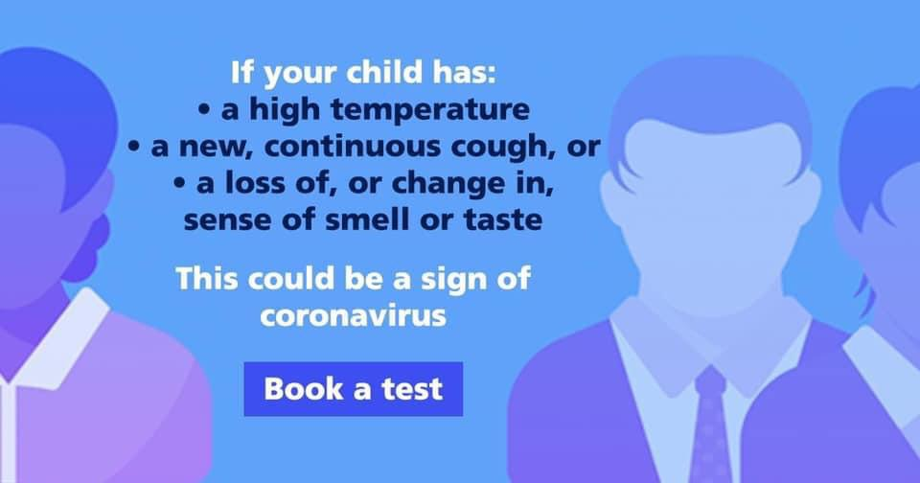 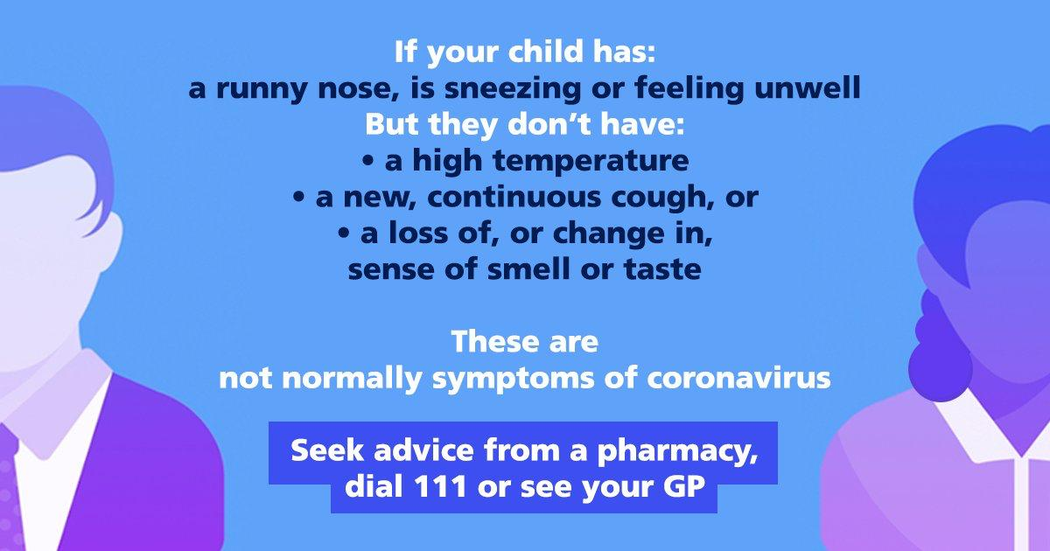

If your child is unwell at school, we will assess the situation as best as we can and send your child home with the following advice, accompanied by a letter.

**Black History**

|  |  |
| --- | --- |
| **Promoting**  **BLACK**  **HISTORY** | In the UK, October 2020, is Black History Month.  While, *‘I have a dream’* has been our focus this month, as a school we aim to ensure representation of the cultural backgrounds and histories of our pupils are weaved in to our curriculum throughout the year.  As parents, if you would like to contribute and support this aim, please speak with our staff. |

**Hot Dinners to resume after October Half Term**

|  |  |
| --- | --- |
| C:\Users\Karen T\Desktop\hot dinners.jpg | After October half term, the kitchen will begin to provide hot meals again. If your child is currently on packed lunches and would like to move onto school dinners, please let the school office know.  For details and to see the full two week menu, please go to the school website @ <https://stignatiuscatholicprimary.co.uk/key-information/school-menu>  Click on Autumn/Winter Menu 2020 |

**Class Dojo**



We have got almost all of our parents connected on Class Dojo now ! **☺**  If you have still not connected, please talk to your teacher as soon as possible.

**Number of parents who are still not connected:**

Year 1 - Only one parent to still connect!

Year 2 - All connected- **Fantastic!**

Year 3 - Two parents need to connect!

Year 4 - Six parents still need to connect!

Year 5 - Seven parents still need to connect!

Year 6 - Three parents still need to connect!

**Should we have to close a bubble or have a local lockdown Class Dojo will be vital in keeping in contact with the school.**

**Times Tables Rock Stars**

|  |  |
| --- | --- |
| **C:\Users\Karen T\Desktop\Humanities\download (1).png** | It is so important that the children learn their times tables and so we are having a big focus on this in school at the moment.  **Did you know that by the time children are in Year 4 they should be able to mentally recall all of their times tables up to 12 x 12 ?!**  Some of the children have been given a log in to a new fantastic website called ‘Times Tables Rock Stars’. Please encourage the children to log on and practise their times tables.  We would also enourage good old fashioned revision of times tables- chanting them, using flash cards, saying them whilst walking to school etc. Please work on these during the half term. |

**Family Learning Conference**

|  |  |
| --- | --- |
| **C:\Users\Karen T\Desktop\Humanities\download.jpg** | As we are unable to have our usual Family Learning Conferences (FLCs), we are looking at ways in which we can still meet (virtually) to discuss your child’s progress.  We will give you further information on this once we return after half term. In the meantime please contact the class teacher via Class Dojo. |

**Year 6 Secondary school transfer – Application deadline of Saturday 31st October 2020**

|  |  |
| --- | --- |
| Year 6 Parents' Secondary Transfer Meeting | St Paul's CofE Primary School | Well done to all our Y6 parents and pupils who have managed to submit their applications for secondary school places.  We have sent Parentmail and Dojo messages to all the families who still need to apply online. Please go on **eAdmissions** today and start your application as there may be sections you need help with and you do not wantt to leave it until the last minute!  Please message Ms Curran via Dojo for any support you need. |

**J2E – Remote Learning platform**

|  |  |
| --- | --- |
| **C:\Users\Karen T\Desktop\j2launch-interface-screens-2.jpg**  Please log on @ [www.J2E.com](http://www.J2E.com) | In this current climate, we need to ensure that the children can access **remote learning**. This is so that, in the event of a lockdown or a bubble being sent home, we can continue to provide the curriculum to our pupils online.  Last week, we trialled using our new online digital platform- J2E. The class teachers uploaded one piece of homework for the children to access. We need ALL pupils (Years 1-6) to log on and try to access this homework.  Moving forward, we will be posting some homework each week on J2E, this is so the children get used to using this new platform.  If you have any problems accessing this platform, please contact the class teacher via Class Dojo. |

**Term dates 2020 - 2021**

|  |  |
| --- | --- |
| http://www.hollywoodpark.stockport.sch.uk/wp-content/uploads/2018/06/img.cdn_.schooljotter2.com_.jpg | To find term dates for the new school year, please go to:  <https://stignatiuscatholicprimary.co.uk/termdates> |

**General Reminders**

* PLEASE BE ON TIME FOR SCHOOL! Your child should be in school for 9:00am ready to start learning.
* PE Kit- Please ensure that your child/children arrive to school in their kits on PE days
* Absence- Please ring the school to report your child’s absence or send a Dojo message
* Please remember we are a NUT FREE school. Do not send your child into school with nuts.
* We are trying to encourage the children to have a healthy packed lunch, please refrain from sending them into school with chocolate and sugary treats.
* For the Health and Safety of all families, please ensure that your child/children dismount their bikes/scooters at the school gates.

|  |  |
| --- | --- |
| keep in touch myspace orkut friendster comments | You can contact us via our [admin@st-igs.haringey.sch.uk](mailto:admin@st-igs.haringey.sch.uk) or via Class Dojo. |