**Stay Connected to St Ignatius**

[www.stignatiuscatholicprimary.co.uk](http://www.stignatiuscatholicprimary.co.uk/)

**‘Safe in God’s hands, we share our PEARL values’** 26th January 2021

Dear Parents / Carers,

I would like to say a big well done and thank you to everyone — staff, parents, carers, children, governors, everyone, — for adapting just brilliantly to this 3rd lockdown and the remote learning that this has meant for all.

As you know, schools are not closed; but open to those who meet the criteria to attend in addition to staff who are here working exceptionally hard. As I’m sure you have noticed, this lockdown is not the same as the last lockdown for schools and we are doing all we can to ensure the children all have access to good quality learning experiences whether in school or at home.

We know the challenge of having your children at home, the expectations around daily lessons, as well as the pressure of everyday family life, and for some, working from home, is immense. But as each day passes we are one day closer to getting back to school. And let’s not lose sight of why we are doing this – to keep everyone in our community safe.

Please continue to follow all government guidelines for this lockdown by staying at home and leaving your house only for essential reasons.

God Bless

Mr Bonner

**Zoom- Live Registration – Daily**

|  |  |
| --- | --- |
| **C:\Users\Karen T\Desktop\zoom.jfif** | **Every morning, the children are expected to log on to Zoom for ‘live registration’**. This session is for the class teacher to check in with the children and talk through the learning on J2E for the day.  The teacher may also talk through the English work that the children are expected to do.  Please read our Zoom acceptable use document on the school website which outlines the protocol for these sessions:  <https://stignatiuscatholicprimary.co.uk/key-information/remote-learning>  Please ensure you log on each morning promptly ready for the session to start. Once the teacher has let pupils in to the meeting, they start the session and are then unable to return to the lobby to let latecomers in. You need to be aware that if you are late logging on, it is unlikely you will be able to join the meeting that day. |

**Online Safety**

|  |  |
| --- | --- |
| **C:\Users\Karen T\Desktop\Remote Learning\download.jfif** | It is important to continue to ensure that you are aware of keeping your child safe online, especially as they will now be spending more time online completing their remote learning.  Our school website has lots of ideas and support for how you can do this @ <https://stignatiuscatholicprimary.co.uk/key-information/online-safety>  On February 9th it is ‘Internet Safety Day’ and so the children will be discussing the importance of being safe online with their class teachers and completing activities on J2E.  For more information please go to: <https://www.saferinternet.org.uk/safer-internet-day/2021> |

**COVID Awareness**

|  |  |
| --- | --- |
| **C:\Users\Karen T\Desktop\Blog_KidsandMasks.jpg** | Can we ask that if you are coming to collect resources from school or you are dropping off your child for the key worker bubble/s, **please make sure you are wearing a mask** on the school premises.  In order to protect yourselves, as well as staff, we may set times in which you can collect resources etc.  Please only arrive at these times, so that we can manage the amount of people on school premises. |

**Take a break!**

|  |  |
| --- | --- |
| **C:\Users\Karen T\Desktop\Remote Learning\P1010719.jpg** | It is really important at the moment to take a break and go and get some fresh air. There are many great parks in London and getting outside for some exercise is a great way to relax and to also have a break from screen time.  <https://www.haringey.gov.uk/libraries-sport-and-leisure/parks-and-open-spaces>  <https://hackney.gov.uk/parks> |

**Virtual School Trip**

|  |  |
| --- | --- |
| **C:\Users\Karen T\Desktop\Remote Learning\virtual3.jpg** | As we are unable to go on any school trips at the moment or travel anywhere, we thought it would be fun for the children to go on a **virtual school trip.**  Teachers will be sending you a letter next week with information on where the children will be travelling to (virtually).  The virtual school trip will take place on Tuesday 2nd February and we would love you to get involved as much as you can at home.  So that the children feel like they are going on a school trip you could prepare them a packed lunch to eat at home or find out some information on the special place they will visit. |

|  |  |
| --- | --- |
| keep in touch myspace orkut friendster comments | You can contact us via our [admin@st-igs.haringey.sch.uk](mailto:admin@st-igs.haringey.sch.uk) or via Class Dojo. |

**Free School Meal vouchers**

|  |  |
| --- | --- |
| Millfield Primary School - Free School Meals | **Free School Meals food voucher**  To check if you are eligible for Free School Meal vouchers, and you are a Haringey resident, please complete an application via Haringey.gov.uk website  [Free school meals and clothing grant | Haringey Council](https://www.haringey.gov.uk/children-and-families/schools-and-education/school-application-forms/free-school-meals-fsm-and-clothing-grant#apply)  If you live in a different borough, you will need to apply to the local authority in which you live, so Hackney residents will need to apply to [Apply for free school meals | Hackney Education](https://education.hackney.gov.uk/content/apply-free-school-meals)  Once you have researched your options, if you need any help, please call our school office on 0208 800 2771. |

**Local Food Bank Support**

|  |  |
| --- | --- |
| https://homelessroomsbirmingham.co.uk/wp-content/uploads/931623-261x300.jpg | We are working alongside Haringey local authority and other local authorities, to support our families who require help with food during these times.  There are food banks in most authorities that we can direct families to should they need the help.  In the next few days, we will also send a detailed list of locations around the borough,  There are also other organisations that may be able to help with food parcels and ready made meals.  Please contact Ms Curran or Ms Taylor via Dojo and we will be happy to help you with the best option for you and your family. |

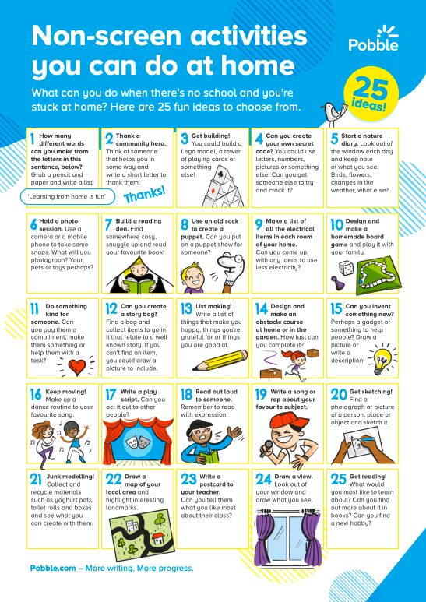

Please visit https://blog.pobble.com/100-non-screen-activities-for-kids

Prayer

He wakes me up;

He makes me sleep.

Provides for me the food I eat.

When I cry, I call on him,

Because I know with him I win.

Even through the hardest day, I trust in him in every way.

He's the One who sees me through, Jesus lives, I know it's true.

With loving kindness, he smiles on me.

Because he died, I am free.

Lord, for all, I thank you so,

I know you'll never let me go!

Amen.

