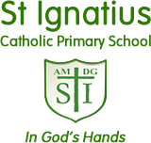**Stay Connected to St Ignatius**

[www.stignatiuscatholicprimary.co.uk](http://www.stignatiuscatholicprimary.co.uk/)

**‘Safe in God’s hands, we share our PEARL values’** 2nd Oct 2020

Dear Parents / carers,

We have now had the children back for a couple of weeks and we are delighted at how well they have settled back in. The teachers have loved having them back and the children have enjoyed seeing their friends and re-engaging with their classroom routines and learning.

So far, we have had no confirmed cases of COVID- 19 and we would like to thank you for your continued support in following the measures in place to keep everyone safe.

**Welcome** to all our new families who have joined us in Nursery, Reception and in other year groups. We hope your children are very happy with us and look forward to watching them grow, learn and have fun along the way!

**New arrangements for arriving and leaving school from Monday 5th October 2020.**

Following discussions with staff and parents, we are putting improved arrangements in place for starting and ending the school day – beginning on Monday 5th October.

These changes are for several reasons including that, now routines have settled down for us all, we would like to ensure that the children are not missing out on precious learning time, but still allowing families to stagger their start and end times and ease congestion. It will also reduce waiting times fro families who have siblings in different bubbles.

Pupils will still be arranged in ‘Building bubbles’ and enter / exit school in and around a one way sytem.

**Morning:**

School gates will be open from 8:45am

All pupils from Nursery, Reception, Y1 Y2 Y3 Y4 Y5 Y6 are to arrive between 8.45am and 9.00am.

Please ensure you wait in a safe, orderly and socially distanced way, on St Ann’s Road.

**Afternoon:**

School gates will be open from 2:45pm

Collection time for Nursery and Reception pupils is between 2,45 - 3.00pm

Collection time for all other year groups is now between 3.00 – 3.15pm

We are asking that only parents of Nursery and Reception pupils arrive in school at 2.45pm so they can pick up their child and leave the premises before 3pm when the parents of all other year groups arrive. This will avoid the restriction of the walkway outside of their classroom.

|  |  |
| --- | --- |
| We are hoping that these new measures will streamline our systems and we can all do our best to keep each other safe, as long as parents continue to :   * **Follow our one way system** * **Wear a mask** * **Socially distance as much as possible** | **Thank you** |

**Pupils who are unwell**

We would like to bring your attention to the two posters below, as they help to explain the difference between COVID-19 symptoms and being generally unwell.

We know that at this time of year many children will feel unwell at some point, but we would like to stress the importance of not bringing them in until they feel better.

Please look at our COVID-19 Guidance for Parents page on the school website for further support and information @ <https://stignatiuscatholicprimary.co.uk/key-information/covid-19-guide-for-families>

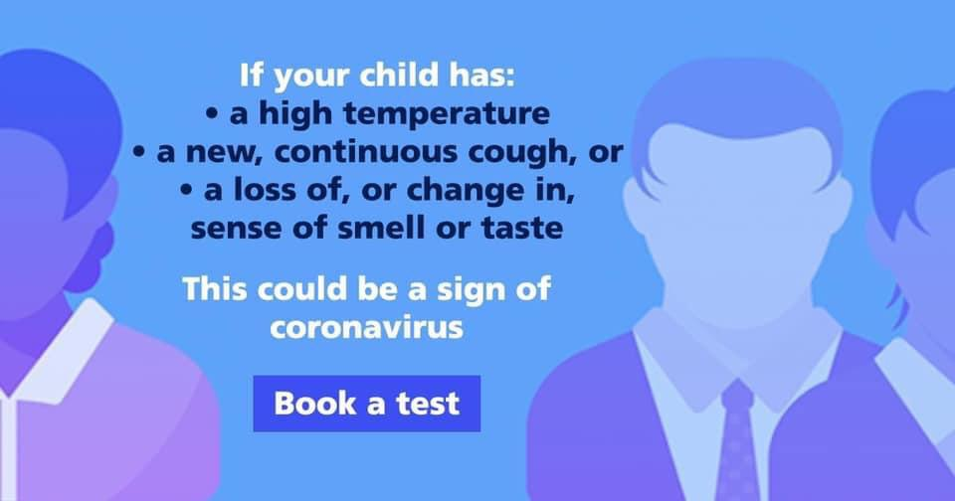 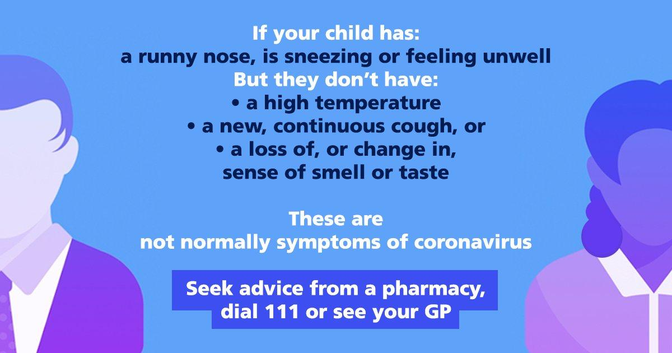

If your child is unwell at school, we will assess the situation as best as we can and send your child home with the following advice, accompanied by a letter.

If your child is presenting with symptoms of COVID-19, we will send them home and ask you to keep them at home, book a test and return to school after 10 days.

If you manage to get a test for your child, which is negative, they can return as soon as they are well again.

If your child is presenting with other symptoms, which are not COVID-19 related, we will send them home with advice to keep them at home until they are well enough to return to school.

If they return to school and continue to present as unwell, we will again request that you take them home until they recover.

**Sherpa Kids Update/Breakfast Club**

|  |  |
| --- | --- |
|  | We are delighted that we can now offer wrap around care for parents who need it. Sherpa kids will be providing after school care five days a week from 3.15 – 6.00pm Monday- Friday. Please book your sessions by going to <https://sherpakids.magicbooking.co.uk/identity/Account/Login> |
|  | Our breakfast club is open everyday from 8:00am.  Drop ins are welcome! The cost is £2 per day.  Children will be kept in their building bubbles. |

**Class Dojo**



Class Dojo will continue to be one of our main forms of communication this term. Teachers have been trying really hard to get all of our families connected. Teachers will be posting regular messages on the class story, so if you are still not connected please speak to your child’s class teacher as soon as possible. Reminders will also be sent via Class Dojo.

You can use Class Dojo to send a direct message to your child’s class teacher. **Should we have to close a bubble or have a local lockdown Class Dojo will be vital in keeping in contact with the school.**

**New Term dates 2020 - 2021**

|  |  |
| --- | --- |
| http://www.hollywoodpark.stockport.sch.uk/wp-content/uploads/2018/06/img.cdn_.schooljotter2.com_.jpg | To find term dates for the new school year, please go to:  <https://stignatiuscatholicprimary.co.uk/termdates> |

**Reading Eggs**

|  |  |
| --- | --- |
|  | The children should be coming home with a login for Reading Eggs this week. This is a fantastic educational website which supports reading at all levels. The teachers will be assigning the children activities on here each week. The activities are fun and are set at your child’s level. Please ensure your child logs on regularly and please keep your log in details safe. We are also able to assign E-books for your child on here. |

**Homework/Remote Learning**

|  |  |
| --- | --- |
| **C:\Users\Karen T\Desktop\j2launch-interface-screens-2.jpg** | The children will be given homework each Friday. It will be a mixture of online homework and work to be completed in a homework book for the moment. Schools are being expected to increase their remote learning offer and so we will continue to explore ways to support the children remotely.  Please do ensure that the homework/reading books are returned when requested by the class teacher, this is in order to quarantine the books so that the teacher can look at them ahead of resetting the work.  We will soon be sharing with you a new online digital platform which will be used for homework and remote learning. It is called J2 Launch and it is run by LGFL (London Grid for Learning), a platform we already use in school. It will give us the opportunity to use more educational online tools in order to support remote learning at home.  Remote learning will be something which will be part of school/home life as we all adjust to a different way of doing things. We encourage parental support with remote learning but also understand that every family has time constraints, so we will do what we can to help explain to the children in school how to access the various online platforms we are using.  By using J2 Launch we hope to have a seamless transition to remote learning via this new platform, as well as using our two main online websites- Sumdog and Reading Eggs. |

**Free School Meals**

|  |  |
| --- | --- |
| Hilbre High School Humanities College - Free school meals are changing.  Please read. | As part of the Government Universal Free School Meals scheme, **all pupils** in Reception, Y1 and Y2 are entitled to receive lunchtime meals for free, regardless of their benefits or financial circumstances.  However we would ask that all parents of Reception, Y1 and Y2, who are entitled to benefits, still complete a Free School Meals Form, as this brings additional funding in to our school.  Please  **Y3 pupils September 2020**  Y2 parents who have accessed Universal FSM for 3 years, when your child moves to Y3 in September 2020, they will be expected to pay for their meals - unless you want them to have packed lunch or you are eligible to continue to receive free school meals – but you need to apply and complete a Free School Meals form.  The cost of meals for Autumn 2020 is £3.00 per day or £15.00 per week.  All meals will be paid for using Parentmail or a Paypoint card? |

**School Dinners**

|  |  |
| --- | --- |
| C:\Users\Karen T\Desktop\no-cook-school-lunches-in-lunch-boxes.jpg | To look at the Lunch menu for this term, please look at the school website@  <https://stignatiuscatholicprimary.co.uk/key-information/school-menu>  Hot meals will resume after October Half Term. |

**Reminders:**

* **PE Kit- please ensure that your child/children arrive to school in their kits on PE days**
* **Absence- Please ring the school to report your child’s absence**
* **For the Health and Safety of all families, please ensure that your child/children dismount their bikes/scooters at the school gates.**
* **If you still have not completed your contact form/medical form, please do so as soon as possible and return to your class teacher.**

|  |  |
| --- | --- |
| keep in touch myspace orkut friendster comments | You can contact us via our [admin@st-igs.haringey.sch.uk](mailto:admin@st-igs.haringey.sch.uk) or via Class Dojo. |

**Today is the Feast Day of the Guardian Angels.**

Throughout our life we are looked over by our Guardian Angel.

Sometimes we all feel a little afraid or lonely but we must remember that they are always there to guide and protect us.

So now is a good time to ask for their help and care by saying this special prayer.



Angel of God,

My Guardian dear,

to whom God’s love commits me here,

Ever this day be at my side, to light and guard,

to rule and guide.

**Amenz**