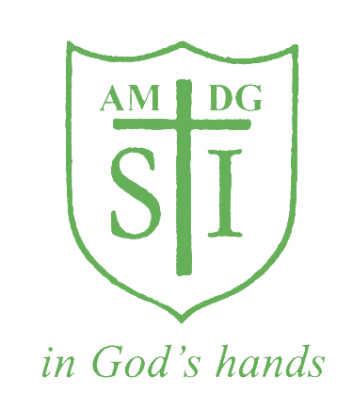

St Ignatius Primary School

Talk for Writing Policy

Status | Non Statutory
Date of policy adoption | JUNE 2023
Date of policy review | JUNE 2025

Aims:
This policy aims to outline the teaching and learning of writing at St Ignatius Catholic Primary School.
Through the implementation of this policy, we aim to continuously raise writing standards at St Ignatius to ensure that all children reach their potential, through the delivery of a well-planned, rich and stimulating literacy curriculum, underpinned by consistent, up-to-date working practices.

The Values of Talk for Writing:
Good writers:
- Enjoy writing and find the process creative, enriching and fulfilling
- Read widely, recognise good writing and understand what makes it good
- Learn about the skills of writing from their reading and draw (consciously or unconsciously) upon its models in their own work
- Have ‘something to say’ (a purpose and audience)
- Know how to develop their ideas
- Know how to plan and prepare for writing
- Make informed choices about what they are writing, as they write (for example, about vocabulary, grammar, text structure etc).
- Understand how to reflect upon, refine and improve their own work
- Can respond to the constructive criticism of others

For knowledgeable writers, many of these methods are internal and automatic. For example, they can hold an internal dialogue with themselves about the language choices available and reflect on how effective a particular word or phrase will be or how well it sounds within a particular piece of writing. However, for emerging writers it is very helpful for these processes to be explored through talk in a supportive learning context. This involves externalising and sharing the thinking involved in the writing process so that ultimately it can be internalised and personalised again. It is this developmental exploration, through talk, of the thinking and creative processes involved in being a writer that encapsulates Talk for Writing.

Talk for Writing and Inclusion:
Talk for Writing (T4W) has a strong contribution to make to the learning and writing development of ALL children, including those identified as having special educational needs, those for whom English is an additional language and children who are more able.

For example:
- wherever possible, include all children, whatever their needs, in Talk for Writing sessions and learning sequences
- scaffold pupils towards the learning objective through the use of resources e.g word mats, sequencing cards, pictorial representations, pre-teaching of key vocabulary etc
- where needed, provide additional support such as a teaching assistant or peer response partner, intermediary or scribe. The nature of this support should always be underpinned by the drive to encourage independence
- provide opportunities to tell stories in their first language to enable children to draw and build on prior learning
- provide support from peers and adults who share their first language and show how the children can draw on this to enrich their writing in English
- model and scaffold talk, particularly in English, through a range of strategies including speaking
- create a classroom climate that encourages risk-taking and accepts and values ‘different’ experimental and, perhaps, idiosyncratic responses
- target provision for ‘depth’ and challenge through guided talk/writing sessions
- provide texts that exceed the expectations of their year group

Teaching and Learning in the Foundation Stage
Talk for Writing is just one kind of the purposeful talk that is key to all areas of learning and development in Reception classes. Speaking and listening are of central importance in their own right as well as paving the way for children to make a good start on reading and writing. Many of the T4W strategies and approaches are suitable for adaptation and use with children in Reception classes, but in this section there is some additional guidance particularly focused on the needs of these younger children.

Story telling and story-making
For younger children, stories told or heard can help them understand the world in which they live and allow them to transmit that understanding to others. Furthermore, the ‘internalisation’ of stories and understanding of their structures, allows children to build confidence through oral re-telling. Teachers should choose an enjoyable story that can be told and retold many times. A story map that records the plot in a simple series of images or symbols provides a visual prompt to guide the children. The storytelling should also include gestures or actions. Teachers should refer to the school’s fixed actions that have been decided for particular conjunctions or other conventions of story language.
Over the course of the re-tellings of the story, children should be encouraged to join in with the aim of learning the story for themselves. As they become more confident in the re-telling, the teacher/practitioner should take a step back to allow the story to be ‘carried’ by the children.
When children have acquired a confident familiarity with the story, the teacher can demonstrate how it can be varied through an innovation, for example by substituting a different character or setting. Children can be encouraged to make substitutions of their own and could record these in their own story map to support them as they tell their own variation of the story to other children. When children are confident with the idea of innovating through substitution, the teacher can demonstrate innovation through adding an element to their story. Children can then experiment with their own additions.
Many of these storytelling techniques can be adapted to support the oral rehearsal of other forms of writing. Another starting point for storytelling could be the exploration of timeline or journey stories through the use of props or story bags. For example, bringing in the fruits that Handa collected for Akeyo in ‘Handa’s Surprise’ and placing them in the correct sequence, or ordering the animals collected on a broomstick in ‘Winnie the Witch’. Accompanied by drama and discussion these multi-sensory approaches can scaffold children’s understanding through into their writing. The use of visual prompts, real objects and other props will also allow children learning EAL to access the story or recount more readily, while the regular re-telling and oral rehearsal will extend their familiarity with the structures of spoken English as well as developing their vocabulary.
Children’s writing should be encouraged and enriched by opportunities throughout the learning environment both indoors and outdoors, supported by props and dressing-up clothes. This allows children, through their child-initiated play, to recreate or extemporise around the stories they have experienced. This, in turn, provides an opportunity to cultivate confident storytellers and early story writers.

Teaching and Learning in KS1 and KS2
Writing lessons are planned and delivered through the Talk for Writing (T4W) scheme and follow the structure below. Talk for Writing allows children to internalise a text’s language and structure across a range of genres. Talk for Writing is taught from Nursery to Year 6 and follows a similar pattern tailored to each year group and the National Curriculum.
To be productive, Talk for Writing needs to be extensively embedded in every phase of this teaching sequence, that is:
- During reading: When familiarising with the genre/text type and its key features; when responding to, exploring and drawing on models
- Before writing: When generating ideas, preparing for and planning writing.
- During all stages of writing (teacher’s demonstration and scribing, and children’s supported, guided and independent writing): When making choices involved in creating, developing and improving texts.
- After writing: When reflecting on and learning from a writing experience.
In this, it will be structured at the following three levels:
Teacher talk: The verbalisation of the reader’s or writer’s thought processes as the teacher is demonstrating, modelling and discussing.
Supported pupil talk: Structured and scaffolded opportunities for children to develop and practise Talk for Writing through class and group conversations and activities.
Independent pupil talk: Opportunities for children to develop and practise Talk for Writing in pairs and small groups, independent of the teacher.

All of this needs to be applied in whole-class learning and teaching and in guided writing.
The Approach:
The Talk for Writing approach consists of three key stages from Imitation through Innovation onto independent application (invent). The first task for any unit will be the choice of a model texts. These can be found on the school’s Long Term Plan for T4W. The first thing to do is to ensure the model text is pitched correctly, according to the Writing Progression of Skills document and the National Curriculum. Teachers will adapt and write their own models to suit.
Imitate

- Teachers to edit/improve model text so that the SPAG for the National Curriculum is met for each year
- Depending on how well the children did with the ‘Cold Task’, the model text may be further adapted so that issues identified can be addressed
- Cold Task to be done at least a week before beginning the T4W unit so time can be given to plan the imitate stage
- This stage begins with a ‘hook’ to engage the children and give them a sense of enjoyment, audience and purpose
- Story map and actions to be drawn/decided for every unit to strengthen memory
- Warm ups- in every lesson- these should be SPAG related
- Short burst writing is used to practise key focuses
- Add key words/phrases to magpie book or area on the working wall
- Drama should be included in the Imitate phase
- Box up text to look at the pattern

Innovate

- Teachers to ensure writing meets yearly NC
- Daily LO and SC
- Warm up starters- SPAG
- Children to plan their own story by using the patterns/focus
- KS1 to plan using pics- KS2 to plan using words and toolkit images- shall we ‘hug’ to the text or shall we ‘fly’ ?
- In KS2 pupils box up their text to ensure pattern and features are evident
- Teacher to model the writing as a class during innovation stage-one paragraph at a time and children are then given time in class to write a paragraph per day that is also self and peer assessed daily
- Children to have spelling and grammar marked daily- use of highlighting pens (pink to think and green is great) during innovation week
- Feedback is also given verbally during the lesson so that pupils can be taught how to improve their writing, make it more accurate, until they can increasingly edit in pairs or on their own
- Teacher to underline parts of shared writing that may not be used by children to promote independence

Invent

- Daily LO and SC
- SPAG to be taught discretely around focus
- Pupils to be given a rich stimulus to make their writing purposeful
- Non-Fiction writing may allow pupils to apply what they have learnt across the wider curriculum
- One or two days of planning and writing in the taught genre
- One or two days to edit and polish their work
- Children to use magpie books or working wall/washing lines when writing toolkit to be displayed

Learning Environment:
- All classes to display elements of T4W on washing lines: story mapping, boxing up, features, toolkit, imitate text modelled by teacher
- All classes to have working walls used to support children’s learning: key vocabulary, SPaG linked to genre, examples of children’s work
- Readily accessible resources e.g word mats, planning frames, dictionaries/thesaurus’, purple pens for editing
- Examples of short burst writing to be celebrated

Learning Feedback:
- Verbal and written feedback is provided to children every lesson ( aside from the cold task)
- Teacher assisted or TA assisted stamp to be stamped in the books of those children working in a focus group
- Deep marking to be done during the Innovation stage, with next steps that children respond to before the next lesson
- Pupils will self and peer assess during the Innovation stage where possible

Planning:
The following principles guide and inform the planning of writing lessons at St Ignatius:
- Teachers will plan literacy lessons in year groups and are expected to follow the same weekly plans.
- Teachers need to carry out a prior assessment (cold task) before a unit of work to establish what the children already know, what their next steps are and to enable them to focus their teaching on closing the gaps.
- Teachers need to carry out an end of genre assessment (hot task) straight after a unit of work to establish what the children have learnt. These will be written into the child’s English book. There will be cold and hot task stickers used for these activities.
- Planning is completed on the T4W planning templates. These are to be uploaded at the beginning of the week of teaching and can be submitted as three separate plans, Imitate, Innovate and Invent.
- It is the responsibility of the class teacher to share planning with teaching assistants.
- Planning is stored in the T4W folder on teams.

Teachers plan lessons that include:
- Clearly identified and shared learning objectives
- All children participating in whole-class activities e.g through the use of mini whiteboards, talk partners, interactive games etc
- Children using and developing success criteria/steps to success to support their learning
- Exciting, engaging and targeted activities in a ‘safe’ environment where children are not afraid to make mistakes
- Opportunities for individual, supported, paired and group learning
- The use of open questions
- Clearly identified plenaries which give everyone the chance to evaluate and assess progress towards the lesson objectives and against the success criteria, using individual and peer assessment strategies.

These things must be done:
- Cold and Hot Task stickers to be used- they do not need success criteria- children to use displays, writing mats and other visual aids independently
- Green and Pink highlighting to celebrate successes and next steps for each child, time should be given for these to be responded to- innovate stage
- Children (KS2 in particular) to self assess against the success criteria and edit in purple pen and afterwards to peer assess partner’s work where possible
- Always model writing before sending children off to write
- Genre specific SPaG to be taught throughout using the Pie Corbett Writing Progression across year group- teachers to RAG and date when these have been taught or achieved- annotate document yearly
- Model texts to be adapted by class teachers to ensure covers national curriculum aims
- Fiction, non-fiction and poetry to be taught every term
- Sentence checkers to be used for KS2 during the Innovation stage and for short burst writing
- Planning to be uploaded at the beginning of the week that it is taught
- Non-fiction and Fiction units to be taught for up to three weeks
- Staff to adopt the agreed actions for the retelling of the story- see video shared on school website
- Teachers to be ‘fussy’ about handwriting

Spelling:
From Year 2 upwards we will be using No- Nonsense Spelling programme from Sept 2022
In each class it is an expectation that the year group word lists are available on the children’s tables and each half term the children are tested on these word lists. We will share the results of these tests with parents.
Handwriting: See separate statement attached to this Policy.

Assessment:
Assessment is a continuous process and is an essential part of teaching and learning. It is the responsibility of the class teacher to assess all children in their class. In our school, we are continually assessing our pupils and recording their progress.
At the beginning of each writing unit, children are required to complete a ‘cold task’. This assessment acts as a planning tool for the teachers and as a pre assessment. It is important that no success criteria, guidance or pre-teaching is given before these tasks. These are completed with a cold task sticker and are kept in English books. Once the genre has been taught, pupils will complete a hot task immediately after the teaching. Pupils will have the time to plan, draft and edit their work before recording their final piece in their English books (hot task sticker).

Targets: Pupils will have personal writing targets that they aspire to meet every lesson, these are stuck in the back of their English books

Monitoring:
The role of SLT and the English Subject Leader will be to:
- create an ethos of achievement in writing
- provide a clear policy for skills development in writing
- ensure rigorous assessment and monitoring takes place
- promote writing across the curriculum/ensure staff access appropriate training opportunities
- ensure staff have effective learning resources for writing
- carry out/facilitate moderations during staff meetings using ‘cold’ and ‘hot’ tasks and book looks
- carry out book scrutinies termly and during PPR meetings
- organised workshops for parents to explain T4W strategies and cover the SPaG requirements of each specific year group

Handwriting at St Ignatius

Aims: To know the importance of clear and neat presentation in order to communicate meaning effectively.
To write legibly with increasing fluency and speed by:
- Having the correct pencil grip
- Knowing the size and orientation of letters
- Forming all letters correctly
- Knowing that all cursive letters start from the line

Teaching time
Throughout EYFS and KS1 it is recommended that children have regular handwriting practise. At St Ignatius Catholic Primary School it is recommended that handwriting is timetabled for at least 2 x 15 sessions from Year 2 - Year 5.

At St Ignatius we have adopted a cursive, or ‘joined-up’ style for handwriting throughout the school from Year 2. We believe this raises standards in writing across the whole school, developing confidence, accuracy and fluency and improved presentation.

The cursive handwriting style helps:
• To minimise confusion for the child as every letter starts on the line with an entry stroke and leads out with an exit stroke
• As letters naturally flow into each other, this helps children to join their handwriting
• Form spacing between words as the child develops whole word awareness
• To develop a child's visual memory
• All children's writing skills regardless of academic ability
• To develop skills of punctuation and grammar.

The National Curriculum specifies that primary school children should work towards mastering handwriting that is fluent, legible and, eventually, speedy.
There are specific targets for each year group.
In Year 1, pupils should be taught to:
- Sit correctly at the table, holding a pencil comfortably and correctly.
- Begin to form lower case letters in the correct direction, starting and finishing in the right place.
- Form capital letters.
- Form the digits 0 to 9.

In Year 2, pupils are expected to:
- Form lower case letters of the correct size, relative to one another.
- Start using some of the diagonal and horizontal strokes needed to join letters, and understand which letters are best left un joined.
- Write capital letters and digits of the correct size, orientation and relationship to one another.
- Use spacing between words that is appropriate for the size of the letters.

In Years 3 and 4, children should:
- Continue to develop their joined-up handwriting.
- Increase the legibility, consistency and quality of their handwriting – for example, ensuring that downstrokes of letters are straight and parallel, not sloping.

In Years 5 and 6, children are taught to:
- Write with increasing legibility, fluency and speed.
- Choose which shape of a letter to use, and decide whether or not to join specific letters.
- Choose the writing implement that is best suited for a task.

Handwriting statements in the End of KS1 Framework:

WTS- form lower-case letters in the correct direction, starting and finishing in the right place – form lower case letters of the correct size relative to one another in some of their writing

EXS- form capital letters and digits of the correct size, orientation and relationship to one another and to lower-case letters

GDS- use the diagonal and horizontal strokes needed to join some letters

Handwriting and SATs
Handwriting Development
Young children develop the skills needed to write through both gross and fine motor movements. It is therefore important that our very youngest children continue to get opportunities to climb and scramble as well as having access to a range of chunky and fine mark making equipment.

Pupils in EYFS should encounter lots of opportunities for mark making linked to their interests including:
Squiggle while you wiggle
Dough Disco
Threading
Fastening and unfastening
Tracing patters
Plasticine
Pincer grip activities

Handwriting Model used at St Ignatius Catholic Primary School

At St Ignatius we teach letter formation using the Little Wandle Formation phrases in EYFS and Year 1.
Year 2 move onto joining and cursive handwriting.
Our children in EYFS/KS1 are introduced to actual letter formation through the Little Wandle programme as well as focused classroom and practical activities. The letter formation is print. They are introduced to letter formation alongside the teaching of graphemes in Phase 2 of Little Wandle.
In particular in EYFS, children are encouraged to write their first names correctly, using capital letter for the first letter only.
The formation phrases documents are found here, under Teaching Handwriting outside the Phonics lesson-
https://www.littlewandlelettersandsounds.org.uk/resources/my-letters-and-sounds/weekly-reading-and-phonics/

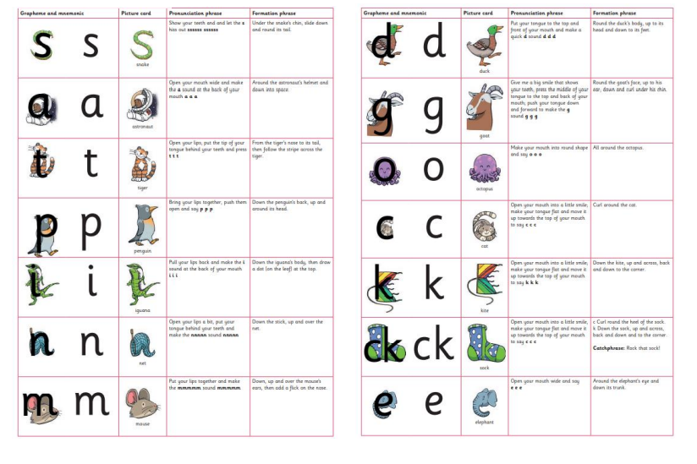
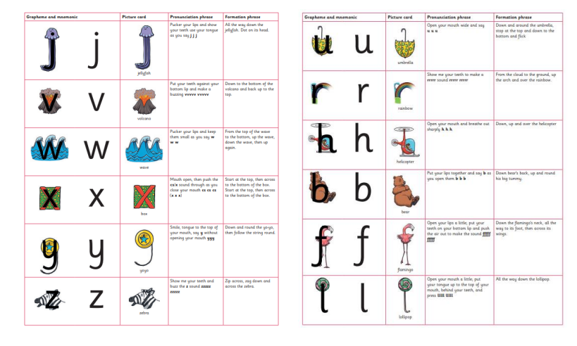
The letter formation of ‘k’ that children encounter in the formation phrases in Reception in the ‘k’ without the loop as the DFE has stated that schools should teach print at this phase. This ‘k’ is evident in all the grapheme cards and displays of our phonics programme and is how children will encounter ‘k’ in reading books. The font used by Little Wandle Letters and Sounds Revised is Sassoon Infant 6.
In Year 1 children are introduced to the letter ‘k’ with the loop. This is the formation that joins most easily.

Children learn to write with a pencil. The most appropriate grip is the ‘tripod grip’ which allows both control and fluid movement. If your child finds it difficult to hold a thin pencil it may be worth investing in something chunkier or pencil grips which are designed to encourage a tripod grip. We encourage our children to take care with presentation. When children enter Key Stage 2, they have the chance to earn a pen license.

Important Points To Remember

- Always start forming the letters on the line
- “Tall letters,” will touch the line above (b d h k l t )
- “Middle letters,” are all the same height and stop at the midpoint of the line ( a c e I m n o r s u v w x y z )
- Some letters stretch down below the line. The top of these letters touch the midpoint (f g j p q y )
- Capital letters never join to the rest of a word
In Reception and at the beginning of Year 1 the children learn to form each letter separately. As the children are introduced to digraphs and trigraphs in Year 1 they may begin to join certain letter combinations, although joining is not expected until Year 2.
For example: ch sh th ee ea igh

By Year 1, most children should be secure forming individual letters. However, some may still need small group support.
The formation of all capital letters and numbers should be taught in Year 1.
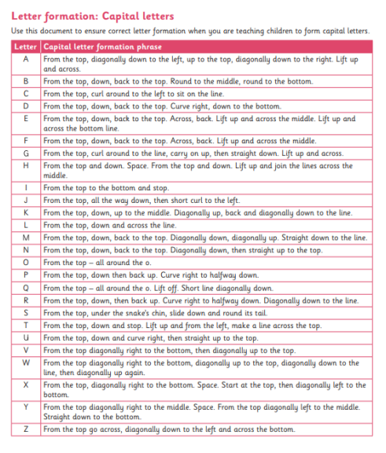

Key Stage 2
During this stage the children continue to have direct teaching and regular practice of handwriting. We aim for them to develop a clear, fluent style and by the end of Year 6 be able to adapt their handwriting for the for different purposes, such as: a neat, legible hand for finished, presented work, a faster script for note making and the ability to print for labelling diagrams etc.
Capital letters
Capital letters stand alone and are not joined to the next letter. Children must practice starting sentences and writing names using a capital letter and not joining the subsequent letter. This should be modelled by the teacher during Literacy and Phonics sessions.
The Learning Environment
In all classes, pencil pots with suitable materials are available for pupils to work at their own tables. Classrooms are equipped with a range of writing implements, line guides, word lists and dictionaries.
Lower case letters (Year 1 upwards)
Capitals
ABCDEFGHIJKLMNOPQRSTUVWXYZ
The Four Joins (Introduced in Year 2)
1. Diagonal join to letters without ascenders
2. Diagonal join to letters with ascenders
3. Basic horizontal joins
4. Horizontal joins to letters with ascenders
Further Y2 Joins:
- practising two ways of joining the letter s
- practising joining from the letter r
- practising joining to and from the letter a
- practising joining from the letter e
- practising joining from the letter o
- practising joining to the letter y
- practising joining to the letter a
- practising joining from the letter o
- practising joining to the letter r
- practising the horizontal join to the letter e
- practising the horizontal join to the letter u
- practising joining to ascenders
The break letters (letters that aren’t joined from) are: bgjpqxyzs
NB children must be taught individual letters first so that they see them as individual units BEFORE learning to join.
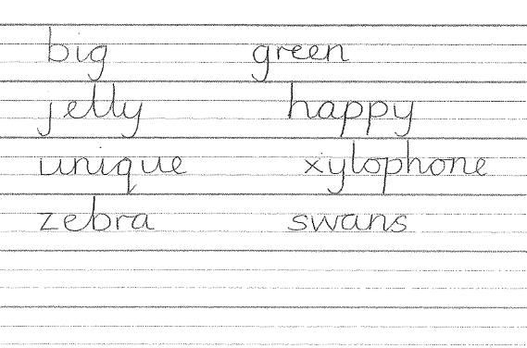
Year 2
The majority of children should be ready to start the year using handwriting books.
All children should be allowed to use unlined paper from time to time so that they can apply skills and consider issues of presentation and aesthetics. Handwriting should be timetabled and where appropriate link with revision of phonics. It is recommended to timetable at least 2 x 15 minute sessions per week. No Nonsense spelling is introduced in Year 2, which gives pupils opportunities to practise their handwriting.
Teaching Sequence
To develop independence the following teaching technique would be seen across Key Stage One.
• Hand and finger strength activities
• Tracing
• Pattern work

Year 3 and Key Stage 2
In Key Stage 2 all pupils will have access to a minimum of 2 x 15 minute discrete sessions to develop handwriting.
Pupils who are able to join neatly can be given a ‘pen license’ and pen for writing if the teacher is happy the writing is to a good standard.
• Model good handwriting all the time
• Demonstrate
• Encourage children to verbalise the process
• Children form letters in the air
• Write over highlighter pen (or dotted letters)
• Draw round templates
• Write in sand with finger or stick
• Write with chalk on chalkboard
• Wax resist letters
• Form letters with pegs on pegboard
• Form letters with beads in plasticine
• Finger trace the outline of letters on the back of the person in front of you
Seating and posture
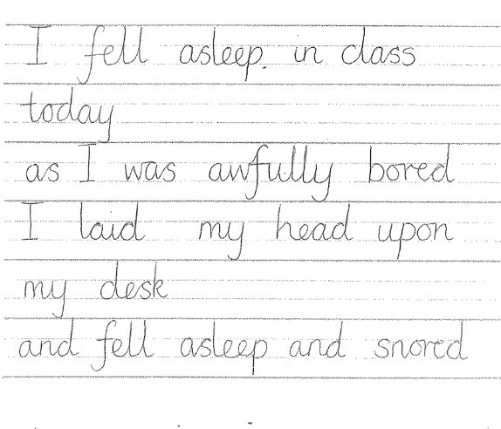
• Chair and table should be at a comfortable height
• The table should support the forearm so that it rests lightly on the surface and is parallel to the floor
• Encourage children to sit up straight and not slouch
• The height of the chair should be such that the thighs are horizontal and feet flat on the floor
• Tables should be free of clutter
• Rooms should be well lit
• Left handed pupils should sit on the left of their partners

Pencil grip
• Children should write with a pencil (or pen when introduced in Y4 upwards) with a blue rounded nib (berol pen). Pencils should be reasonably sharp.
• A tripod grip is the most efficient way of holding a pencil
For right handers
• Hold lightly between the thumb and forefinger about 3cm away from the point • The paper should be placed to the right tilted slightly to the left
• Use the left hand to steady the paper

For left handers
• Hold lightly between thumb and forefinger resting on the first knuckle of the middle finger
• Hold about 3cm from the tip
• The hand should be kept below the writing line
• The paper should be tilted slightly to the right at about 20 - 30° • Use the right hand to steady the paper
NB It is very important that a right-handed child is NOT seated on the left hand side of a left handed child as their elbows will collide!
Teachers should demonstrate writing with their left hand wherever possible or use the expertise of left-handed writers.
Assessment
Phase leaders in team meetings and senior leaders should monitor children’s writing and presentation in books regularly (at least termly). The following should be considered:
• Is the writing generally legible?
• Are the letters correctly shaped and proportioned?
• Are the joins made correctly?
• Are the spaces between the letters, words and lines appropriate?
• Is the size of the writing appropriate?
• Is the writing properly aligned?
• Are the writing standards achieved by the majority of pupils in line with age related expectations?
Individual assessment
Children should be observed as they write during handwriting lessons – the teacher must circulate, monitor and intervene. Teachers also need to monitor and mark whole pieces of writing. The following should be considered:
• Is the posture correct?
• Does the child hold the pencil correctly?
• Does the child use the correct movement when forming and or joining letters?
• Are any letters reversed or inverted?
• Does the child write fluently and rhythmically?
• Is the writing easily legible?
• Is the pupil’s handwriting development should be in line with age related expectations
IMPACT:
The impact of using the full range of Little Wandle formation phrases, implementation of a consistent handwriting strategy etc, including display, will be seen across the school with an increase in the profile of handwriting. Following this statement, will give our school a consistent approach where handwriting expectations are clear and the same technical vocabulary is used with, and spoken by, all teaching staff and learners. Whole school and parental engagement can also be improved through the use of handwriting resources as home learning tasks.
Handwriting lessons should not feel like a chore for teachers and pupils and should encourage a sense of pride in pupils’ written work.
Our children’s handwriting will become automatic and to a high standard so that they are able to focus on the content of their writing rather than the presentation. The impact of the scheme should be noticeable within written work in all areas of the curriculum.

