Home Learning for Year 1

Hello everyone. I hope you had a peaceful and restful mid term break. Below is the home learning weekly timetable for your child. Please check the Year 1 page for additional resources/website links. If you have any questions, please contact us (Miss Haddon or Miss Harte) on ‘Class Dojo’.
Week commencing: Monday 1st June
St Ignatius Home Learning Weekly Timetable
Subject | Resource/Access | Activity
Daily Reading- 30 mins | activelearnprimary.co.uk  (find login details inside the cover of your green book – same as lgfl login with school code: stig)  Free eBooks are also available on oxfordowl.co.uk (you do need to register using your email address and password but it is completely free) | Please continue to read every day with your child. You can find books allocated to your child on active learn. Login to Active Learn and click on ‘My Stuff’ to find your allocated reading books. Don’t forget to look at the inside cover of the book to practise the sounds and words that you will find inside the book.
Daily Phonics | activelearnprimary.co.uk  (find login details inside the cover of your green book – same as lgfl login with school code: stig)  busythings.co.uk  (find login details inside the cover of your green book – same as lgfl login) | Login to Active Learn and click on ‘My Stuff’ to find phonics games you can play.  Key stage 1 > Year 1 setup > English > Phonics programme  Children can select phases 2, 3 &4 or phase 5 to access a variety of games that will help with reading and writing words.
Daily Times Tables | https://www.topmarks.co.uk/maths-games/mental-maths-train  https://www.topmarks.co.uk/times-tables/coconut-multiples  https://www.topmarks.co.uk/maths-games/hit-the-button  (Select ‘Times tables’ and then choose which one you want to practise)  busythings.co.uk  (find login details inside the cover of your green book – same as lgfl login)  Three times tables video  https://www.youtube.com/watch?v=p7QM3Qfxt1s | Revise your 2, 5 and 10 times tables by getting family to test you. You can also play a number of games to give you more practice. Have a look at the links to the left.  Key stage 1> Year 2 setup> Mathematics> Multiplication and division> Miner birds:Times tables  Challenge:  If you feel you have conquered your 2, 5- and 10-times tables, why not challenge yourself to learn your 3 times tables?
Twice Weekly Spelling | Weekly spellings:  We are practising the ‘u_e’ sound.  ‘’Huge brute u_e’’  - huge  - use  - tube  - prune  - rude  - include  - excuse  - volume  - refuse  - conclude  Challenge words (year 2 common exception):  clothes floor | Practise your words using the spelling sheet format:  Read, cover, write, check x3.  Can you put the words in a sentence?
Maths- Daily | https://whiterosemaths.com/homelearning/ | See next page for more details
English- Daily |  | See daily lessons below
Topic | https://www.bbc.co.uk/cbeebies/puzzles/lets-go-club-dino-quiz  Take this fun quiz from BBC Cbeebies  ‘’What Dinosaur are you?’’  Whichever dinosaur you would be, could you design and make it using an empty toilet roll?  Here are some examples of what you could make.  Remember to ask an adult for help when using scissors.  Will your dinosaur need wings? Giant teeth? A spiky back? What colour will your dinosaur be? | 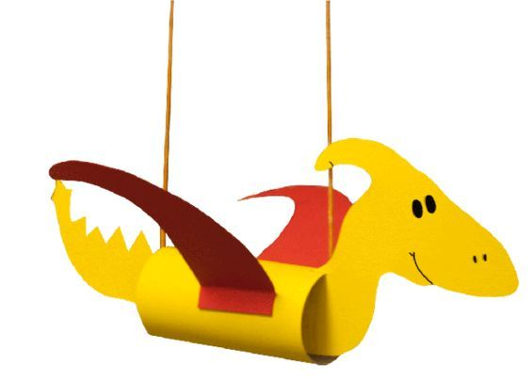  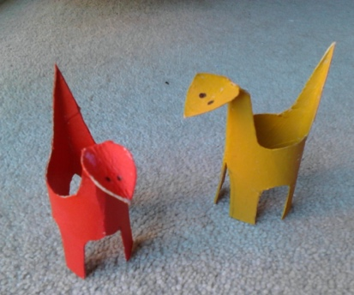  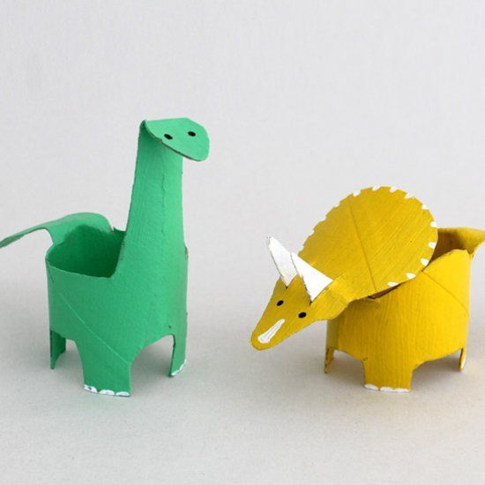

Maths Lessons- Monday-Friday
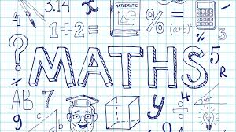
Please click on the links below that will take you straight to the activities on White Rose Home Learning. For each lesson there is:
- A video
- An activity
- An answer Sheet

HOW TO USE THE LESSONS

Just follow these four easy steps…
- Find a calm space where your child can work for about 20-30 minutes.
- Click on the link to the lesson you are going to work on and watch the relevant video.
- Click on the questions link and support your child as they work through the activity.
- Check your child’s answers with them by clicking on the answers link. Correct any mistakes.

JOIN IN THE DAILY MATHS!
Monday  Summer term – Week 6  Lesson 1 - Measure mass | Find Monday’s activity sheets and answers on the school website  https://stignatiuscatholicprimary.co.uk/key-information/online-learning/year-1-home-learning
Tuesday  Summer term – Week 6  Lesson 2 - Compare mass | Find Tuesday’s activity sheets and answers on the school website  https://stignatiuscatholicprimary.co.uk/key-information/online-learning/year-1-home-learning
Wednesday  Summer term – Week 6  Lesson 3 - Introduce capacity and volume | Find Wednesday’s activity sheets and answers on the school website  https://stignatiuscatholicprimary.co.uk/key-information/online-learning/year-1-home-learning
Thursday  Summer term – Week 6  Lesson 4 - Measure capacity | Find Thursday’s activity sheets and answers on the school website  https://stignatiuscatholicprimary.co.uk/key-information/online-learning/year-1-home-learning
Friday | Try BBC Bitesize challenges 1 and 2  Friday challenge

English Lessons- Monday- Friday
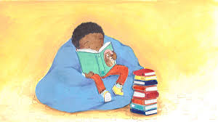
Below is a series of five lessons we have planned. If you can manage all five then that’s great. If not, choose a few to complete with your child. There are challenges for children who can complete the main activity with ease. If your child finds the main activity a struggle, then don’t worry about completing the challenge.
Monday | 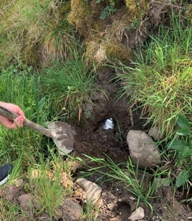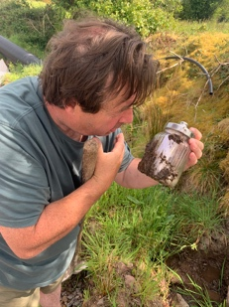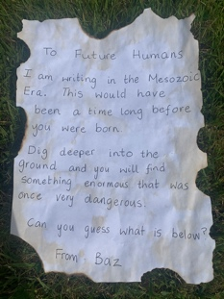  Show children these photos enlarged below.  Read this passage:  A man was out digging, looking for worms, when all of a sudden, his shovel hit something hard. He kept digging until the hard object was revealed. Buried deep in the ground was a jar. He examined it closely and found that inside was a very old looking letter.  (Show and read the letter below)  Ask the children:  Who do you think Baz was?  How long ago do you think the Mesozoic Era was?  (roughly 250 million years ago)  What do you think Earth looked like back then?  What sort of creatures may have roamed the land?  What do you think may be buried below?  Activity:  Children are to answer Baz’s question: Can you guess what is below?  It is important to discuss different ideas of what might be hidden underneath. Could it be treasure? A magic lamp? A witch’s wand? A skeleton?  Begin your sentence with ‘’I think…’’  For example  I think there is a magic lamp below the ground with a crazy genie that will grant me three wishes.  Children can draw a picture of their predictions. | Challenge:  To write some objects that it could not possibly be. (The object is very old.)  For example:  It could not be a TV because they were not invented millions of years ago.
Tuesday | The man kept digging and he was shocked at what he found. (Reveal what he has found by deleting the red box below or moving it over to show the picture).  Buried underneath was the bones of an enormous tyrannosaurus rex!  Watch video from cbeebies:  https://www.bbc.co.uk/cbeebies/watch/andys-dinosaur-adventures-tyrannosaurus-rex-facts  Activity  Watch the video and write in bullet points some facts that you have learned about the tyrannosaurus rex.  For example:  - They made nests out of old branches.  - Their bite was three times stronger than a lion.  How many facts did you get? | Challenge:  What would you do if you bumped into a tyrannosaurus rex?  Write one or two sentences explaining how you would feel (use exciting adjectives) and what you might do.
Wednesday | 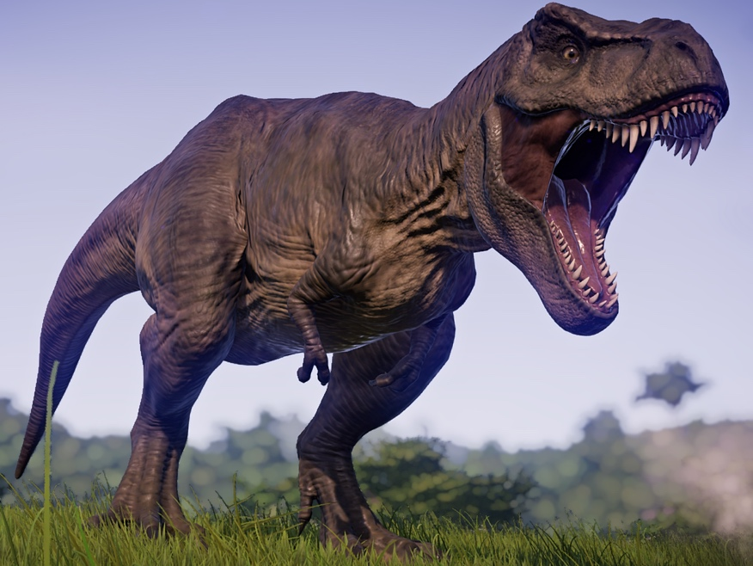  Look at this picture of a tyrannosaurus rex. What features can you see? How would you describe it’s...  - Teeth  - Legs  - Tail  - Eyes  - Body  - Arms  Activity  Draw your own image of the dinosaur.  Underneath their picture children are to write a detailed description of a tyrannosaurus rex.  Use as many features as you can.  *Challenge* can you use the word ‘for’ to explain why the dinosaur has those features?  For example:  Big huge strong legs for jumping on their prey.  (notice the use of different adjectives) | Challenge  Can you see any similarities to other animals?  Use the word ‘like’ to compare it’s features to well-known animals.  For example:  Tyrannosaurus rexs’ stand on their back legs like a meerkat.
Thursday | To make a story board of the man finding the bones.  Use the template below or draw four boxes on your page/book. You must sequence the story of finding the letter and bones. You must come up with an ending to your story. Did the man cover the bones over and tell no one, or donate the bones to a museum so everyone could see them?  In each box, begin your sentence with..  - Firstly  - Next  - Then  - Finally | Challenge:  Using speech marks, include something the man may have said when he discovered either the letter or the bones  For example:  ‘’This is amazing!’’ shouted the man.
Friday | Reread the letter from the past.  Children must write a letter to the future humans of earth. Send the letters on DOJO if you want them buried.  Include letter features  Dear _____  Why you are writing  From ______  Things you could include:  - What animals are on earth  - What the buildings are like  - What school you go to  - What age you are  You could include all about the coronavirus, what year it is and what has happened (no schools, shops closed etc) | Challenge:  Can you include a question in your letter? Do not forget to put a question mark at the end of your sentence.

Monday 1st of June – Lesson pictures
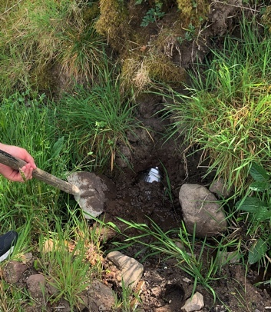
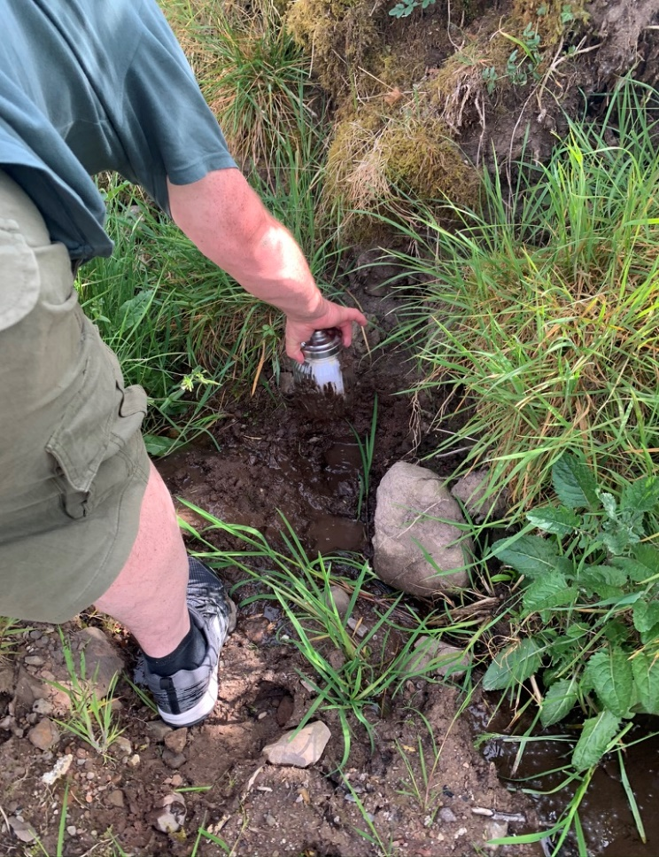

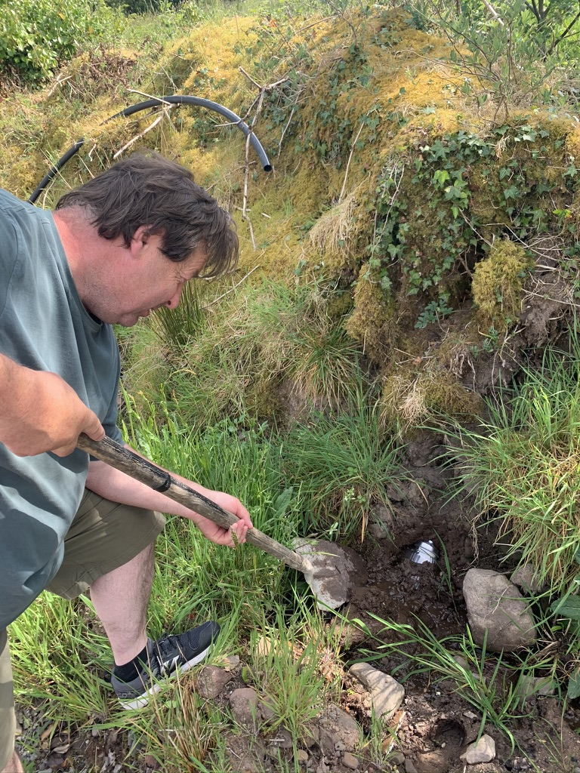

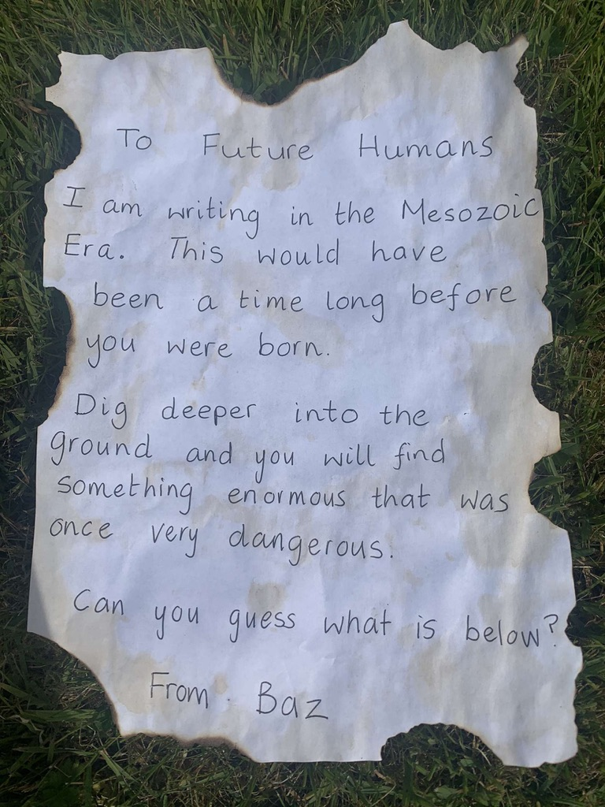

Tuesday 2nd of June – Lesson picture

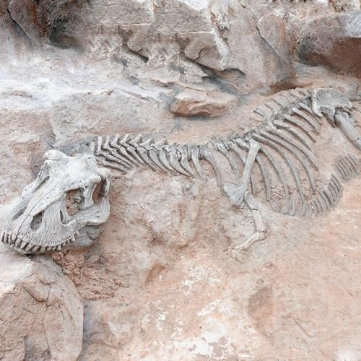

Skeleton of a tyrannosaurus rex.

Wednesday 3rd of June – Lesson picture
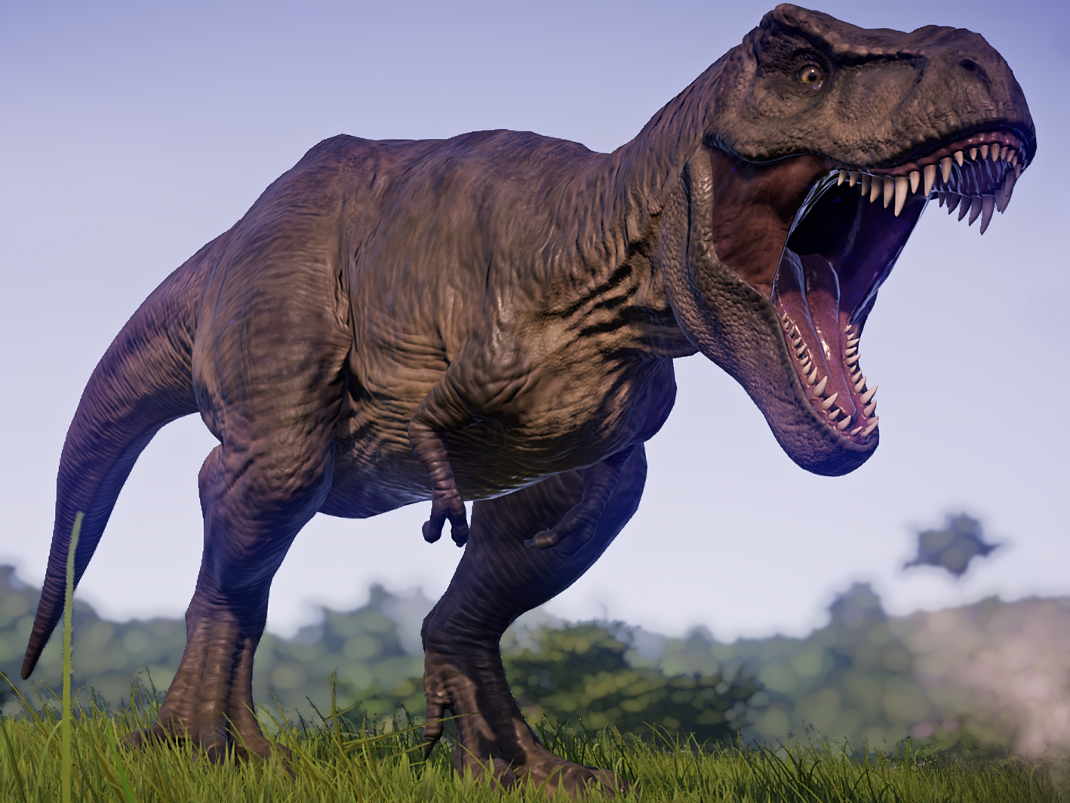

Thursday 4th June – Lesson template

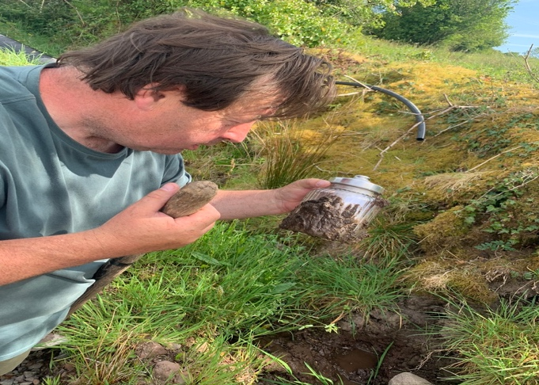  First ______________________________________  __________________________________________  __________________________________________ | 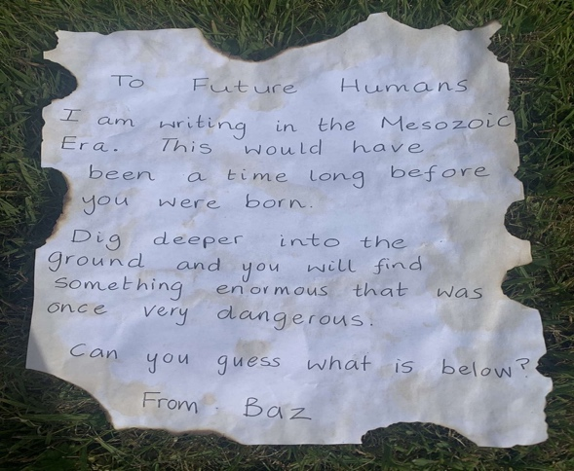  Next ______________________________________  __________________________________________  __________________________________________
Then______________________________________  __________________________________________  __________________________________________ | Finally_____________________________________  __________________________________________  __________________________________________

