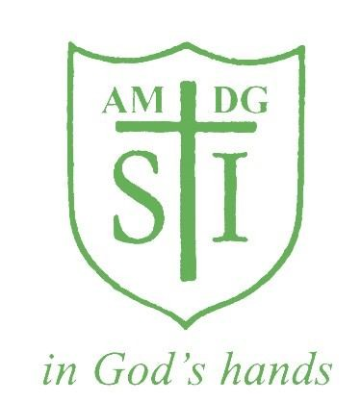

St Ignatius Primary School

Uniform Policy

Status | Non Statutory
Date Created | JUNE 2023
Date to be reviewed | JUNE 2026

School Uniform Policy

We are proud of our school uniform and of the image it gives of the school. It helps us if all children come to school in correct school uniform and with all items of clothing and footwear clearly labelled with the pupil’s name.
We encourage children to become independent so please consider this when buying uniform and only buy clothing and shoes that your child can put on and take off without much assistance. Footwear should be comfortable and safe; fashion shoes NOT permitted. Coats and jackets should keep the children warm and dry and are only worn outside.
We believe strongly that children need the security of a clearly defined and consistent disciplinary structure within which their personal and intellectual growth may flourish. We attach a great deal of importance to the personal appearance of each pupil and expect school uniform to be strictly adhered to and correctly worn.

School uniform can be purchased from (See attached sheets):
- Divine Solutions Schoolwear Ltd
- Uniform –me
Items that can be purchased from the school office are:
- School book bags- £5.00 ( It is an expectation that all children have a school book bag. This needs to be brought in daily to school).

- School PE bags- £5.00 (These are compulsory for all children- purchase from the school office)
Girls Uniform
- Dark green pinafore or skirt
- White blouse or white polo shirt
- Dark (bottle) green jumper, cardigan or school’s sweatshirt
- Green and yellow tie (optional)
- Green and white checked or striped dress in any simple style for the summer
- Black trousers (Black skirts are not allowed)
- Flat Black shoes, Dark Green Tights/White Socks
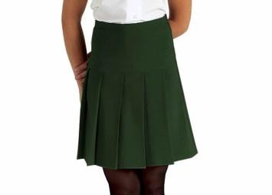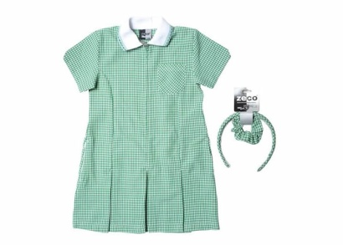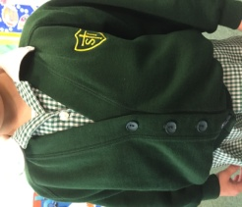

Boys Uniform
- Black school trousers, long or black shorts
- White Shirt/White polo Shirt
- Dark (bottle) Green Jumper or school sweatshirt
- Green and yellow striped tie (optional)
- Black shoes- Black or white socks
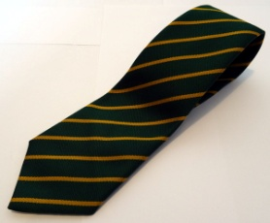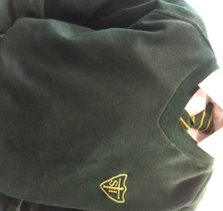

P.E Kit for Boys and Girls
Each child is expected to have a school PE bag. These can be purchased from the school. These PE bags will remain at school for the duration of the half terms (approx 6 weeks). At the end of each half term the children will bring home the P.E kit to be washed. It will then need to be returned the first day back of the new half term.
Children MUST adhere to the School P.E uniform.
- White T Shirt (This can be a polo shirt or a plain round necked t-shirt)
- Black shorts
- Plimsolls
- Black or Dark Green tracksuit bottoms are allowed in Winter.
- Black trainers can be worn for outdoor P.E only.

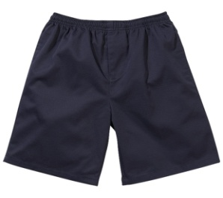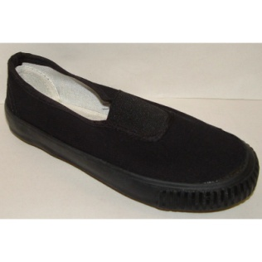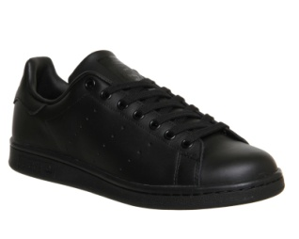
Please note for health and safety reasons:

Jewellery:
We do not encourage the wearing of jewellery to school. If parents/carers choose to allow their child to wear earrings, these need to be small plain studs and one pair only. No other jewellery is permitted. Children MUST NOT wear nail varnish, make-up or any type of tattoos including the stick-on variety to school. Children are encouraged to wear a watch.

Hairstyles:
All hair must be neatly tied back and off the face. Hair accessories should be neutral or in school colours. Mohican hair styles and shaved patterns in hair are not permitted. No dyed hair, hair extensions/colourful hair extensions. Caps with motifs/logos are not permitted. A green school cap can be purchased instead from the school shop.

