Home Learning for Year 5
Below is the expected home learning weekly timetable for your child. Please check the year group page for additional resources/website links. If you have any questions please contact the class teacher on ‘Class Dojo’.
Week commencing: Monday 20th April
St Ignatius Home Learning Weekly Timetable
Allocated time | Resource/Activity | Access
Twice weekly PE workout | YouTube  Joe Wicks – The Body Coach | https://www.youtube.com/user/thebodycoach1  If you are unable to watch the live stream, you can also catch up with them and watch them at a later day or time.
Daily Reading- 30 mins | Individual reading | Books that were taken home  David Walliams Audiobooks  First News Newspaper  Funbrain EBooks
Daily Spelling/Phonics | Spelling Frame:  Rule 43 – Silent letters  Sumdog – Silent Letters Challenge | Spelling Frame – Rule 43  This website has free access. No password needed- Click the link above.  https://www.sumdog.com/user/sign_in
Daily Times Tables | All Times tables | Times tables  This website has free access. Click the link above.
Daily Sumdog- 30 mins | Decimals, Fractions and Percentages Challenge | https://www.sumdog.com/user/sign_in  Username and password included in home learning pack.
Twice Weekly Grammar | Active Learn – Formal Language | Active Learn
Maths- Daily | White Rose- Maths | https://whiterosemaths.com/homelearning/  See Week 2 - Lessons 1-5 – See daily lessons below.
English- Daily | Active Learn and Home book (purple) | See daily lessons below.
Topic | Do we make the most of what is on our doorstep?  Lesson 1 – (PowerPoint)  Lesson 2 | PowerPoint on the Year 5 Home Learning Page. Go through each of the slides and complete the activities. (Press F5 when the PowerPoint presentation is open)  You will need to use your home book or some paper to complete the tasks.  Have a look at some of the different documentaries David Attenborough has produced. You DO NOT have to watch the whole thing.  David Attenborough Documentaries  Write some notes about the different habitats that the animals live in.  For example:  Is it a hot or cold place?  Is it urban or rural?  Is it populated or empty?

Maths Lessons- Monday-Friday
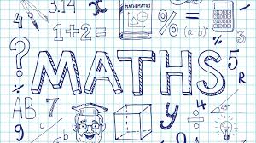
Please click on the links below that will take you straight to the activities on White Rose Home Learning. For each lesson there is a
- Video
- Activity
- Answer Sheet

HOW TO USE THE LESSONS

Just follow these four easy steps…
- Click on the set of lessons for your child’s year group.
- Watch the video (either on your own or with your child).
- Find a calm space where your child can work for about 20-30 minutes.
- Use the video guidance to support your child as they work through a lesson.

JOIN IN THE DAILY MATHS!
White Rose Maths – Week 2 lessons
Lesson 1 (Monday) – Rounding Decimals  Rounding Decimals- video  Challenge- See Problems of the Week | Day 1 Activity | Answers
Lesson 2 (Tuesday) – Order and Compare Decimals  Order and Compare Decimals -video  Challenge- See Problems of the Week | Day 2 Activity | Answers
Lesson 3 (Wednesday) – Understanding Percentages  Understanding Percentages -video  Challenge- See Problems of the Week | Day 3 Activity | Answers
Lesson 4 (Thursday) – Percentages as Fractions and Decimals  Percentages as Fractions and Decimals -video  Challenge- See Problems of the Week | Day 4 Activity | Answers
Lesson 5 (Friday) – Equivalent FDP (Fractions, decimals and Percentages)  Equivalent FDP -video  Challenge- See Problems of the Week | Day 5 Activity | Answers

English Lessons- Monday- Friday
Monday | 1. Read through and listen to the poem – Top Board by Michael Rosen.  Read – Top Board (Book)  Listen – Top Board (Performance)  2. Answer the questions about the poem, Top Board, on Active Learn. Read through and use evidence from the poem to support your answers. Make sure you read through your answers before you finish.  https://www.activelearnprimary.co.uk/downloadable-resource?id=236865&file=P_PCM_5.2.6.pdf | Challenge:  Come up with 5 questions about this poem and answers them.
Tuesday | 1. Reread the poem Top Board.  Read – Top Board (Book)  2. Can you find examples of:  - Capital letters  - Punctuation (! … ? , )  - Figurative language (Similes, metaphors, personification) | Challenge:  Explain the uses of each of these punctuation marks:  !  ?  ,  .  …
Wednesday | 1. Read If You Don’t Put Your Shoes On by Michael Rosen.  Read - If You Don’t Put Your Shoes On  2. Look at the way the poem is set out. Convert the poem in to a script between a parent and yourself.  WAGOLL:  Mum: If you don’t put your shoes on before I count to ﬁfteen then we won’t go to the woods to climb the chestnut tree one  Me: But I can’t ﬁnd them  Mum: Two  Me: I can’t | Challenge:  What could an alternative ending to this poem be?
Thursday | 1. Read through the poem – Chivvy by Michael Rosen.  Read – Chivvy (Book)  2. Comprehension- Answer the Questions about the poem- see below!, Chivvy, on Active Learn  Read through the poem again if you need to check something. Use full sentences for your answers. Read all your answers through carefully before you finish.  https://www.activelearnprimary.co.uk/downloadable-resource?id=236867&file=P_PCM_5.2.8.pdf | Challenge:  Create a list of things that adults tell you to do or not to do.  For example:  You can’t eat sweets before dinner.  Using the list you have made, create a short introduction to a poem in the style of Chivvy.
Friday | 1. Reread the poem, Chivvy and If you don’t put your shoes on by Michael Rosen.  Big Write Task:  Create a poem in one of the styles similar to Michael Rosen’s.  2. Think about times when you have been in similar situations at home or at school.  Write down somethings you remember the adult saying to you and your responses.  3. Create a plan for your poem. Think about the features you may need.  Rhyming couplets? Capital letters? Punctuation marks?  4. Write your poem. | Challenge:  Self-evaluate your work using two ticks and a wish. (Two things you did well and one thing that you could improve).

English Resources:
Top Board Poem: (Monday and Tuesday)

Top Board Questions: (Monday)
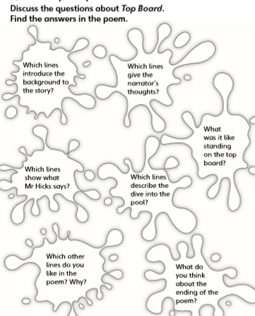
If You Don’t Put Your Shoes on Poem: (Wednesday)
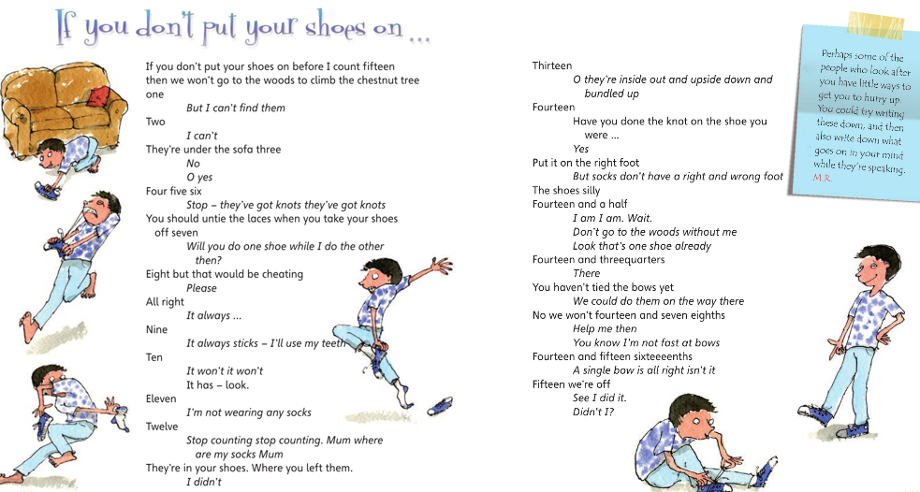

Chivvy Poem: (Thursday and Friday)
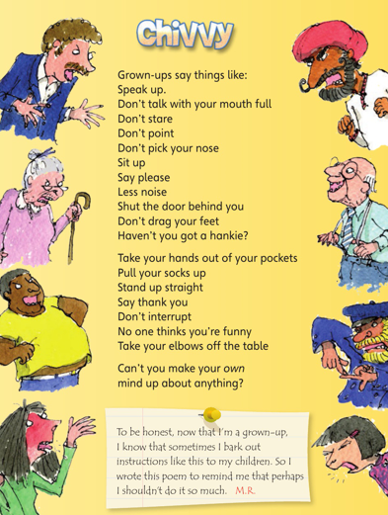

Chivvy Questions: (Thursday)
