Learn how to do hand breathing so that you feel nice and calm when you feel either anxious, angry or upset. Could you make a print of your own hand? Let’s make poster….

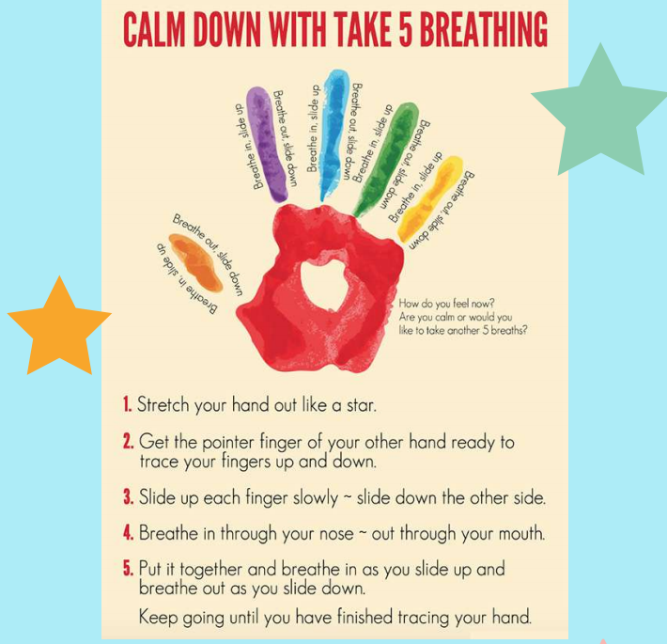

Watch a video: https://www.youtube.com/watch?v=sh79w9pn9Cg

