Wellbeing Newsletter No. 3
Welcome to Wellbeing newsletter no. 3 where you will find suggestions, website links and advice for supporting your child’s mental health and wellbeing whilst we are away from school.

We’d love to hear what you’ve been up to and if you’ve tried any of the activities let us know how you get on. You can send photos via Class Dojo.

Five Ways to Wellbeing
At school we promote the ‘Five Ways to Wellbeing’ approach which is all about how positive actions can contribute to and boost feelings of wellbeing. Each of these actions or ways will have a beneficial impact. Here are some activities you can try at home that link to each area. Have fun and let me know how you get on with them.

Connect | Be active | Take Notice | Keep Learning | Give
- Curious Conversations – create some cards and with your family, shuffle the cards, read out the questions and take turns to answer. Great for Facetime/video conversations too.  - Divide an A4 sheet of card or paper into twelve equal-sized boxes.  - Cut them out so you have 12 small cards  - On each card, write a question or topic to discuss with your friends.  - You can use the list on the next page or make up your own.  - The aim is that each card will start a conversation! | - ‘Happy Games’ event – gather your family, head outside and have fun!  - Ideas for activities:  - how many times can you throw a ball up in the air and catch it again, clapping three times after each throw?  - who can skip on the spot for the longest time while singing a song?  - race while balancing a potato on a spoon and stepping over small obstacles  - After each activity ask everyone to give themselves a happiness score out of 10 to show how much they enjoyed it. | - At the moment I am noticing that the natural environment is looking so green and full of life.  - Next time you go out for a walk, practise ‘noticing and being present’  - What does the air feel like on your skin? Is it warm or cold?  - Look up at the sky. What can you see? Is it sunny or is it rainy?  - What does the ground feel like under your feet?  - What shapes and colours are around you?  - What about the smells and scents?  - What sounds can you hear?  - After your walk you could draw a picture of something beautiful you noticed. | - Create a curiosity collage.  - Next time you’re out for a walk, look up high and look down low.  - Collect small items such as leaves, take some photographs or draw pictures of all the new things you have seen or found.  - Attach them to a big sheet of paper, label them and decorate your curious collection.  - You could get even more curious and find out a fact about each item you’ve collected and add these to your collage. | - The ‘many ways of being kind’ challenge  Make a list of all the ways you could be kind or help other people. Some things will be quick and easy; others will be harder or take longer.  - How many ideas can you think of right now? Keep thinking and add to your list – can you get to 100 different ways of being kind, giving or helping people?  - Take the challenge to the next level by trying to do everything on your list. It may take a few weeks or even months and you might need help with some things but give it your best shot – how many can you do?

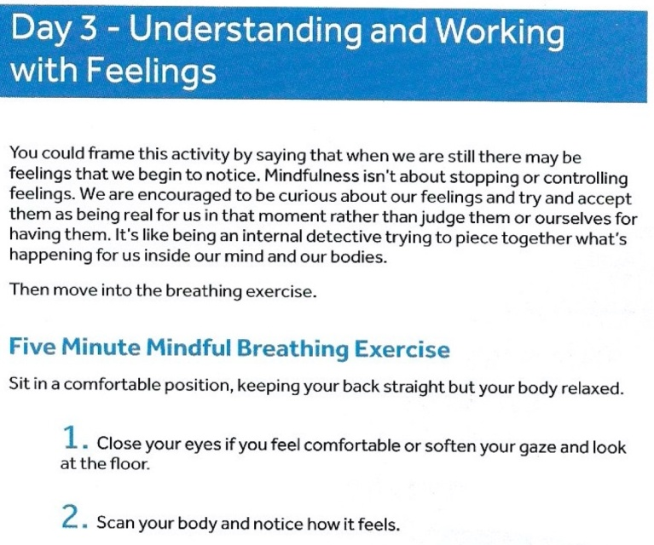
The basic breathing technique was shown in Newsletter 1.
Conversation Corner
Some questions to discuss in your families:
- Would you rather go to space or the bottom of the ocean?
- Would you rather have hands for feet or feet for hands?
- If you could have any pet, what would you choose?
- Would you rather have a flying carpet or a car that can drive underwater?
- If you could have any superpower, what would it be?

Mindfulness
Sitting still  - Sit comfortably and as still as you can for a full minute.  - During this time, pay attention to what may be happening in your mind or body.  - Don’t worry if you don’t quite get the hang of it – the whole point of mindfulness is not to focus on succeeding but to pay attention to the experience.  This Photo by Unknown Author is licensed under CC BY-NC | The Volcano  - Sit comfortably with your back straight and you can close your eyes if you wish.  - Imagine you are a big and powerful volcano and be aware of your feet on the ground.  - Imagine what it would feel like to be that volcano.  - Repeat this for a few minutes before bringing your awareness back to the room.
‘To plant a garden is to believe in tomorrow.’
Audrey Hepburn

