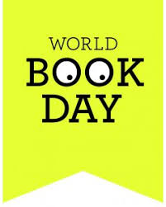
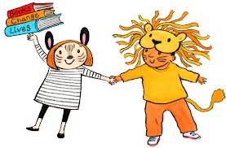

St Ignatius Catholic Primary School
Wednesday 7th February 2024
Dear Parents/Carers,
This year World Book Day is being celebrated on Thursday 7th March 2024.
Reading is something we really value at St Ignatius and we understand the importance of children getting enjoyment from their reading. This year World Book Day’s theme is ‘Read your way this World Book Day’.
This year for World Book Day we would like the children to come dressed as a word:
- This could be as simple as coming dressed as their favourite colour – e.g ‘red’, ‘blue’
- Or they could come dressed as any other word e.g:
- Blizzard- come dressed all in white
- Confused- draw lots of question marks over you
- Weekend – come to school dressed in your down-time clothes
- Party/Celebration- come to school wearing your party clothes
- Sleepy- wear your pyjamas
Please do not feel the pressure to purchase expensive costumes and recycle and reuse items you can find in the home.
The children will be taking part in lots of fun activities on World Book Day as well as taking part in a special workshop with Olaf Falafel, a famous children’s author who is visiting us on Wednesday 28th February to launch our World Book Day week of celebrations.
The Children will receive their £1 book tokens on World Book Day that they can spend in local book stores/supermarkets. At home you can encourage your child further by visiting the website www.worldbookday.com and getting involved with the many activities online.
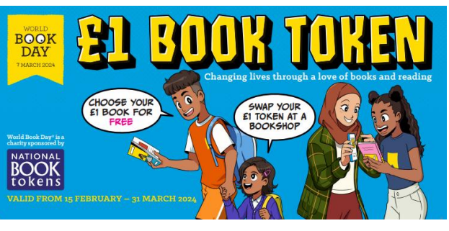

You can join us in building your child’s enthusiasm for books well beyond World Book Day by reading together regularly and joining your local library. Remember – you can read to your child in your home language as well as English – Reading is reading in every language!

The expectation at St Ignatius is that children read at least 5 times per week at home and this should be evidenced in their reading record. A great reader then becomes a great writer! Sharing stories together for just a few minutes a day will encourage a love of reading and it’s fun for everyone.
Thank you for your support!
Miss Taylor

