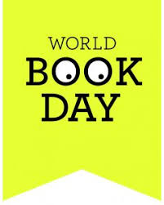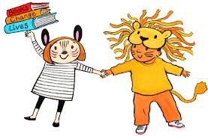
St Ignatius Catholic Primary School
Thursday 27th February 2020
Dear Parents/Carers,
This year World Book Day is being celebrated on Thursday 5th March 2020.
Reading is something we really value at St Ignatius and we understand the importance of children getting enjoyment from their reading. This year World Book Day is encouraging children to ‘share a million stories.’
We are giving our children the choice this year as to whether they want to either:
- dress up as their favourite well known book character or
- dress in their favourite pyjamas, dressing gowns/ slippers and pretend it is night-time!
- Dress in their own home clothes / non-uniform
Whatever they choose, as the weather is cold still, they may want to come to school in their own clothes and change when they get here. If they choose pyjamas, they can also wear legging/ tights / tops under their pyjamas or even just jogging bottoms / sweatshirt, if they do not have or want to wear their pyjamas.
We are asking for a donation of £1 to support the purchase of additional reading activities in school.
The children will be participating in reading activities throughout the day and taking part in fun book related experiences. The children will receive their £1 book tokens on World Book Day that they can spend in local book stores.
At home you can encourage your child further by visiting the website www.worldbookday.com and getting involved with the many activities online. You can join us in building your child’s enthusiasm for books well beyond World Book Day by reading together regularly and joining your local library.
Remember – you can read to your child in your home language as well as English – Reading is reading in every language!!
The expectation at St Ignatius is that children read at least 5 times per week at home and this should be evidenced in their reading record. A great reader then becomes a great writer!
Please also join us for Parent Reading Morning on the day - Thursday 5th March from 8:45- 9:15am. Please feel free to bring along your favourite children’s book to share with a small group of children. We will also have a selection in the class to share.
Book Swap This year we would also like to have a book swap. The children can bring in a book that they have read and swap it with another book that someone else has donated in their class or year group.
Thank you for your continued support. Happy Reading!!

