Writing Intention at St Ignatius | 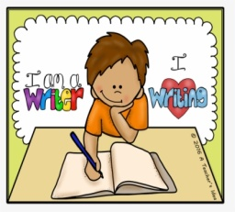
‘Stories are magical. Every teacher knows that. You read or tell a stpry. Silence descends.Children stare at you, through you and into a world beyond and yet, inside of them. In this inner world, the story is recreated. Indeed, the telling can be so powerful that a story may make us laugh, feel afraid or even cry’
‘We know linguistically children can’t write sentences unless they can say them and they can’t say a sentence unless they hear them a lot,’ (Pie Corbett)
St Ignatius Catholic Primary School uses the ‘Talk for Writing’ approach to teach children to write.

All classes plan, draft, proof-read, suggest improvements to their own and others’ writing, edit and then
produce final written pieces before reading their compositions aloud.

The statutory word lists for Year 3-4 and Years 5-6 can be found here:

Year 3 and 4

Year 5 and 6

