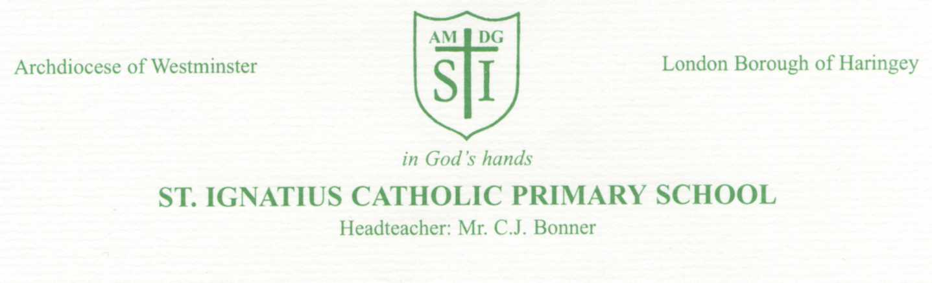

#Friday 16th September 2022

Dear Parents/Guardians,

We will be holding a reading information meeting for parents of children in Year 1 on Wednesday 5th
October at 9am in the school hall. The aim of the meeting is to give parents information about the Little Wandle phonics scheme that we are following and in which your children are participating.

We will also be sharing with you information on the Phonics screening check which the children will take in June of next year. As you may know, in the summer of Year 1 children have to undertake a phonics screening check, the results of which each school publishes. It is extremely important that children read regularly at home and that they learn how to decode and recognise phonemes. The Little Wandle scheme is designed to support pupils in being successful at this check and help them to become fluent readers. We will also explain our home reading system and how and why we choose the books that are sent home.

We will also have some resources that you can use at home in order to support the learning that is taking place in school. We will provide a phonics pack for each child which you can collect at the meeting.

This is good opportunity for you to understand our approach to phonic teaching and how you can further support your child at home. This will also be an opportunity for you to ask any questions about the teaching of reading which are not covered in the presentation. We would like ALL parents to attend if possible as reading is so important in Year 1 and good home/school partnerships are key to your child making progress.

We will be happy to chat to you after school regarding any queries you may have. Look forward to seeing you soon.

Yours sincerely

Miss Taylor

