Home Learning for Year 1

Hello everyone. Below is the home learning weekly timetable for your child. Please check the Year 1 page for additional resources/website links. If you have any questions, please contact us (Miss Haddon or Miss Harte) on ‘Class Dojo’.
Week commencing: Monday 22nd June
St Ignatius Home Learning Weekly Timetable
Subject | Resource/Access | Activity
Daily Reading- 30 mins | activelearnprimary.co.uk  (find login details inside the cover of your green book – same as lgfl login with school code: stig)  Free eBooks are also available on oxfordowl.co.uk (you do need to register using your email address and password but it is completely free) | Please continue to read every day with your child. You can find books allocated to your child on active learn. Login to Active Learn and click on ‘My Stuff’ to find your allocated reading books. Don’t forget to look at the inside cover of the book to practise the sounds and words that you will find inside the book.
Daily Phonics | activelearnprimary.co.uk  (find login details inside the cover of your green book – same as lgfl login with school code: stig)  busythings.co.uk  (find login details inside the cover of your green book – same as lgfl login)  BBC Bitesize phase 3 sounds  https://www.bbc.co.uk/bitesize/topics/zvq9bdm | Login to Active Learn and click on ‘My Stuff’ to find phonics games you can play.  Key stage 1 > Year 1 setup > English > Phonics programme  Children can select phases 2, 3 &4 or phase 5 to access a variety of games that will help with reading and writing words.  BBC bitesize gives help with teaching phase 2 and 3 phonics
Daily Times Tables | https://www.topmarks.co.uk/maths-games/hit-the-button  (Select ‘Times tables’ and then choose which one you want to practise)  busythings.co.uk  (find login details inside the cover of your green book – same as lgfl login)  https://www.youtube.com/watch?v=dzVyBQ5uTbo | Keep practising your 2, 5 and 10 times tables so you don’t forget them. Focus extra hard on the ones you find difficult to remember.  Key stage 1> Year 2 setup> Mathematics> Multiplication and division> Miner birds:Times tables  Continue to learn your 3 times tables with this funny song.
Twice Weekly Spelling | Weekly spellings:  We are practising the ‘tion’ sound.  “Pay attention, it’s a celebration”  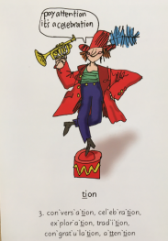  - nation  - option  - station  - caution  - fiction  - solution  - relation  - ambition  - correction  - translation  Challenge words (year 2 common exception):  move improve | Practise your words using the spelling sheet format:  Read, cover, write, check x3.  Can you put the words in a sentence?
Maths- Daily | https://whiterosemaths.com/homelearning/ | See next page for more details
English- Daily |  | See daily lessons below
Topic | 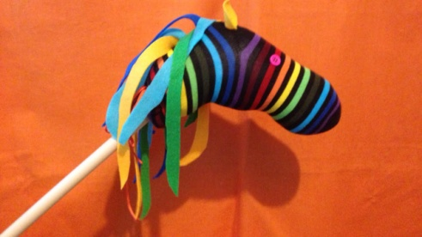  https://www.youtube.com/watch?v=TAnvVwh6-tI | Make your own hobby horse using a long stick or tube, an old sock and some paper or fabric scraps. You can stuff the sock with newspaper or plastic bags if you don’t have stuffing.  Then you can take it to the park and ride like the Highway Rat!

Maths Lessons- Monday-Friday
Please click on the links below that will take you straight to the activities on White Rose Home Learning. For each lesson there is:
- A video
- An activity
- An answer Sheet

HOW TO USE THE LESSONS

Just follow these four easy steps…
- Find a calm space where your child can work for about 20-30 minutes.
- Click on the link to the lesson you are going to work on and watch the relevant video.
- Click on the questions link and support your child as they work through the activity.
- Check your child’s answers with them by clicking on the answers link. Correct any mistakes.

JOIN IN THE DAILY MATHS!
Monday  Summer term – Week 9  Video for Lesson 1 - counting to 100 | Find Monday’s activity sheets and answers on the school website  https://stignatiuscatholicprimary.co.uk/key-information/online-learning/year-1-home-learning
Tuesday  Summer term – Week 9  Video for Lesson 2 - partitioning numbers | Find Tuesday’s activity sheets and answers on the school website  https://stignatiuscatholicprimary.co.uk/key-information/online-learning/year-1-home-learning
Wednesday  Summer term – Week 9  Video for Lesson 3 - comparing numbers | Find Wednesday’s activity sheets and answers on the school website  https://stignatiuscatholicprimary.co.uk/key-information/online-learning/year-1-home-learning
Thursday  Summer term – Week 9  Video for Lesson 4 - comparing numbers (2) | Find Thursday’s activity sheets and answers on the school website  https://stignatiuscatholicprimary.co.uk/key-information/online-learning/year-1-home-learning
Friday | Try these BBC Bitesize activities  Position and direction

English Lessons- Monday- Friday
Below is a series of five lessons we have planned. If you can manage all five then that’s great. If not, choose a few to complete with your child. There are challenges for children who can complete the main activity with ease. If your child finds the main activity a struggle, then don’t worry about completing the challenge.
Monday | Look at a picture of the Highway Rat (below). What do you think he is like? Is he kind and gentle? How do you know? Read the first few pages of ‘The Highway Rat’ (below). Talk to someone in your family about what the Highway Rat is doing and what you think about this. Now watch the Mr Bear’s video on Class Dojo.  Activity  Write a letter to the bear to suggest what he might do to solve the problem. Should he call the police? Should he steal his food back? Should he ask someone else to help? Or should he just stay away from the Highway Rat in case he gets hurt? You could start your letter like this:  Dear Bear,  I think you should ... | Challenge:  Can you think of some adjectives to describe how the woodland creatures must have felt when they met the Highway Rat? Try to think of 5 different words.
Tuesday | Talk about the Highway Rat again and how his actions made the other animals feel terrified and hungry. Which word would best describe his actions?  Funny Grey Selfish  Can you think of some more words to describe his actions?  Activity  Make a ‘Wanted’ poster for the Highway Rat. I have done an example one (below). Either design your own or print the template (below) and fill in the boxes. | Challenge:  Can you make a list of bad characters from stories you know? Is there something about all of them that is the same?
Wednesday | Watch the whole of the story of ‘The Highway Rat’ on Youtube https://www.youtube.com/watch?v=bkVoYeCLIXU  Do you notice that it rhymes? Example rhyming pairs are:  beast and feast cake and take  rude and food be and me  Activity  Can you listen to the story and the find the second word in each rhyming pair?  1. clover and ...  2. shiver and ...  3. leaf and ...  4. hill and ...  5. round and ... | Challenge:  Make up your own rhyming poem using characters from the story. Use this format:  I see a frog that sits on a log.  I see a mouse...  I see a rat...
Thursday | Who are the characters in the story? How many can you find? Now choose one of the characters that the Highway Rat steals from and imagine you are them. How do you feel when the Highway Rat appears? And how do you feel when he has gone forever?  Activity:  Draw your character and write 2 speech bubbles for him/her – one from the beginning of the story and one from the end.  Example:  Hurray! That mean rat is gone! I don’t have to be scared anymore.  I am shaking and scared. That rat is so nasty. I can’t believe he has stolen my clover! | Challenge:  Get someone to film you pretending to be your chosen character and saying how you feel at the beginning and the end of the story. Remember to use your voice, face and body to show us how you feel.
Friday | The Highway Rat learnt that his behaviour had been bad, and luckily he changed his ways. Can you think of some rules you could write down in case another young rat decides to do the same thing?  For example:  - Do not carry a sword.  - Do not scare others.  Activity:  Write down your rules in bullet point form and then decorate with pictures from the story. | Challenge:  Use ‘but’ after each rule to give an alternative type of behaviour.  For example:  - Do not scare people but make them laugh instead.

Monday pictures from ‘The Highway Rat’:
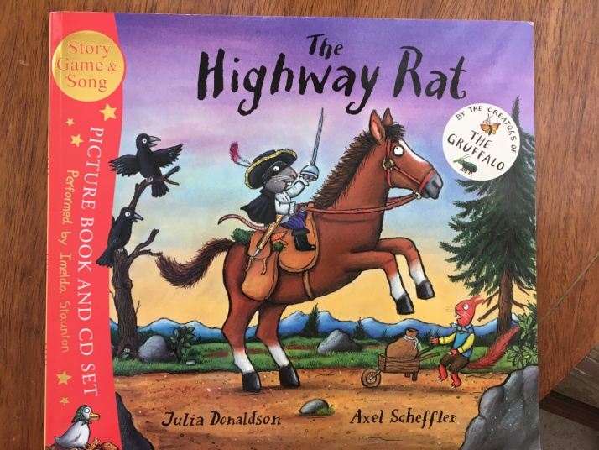
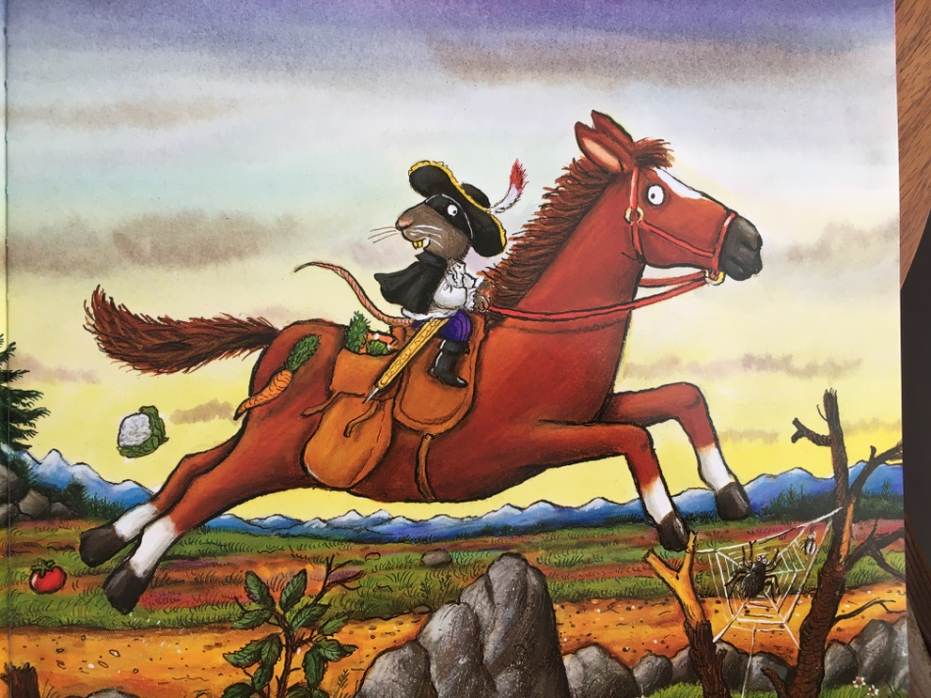
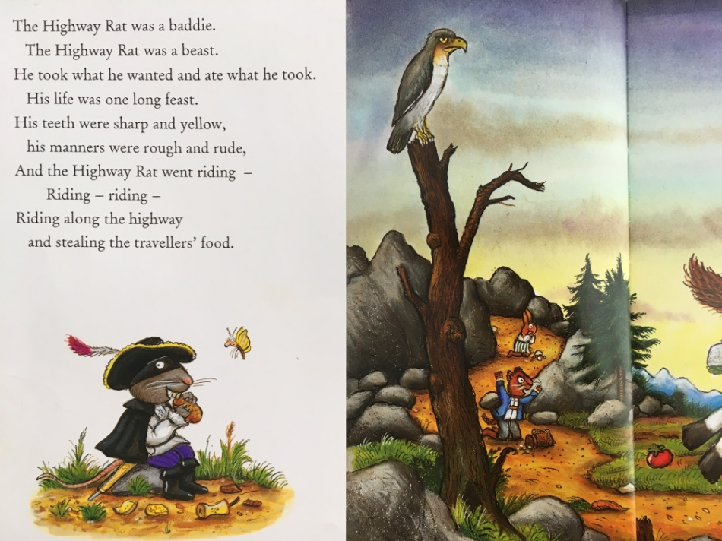
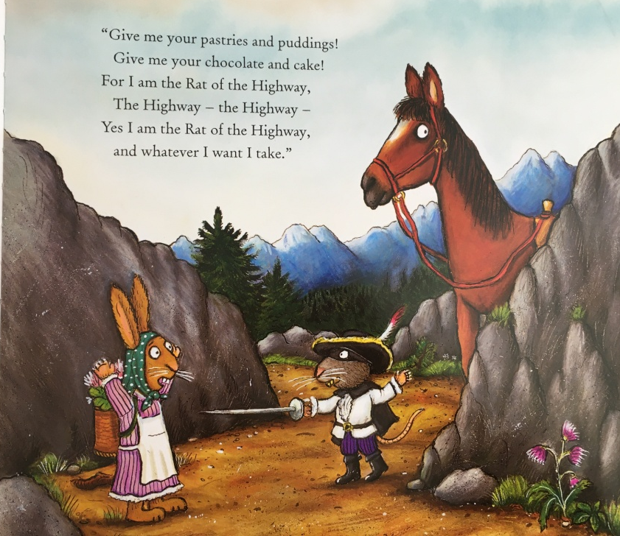
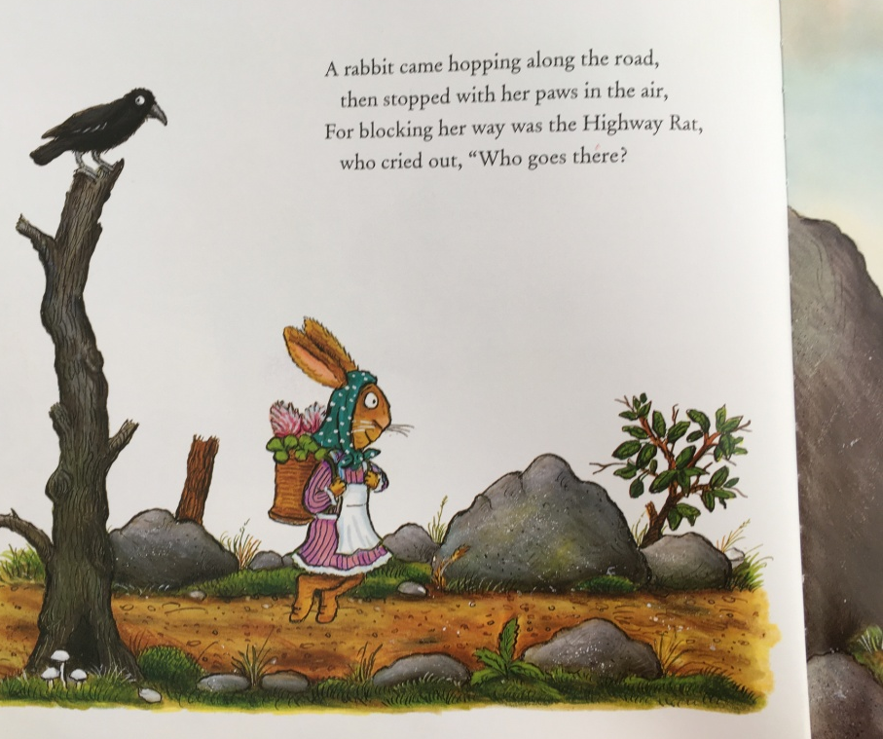
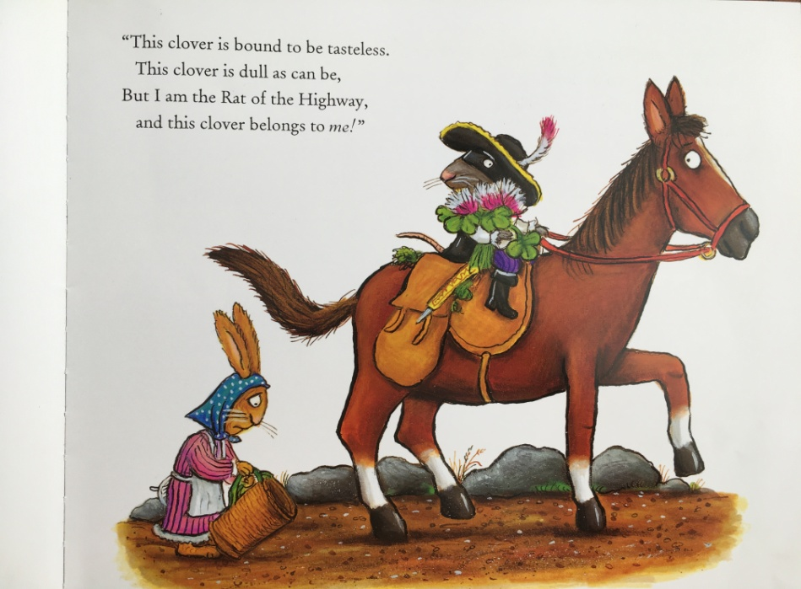
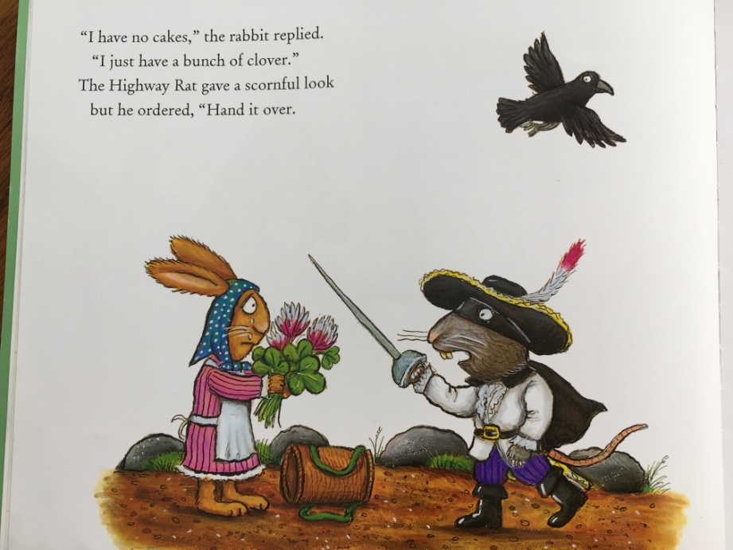

Tuesday example ‘Wanted’ poster:

REWARD £450
The Highway Rat is has sharp, yellow teeth and a long tail. He carries a sword and wears a black hat and mask. He can be found on the highway, riding a brown horse.

He is wanted for stealing food from innocent woodland animals.

Be careful – he is DANGEROUS!
The Highway Rat

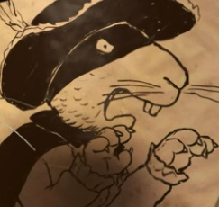

Tuesday ‘wanted’ poster template:

REWARD:

