Home Learning for Year 1

Hello everyone. Below is the home learning weekly timetable for your child. Please check the Year 1 page for additional resources/website links. If you have any questions, please contact us (Miss Haddon or Miss Harte) on ‘Class Dojo’.
Week commencing: Monday 29th June
St Ignatius Home Learning Weekly Timetable
Subject | Resource/Access | Activity
Daily Reading- 30 mins | activelearnprimary.co.uk  (find login details inside the cover of your green book – same as lgfl login with school code: stig)  Free eBooks are also available on oxfordowl.co.uk (you do need to register using your email address and password but it is completely free) | Please continue to read every day with your child. You can find books allocated to your child on active learn. Login to Active Learn and click on ‘My Stuff’ to find your allocated reading books. Don’t forget to look at the inside cover of the book to practise the sounds and words that you will find inside the book.
Daily Phonics | activelearnprimary.co.uk  (find login details inside the cover of your green book – same as lgfl login with school code: stig)  busythings.co.uk  (find login details inside the cover of your green book – same as lgfl login)  BBC Bitesize phase 3 sounds  https://www.bbc.co.uk/bitesize/topics/zvq9bdm | Login to Active Learn and click on ‘My Stuff’ to find phonics games you can play.  Key stage 1 > Year 1 setup > English > Phonics programme  Children can select phases 2, 3 &4 or phase 5 to access a variety of games that will help with reading and writing words.  BBC bitesize gives help with teaching phase 2 and 3 phonics
Daily Times Tables | https://www.topmarks.co.uk/maths-games/hit-the-button  (Select ‘Times tables’ and then choose which one you want to practise)  busythings.co.uk  (find login details inside the cover of your green book – same as lgfl login)  https://www.youtube.com/watch?v=dzVyBQ5uTbo | Keep practising your 2, 5 and 10 times tables so you don’t forget them. Focus extra hard on the ones you find difficult to remember.  Key stage 1> Year 2 setup> Mathematics> Multiplication and division> Miner birds:Times tables  Continue to learn your 3 times tables with this funny song.
Twice Weekly Spelling | Weekly spellings:  We are practising the ‘are’ sound.  “Care and share, are’’  - care  - share  - rare  - scare  - glare  - hare  - aware  - stare  - square  - flare  Challenge words (year 2 common exception):  only parents | Practise your words using the spelling sheet format:  Read, cover, write, check x3.  Can you put the words in a sentence?
Maths- Daily | https://whiterosemaths.com/homelearning/ | See next page for more details
English- Daily |  | See daily lessons below
Topic | https://www.bbc.co.uk/newsround/17273317  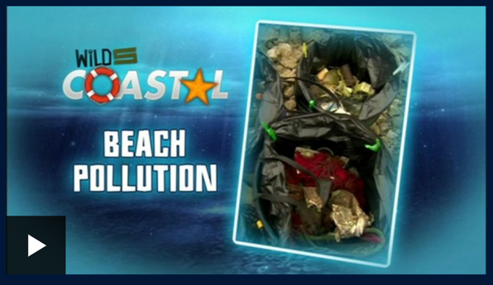 | Watch this coastal beach video.  It shows what is happening on our lovely beaches.  What do you see?  How do you feel about this?  Discuss what we can do to prevent people from littering on the beach.  Design a banner to tell people to stop littering.  You can make it as big or small as you wish.  It can be made out of any material, cardboard, old bed sheets or pillowcases, paper, cereal boxes.  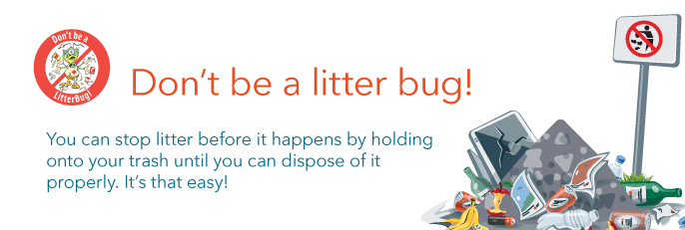

Maths Lessons- Monday-Friday
Please click on the links below that will take you straight to the activities on White Rose Home Learning. For each lesson there is:
- A video
- An activity
- An answer Sheet

HOW TO USE THE LESSONS

Just follow these four easy steps…
- Find a calm space where your child can work for about 20-30 minutes.
- Click on the link to the lesson you are going to work on and watch the relevant video.
- Click on the questions link and support your child as they work through the activity.
- Check your child’s answers with them by clicking on the answers link. Correct any mistakes.

JOIN IN THE DAILY MATHS!
Monday  Summer term – Week 10  Video for Lesson 1 - Ordering numbers | Find Monday’s activity sheets and answers on the school website  https://stignatiuscatholicprimary.co.uk/key-information/online-learning/year-1-home-learning
Tuesday  Summer term – Week 10  Video for Lesson 2 - Recognising coins | Find Tuesday’s activity sheets and answers on the school website  https://stignatiuscatholicprimary.co.uk/key-information/online-learning/year-1-home-learning
Wednesday  Summer term – Week 10  Video for Lesson 3 - Recognise notes | Find Wednesday’s activity sheets and answers on the school website  https://stignatiuscatholicprimary.co.uk/key-information/online-learning/year-1-home-learning
Thursday  Summer term – Week 10  Video for Lesson 4 - Counting in coins | Find Thursday’s activity sheets and answers on the school website  https://stignatiuscatholicprimary.co.uk/key-information/online-learning/year-1-home-learning
Friday | Try these BBC Bitesize activities  Coin game BBC Bitesize

English Lessons- Monday- Friday
Below is a series of five lessons we have planned. If you can manage all five then that’s great. If not, choose a few to complete with your child. There are challenges for children who can complete the main activity with ease. If your child finds the main activity a struggle, then don’t worry about completing the challenge.
Monday | 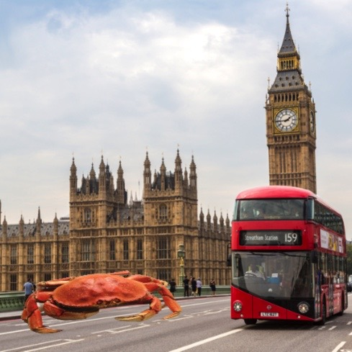  Look at the picture enlarged below.  Discuss with the children what you can see.  Where do you think the crab is?  Do you think the crab belongs here?  Year One I am very lost. My name is Mr Crab and I am a long way from my home. Do you know where it is?  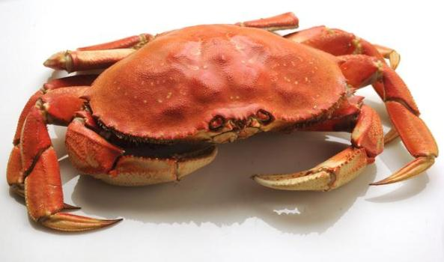  Activity  Discuss with your child that the Mr Crab should be at the beach.  Children must draw the beach and make a list of all the things the beach has underneath. Use exciting adjectives. Try to use different words than usual, it would be nice if you discussed the words. For example: swapping yellow sand with velvet honey sand.  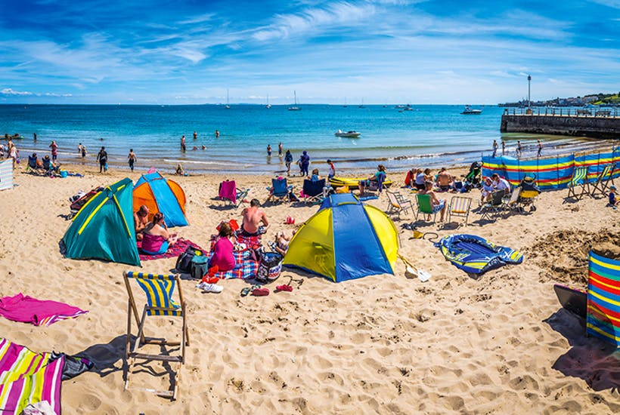  - Golden grainy sand  - Glistening sparkly sea  - Tall peaked tents | Challenge:  Reread your sentences, is there any words that you think you could make more exciting?
Tuesday | Today is role play and today, you are Mr Crab!  You want to get home to your family at the beach but in order to get home, you must ask the driver to take you.  The bus driver wants to know what the beach looks like so he will know when to let you off the bus.  Activity  What are you going to say to the bus driver?  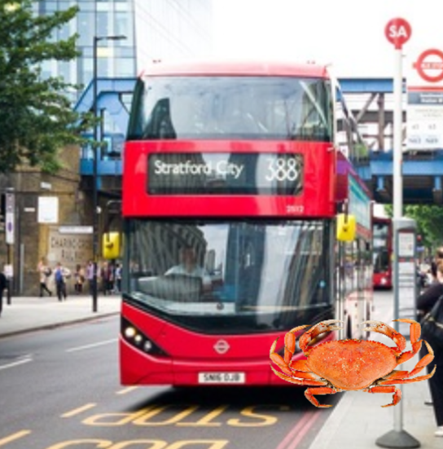  You can use your bullet pointed list from yesterday’s writing to read from.  When doing role play, it is important to remember that you are the character. ‘’I am Mr Crab’’ etc.  Maybe you want to creep across the floor or put on a squeaky voice. You could make a crab mask or wear a red t-shirt. (crab mask template below).  How are you going to start your role play? Are you going address the bus driver?  Example: ‘’Good morning sir, how are you? I want to go to the beach. The sand is sparkly and covered in interesting shells.’’  You can record a video or just take a picture of you being Mr Crab and send it to your teacher. | Challenge:  Using speech marks, write out what the bus driver might say in response.  Example:  ‘’Hello Mr Crab, yes hop on the bus! I would love to take you back to the beach.’’ Exclaimed the bus driver.
Wednesday | Mr Crab is back at the beach  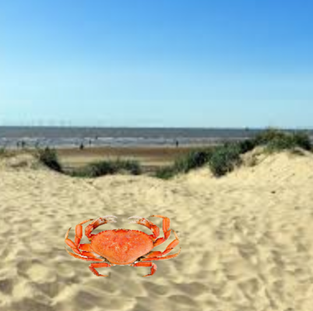  Lets go visit him for the day.  First, we need to sort the things we want to take and the things we want to leave behind. Think about what you might need for the beach.  Activity:  Draw a two columned table  Take Leave  Sort these words and draw a picture of them beside their name. Put the things you think you would need at the beach in the ‘take’ column (left) and the rest in the ‘leave’ (right).  Words:  boots lotion ball  raincoat sunglasses jumper  bucket and spade socks sandals  Something fun to do  Pack your bag for the beach! What will you take?  Send pictures to your teachers to share with the class. | I there anything you think might belong in ‘take’ as well as ‘leave’ ? Explain your answer.
Thursday | Yesterday you went to the beach to see Mr Crab.  You must write a post card from the beach.  - Decide who you're writing the postcard to. It could be someone in your family, a friend or even your school teacher.  - Make sure all your sentences include a capital letter at the start and the correct punctuation at the end.  - Try to include some statements in there too (you can use the ones from activity two if needed).  - Remember to finish your postcard with an ending like 'lots of love' or 'from'.  Layout:  To____ Why you are writing. Where? What you have done. From _______ Address and stamp | Include something nice to say in your postcard  Example  I miss you and wish you were here
Friday | Words that rhyme often have the same letters at the end and therefore sound similar. For example bat and cat.  Read the poem below. Can you spot any words that rhyme? Do they end the same?  I want to have fun in the sun.  A lolly each at the beach.  Oh no crab, please don’t grab!  Listening to hip hop dancing in my flip flop.  Eating fish and chips and watching the big ships.  Activity  Rewrite the poem. Underline the two rhyming words in each sentence. | Challenge  Add two more rhyming sentences to the poem.  Can you think of words that rhyme with hat and cream?

Monday
Year One I am very lost. I am a long way from my home. Do you know where it is?

Tuesday
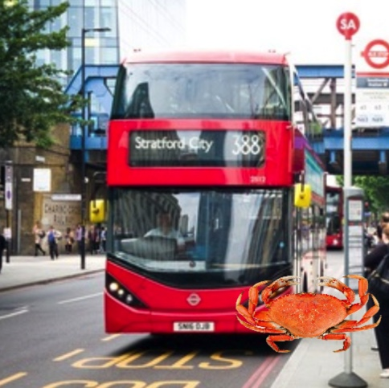
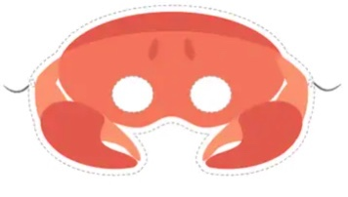

Thursday

