Home Learning for Year 1

Hello everyone. Below is the home learning weekly timetable for your child. Please check the Year 1 page for additional resources/website links. If you have any questions, please contact us (Miss Haddon or Miss Harte) on ‘Class Dojo’.
Week commencing: Monday 6th July
St Ignatius Home Learning Weekly Timetable
Subject | Resource/Access | Activity
Daily Reading- 30 mins | activelearnprimary.co.uk  (find login details inside the cover of your green book – same as lgfl login with school code: stig)  Free eBooks are also available on oxfordowl.co.uk (you do need to register using your email address and password but it is completely free) | Please continue to read every day with your child. You can find books allocated to your child on active learn. Login to Active Learn and click on ‘My Stuff’ to find your allocated reading books. Don’t forget to look at the inside cover of the book to practise the sounds and words that you will find inside the book.
Daily Phonics | activelearnprimary.co.uk  (find login details inside the cover of your green book – same as lgfl login with school code: stig)  busythings.co.uk  (find login details inside the cover of your green book – same as lgfl login)  BBC Bitesize phase 3 sounds  https://www.bbc.co.uk/bitesize/topics/zvq9bdm | Login to Active Learn and click on ‘My Stuff’ to find phonics games you can play.  Key stage 1 > Year 1 setup > English > Phonics programme  Children can select phases 2, 3 &4 or phase 5 to access a variety of games that will help with reading and writing words.  BBC bitesize gives help with teaching phase 2 and 3 phonics
Daily Times Tables | https://www.topmarks.co.uk/maths-games/hit-the-button  (Select ‘Times tables’ and then choose which one you want to practise)  busythings.co.uk  (find login details inside the cover of your green book – same as lgfl login)  https://www.youtube.com/watch?v=dzVyBQ5uTbo | Keep practising your 2, 5 and 10 times tables so you don’t forget them. Focus extra hard on the ones you find difficult to remember.  Key stage 1> Year 2 setup> Mathematics> Multiplication and division> Miner birds:Times tables  Continue to learn your 3 times tables with this funny song.
Twice Weekly Spelling | Weekly spellings:  We are practising the words with a silent k.  - knee  - knit  - knots  - know  - knows  - knock  - knife  - knives  - knuckle  - knocking  Challenge words (year 2 common exception):  plant pass | Practise your words using the spelling sheet format:  Read, cover, write, check x3.  Can you put the words in a sentence?
Maths- Daily | https://whiterosemaths.com/homelearning/ | See next page for more details
English- Daily |  | See daily lessons below
Topic | 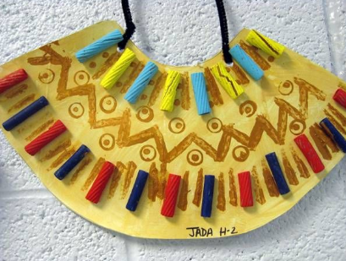  Watch this Youtube video for instructions for dying pasta:  https://www.youtube.com/watch?v=HDsIApk4gkw | Design your own African-inspired jewellery using card, coloured pasta (you can dye it yourself – see Youtube link opposite), glue, string and felt tip pens or coloured pencils. You can make a necklace like this picture, but you can also make cuffs for your wrists and ankles if you like.

Maths Lessons- Monday-Friday
Please click on the links below that will take you straight to the activities on White Rose Home Learning. For each lesson there is:
- A video
- An activity
- An answer Sheet

HOW TO USE THE LESSONS

Just follow these four easy steps…
- Find a calm space where your child can work for about 20-30 minutes.
- Click on the link to the lesson you are going to work on and watch the relevant video.
- Click on the questions link and support your child as they work through the activity.
- Check your child’s answers with them by clicking on the answers link. Correct any mistakes.

JOIN IN THE DAILY MATHS!
Monday  Summer term – Week 11  Lesson 1 - Find a half (1) | Find Monday’s activity sheets and answers on the school website  https://stignatiuscatholicprimary.co.uk/key-information/online-learning/year-1-home-learning
Tuesday  Summer term – Week 11  Lesson 2 - Find a half (2) | Find Tuesday’s activity sheets and answers on the school website  https://stignatiuscatholicprimary.co.uk/key-information/online-learning/year-1-home-learning
Wednesday  Summer term – Week 11  Lesson 3 - Find a quarter (1) | Find Wednesday’s activity sheets and answers on the school website  https://stignatiuscatholicprimary.co.uk/key-information/online-learning/year-1-home-learning
Thursday  Summer term – Week 11  Lesson 4 - Find a quarter (2) | Find Thursday’s activity sheets and answers on the school website  https://stignatiuscatholicprimary.co.uk/key-information/online-learning/year-1-home-learning
Friday | Try the BBC Bitesize challenges  https://www.bbc.co.uk/bitesize/articles/zkfm8hv

English Lessons- Monday- Friday
Below is a series of five lessons we have planned. If you can manage all five then that’s great. If not, choose a few to complete with your child. There are challenges for children who can complete the main activity with ease. If your child finds the main activity a struggle, then don’t worry about completing the challenge.
Monday | Watch the animation ‘Zahra’ on Literacy Shed https://www.literacyshed.com/the-other-cultures-shed.html  You will have to scroll down until you see ‘Zahra’ – it is the 5th story on the page.  Discuss the answers to these questions with an adult:  - Do you like the animation? Why/ why not?  - What is Zahra trying to do in the story?  - How does she feel at the beginning? Why?  - Does the water make the tree grow in the end?  - Where do you think Zahra lives?  Activity:  Look at the world map below and try to find the continent where Zahra lives. What clues do you have that she lives there? Draw one clue in each box underneath the map. | Challenge:  Name 5 countries that can be found in the continent where Zahra lives.
Tuesday | We spotted in yesterday’s lesson that Zahra lives in an African village. How does this compare to your home in London? Think about the following areas to give you some things to compare.  1 Buildings  2 Weather  3 Animals  4 Shops  You can watch the animation ‘Zahra’ again and also look at the photographs below to help you compare.  Activity:  Divide a page of your book in half with ‘African village’ and ‘London’ written at the top of each section. Write a few sentences on each side to compare the places.  For example:  African village London  Many people live in huts Many people lives in tall blocks  made of mud and straw of flats made of concrete  Many families keep cows Many families have pet cats,  and chickens so they can dogs and guinea pigs  have milk and eggs | Challenge:  Draw and label a picture of a traditional African village.
Wednesday | In the story ‘Zahra’, what was it that made the tree grow in the end? The animator, Ramya Chidanand, made the tree seem like it was a person – this is called ‘personification’. How do you think the tree felt about Zahra? If the tree could talk, what do you think it might say?  Activity:  Draw a picture of the tree and around your picture, write one or two (or more) things the tree might say if it could talk, e.g. Zahra, you are a good friend. I want to protect you. | Challenge:  Choose an object in your house and personify it; what might it say?  For example:  The armchair said, “Come over here and get comfortable”.  The taps said, “Let us wash all those germs down the drain.”
Thursday | What do we need when we write a sentence? We need to start with a capital letter and finish with a full stop, question mark or exclamation mark. We also use capital letters at the start of a name of a person or place. For example:  my name is zahra and I am 8 years old  Should be written like this:  My name is Zahra and I am 8 years old.  Activity:  Read the following sentences from Zahra’s diary and see if you can spot the mistakes. Rewrite each sentence with the correct punctuation.  1. today I went to the market with kemi  2. it is so hot I could burst  3. will the tree grow tomorrow  4. next week I am going to travel to bujuuko | Challenge:  Learn how to use commas to separate items in a list by watching the video and doing the activity on BBC Bitesize:  https://www.bbc.co.uk/bitesize/topics/z8x6cj6/articles/zxvcrdm  Then, why not use your knowledge of commas to write about what you can see in Zahra’s village.  In the village I can see ... , ... , ... and ... .
Friday | In the story, how did Zahra get water for the tree?  Her village had a water pump which gave the families clean water for drinking, washing and cooking. There are many villages in Africa that do not have a water pump, and it is often the children’s job to go to the nearest river to collect water. Go to the Cafod website and see if you can find Uganda on the map. Watch the video ‘Guti in Uganda’. Website link: https://cafod.org.uk/Education/Kidz-Zone  Activity:  Can you persuade Miss Haddon and Miss Harte to give some money to CAFOD to help villagers like Guti? Why should we give some money? What good things might come out of it? Why is it important for people to have clean water?  You could design a poster, write a short letter or make a video. If we get some persuasive work sent through we will make a donation to CAFOD. | Challenge:  Can you find another video on the CAFOD website that is filmed in Africa? Watch it and write down what you found out in the form of bullet points.

Monday:
In which continent do you think Zahra lives?

______________________________________________________________________________________

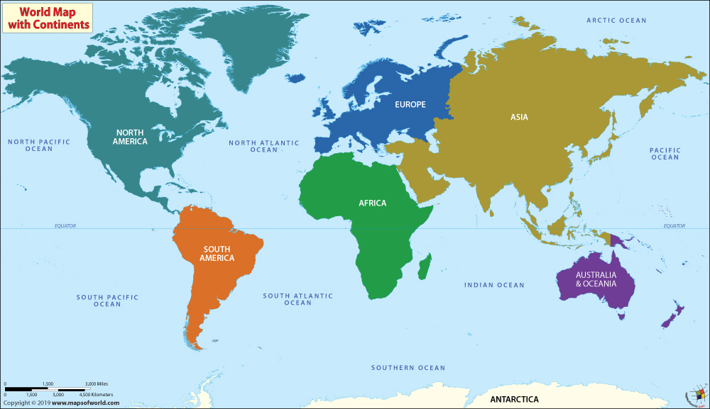

Draw 3 things you saw in the animation that gave you clues:

Tuesday – photographs of a traditional African village:
