Home Learning for Year 1
Hello everyone,
We hope you are all healthy and happy at home. Please see below for school work ideas for this week. Remember, it is important to practise the skills we have learnt in class so you don’t forget them. Take care of yourselves and your families.
Miss Haddon and Miss Harte
Week commencing: 30th March 2020
St Ignatius Home Learning Weekly Timetable
Subject | Resource | Activity
PE | youtube.com  (type in ‘PE with Joe’) | Continue to get your body and brain ready for the day with a 30 minute live workout at 9am Monday to Friday. You can also access it later if you wish.
30 minutes daily reading | activelearnprimary.co.uk  (find login details inside the cover of your green book – same as lgfl login)  Free eBooks are also available on oxfordowl.co.uk (you do need to register using your email address and password but it is completely free) | Login to Active Learn and click on ‘My Stuff’ to find your allocated reading books. Don’t forget to look at the inside cover of the book to practise the sounds and words that you will find inside the book.
Daily phonics | activelearnprimary.co.uk  (find login details inside the cover of your green book – same as lgfl login)  busythings.co.uk  (find login details inside the cover of your green book – same as lgfl login) | Login to Active Learn and click on ‘My Stuff’ to find phonics games you can play.  Key stage 1 > Year 1 setup > English > Phonics programme  Children can select phases 2, 3 &4 or phase 5 to access a variety of games that will help with reading and writing words.
Daily times tables | busythings.co.uk  (find login details inside the cover of your green book – same as lgfl login)  topmarks.co.uk/maths-games/hit-the-button  (online game - no login needed) | Practise 2 times tables by selecting:  Key stage 1 > Year 1 setup > Mathematics > Multiplication and division > 2 times tables - recall  Select ‘Times Tables’ > x2  Another way to practise your 2 times tables, but timed! Can you beat your previous score?
Twice weekly spelling and grammar | Weekly spellings:  like one  Challenge words (year 2 common exception):  any beautiful | Practise your tricky words using the spelling sheet format:  Read, cover, write, check x3.  Can you put the words in a sentence?
Maths | whiterosemaths.com  (no login needed)  Home learning > Year 1 > Week 1  Home learning > Year 1 > Week 2 | These are a series of short teaching videos (about 5 minutes or so each) followed by question sheets. We would recommend 1 lesson per day as this will be in addition to daily times tables work. This week though, you could start with Week 1, lessons 4 and 5 on Monday and then move on from there.  Follow up: In the garden or in the bath, let your child practise filling containers with various capacities for comparison. Challenge: How many cups of water will fill a bottle? A jug? A bowl?
Writing | Choose a member of your family and then write in your green book.  Example:  My brother is called Patrick. He is 38 and he is tall and slim. He has spiky, brown hair and pale blue eyes. He loves listening to music and he is an excellent footballer. At the weekends he enjoys cooking delicious food. | Describe one of the people in your family. How old are they? What do they look like? What do they enjoy doing? Try to use interesting adjectives.  Challenge: Use speech marks to write down something they said to you today, for example: “Can you play football with me?” Patrick asked.  Try writing about a different person each day.
Science/arts and crafts | You will need: Some plain paper, a pencil, 3 coloured pencils or felt tip pens.  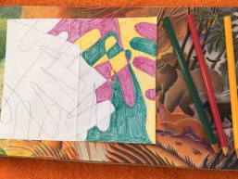  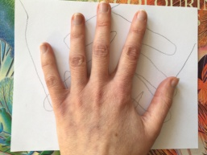  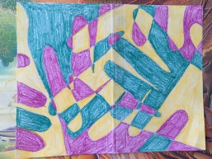  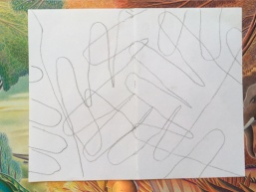  Example: | Create some artwork by drawing around your hand with a pencil lots of times, turning the page and allowing the lines to overlap. Once you are happy with the line drawing, use the 3 colours to colour in each section – try not to use the same colour for sections that are next to each other.

