Home Learning for Year 1

Hello everyone. Below is the home learning weekly timetable for your child. Please check the Year 1 page for additional resources/website links. If you have any questions, please contact us (Miss Haddon or Miss Harte) on ‘Class Dojo’.
Week commencing: Monday 18th May
St Ignatius Home Learning Weekly Timetable
Subject | Resource/Access | Activity
Daily Reading- 30 mins | activelearnprimary.co.uk  (find login details inside the cover of your green book – same as lgfl login with school code: stig)  Free eBooks are also available on oxfordowl.co.uk (you do need to register using your email address and password but it is completely free) | Please continue to read every day with your child. You can find books allocated to your child on active learn. Login to Active Learn and click on ‘My Stuff’ to find your allocated reading books. Don’t forget to look at the inside cover of the book to practise the sounds and words that you will find inside the book.
Daily Phonics | activelearnprimary.co.uk  (find login details inside the cover of your green book – same as lgfl login with school code: stig)  busythings.co.uk  (find login details inside the cover of your green book – same as lgfl login) | Login to Active Learn and click on ‘My Stuff’ to find phonics games you can play.  Key stage 1 > Year 1 setup > English > Phonics programme  Children can select phases 2, 3 &4 or phase 5 to access a variety of games that will help with reading and writing words.
Daily Times Tables | https://www.topmarks.co.uk/maths-games/mental-maths-train  https://www.topmarks.co.uk/times-tables/coconut-multiples  https://www.topmarks.co.uk/maths-games/hit-the-button  (Select ‘Times tables’ and then choose which one you want to practise)  busythings.co.uk  (find login details inside the cover of your green book – same as lgfl login) | Revise your 2, 5 and 10 times tables by getting family to test you. You can also play a number of games to give you more practice. Have a look at the links to the left.  Key stage 1> Year 2 setup> Mathematics> Multiplication and division> Miner birds:Times tables
Twice Weekly Spelling | Weekly spellings:  We are practising the ‘o_e’ sound.  “Phone home, o_e”  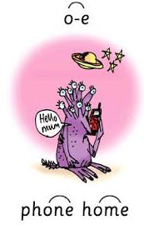  - bone  - rope  - chose  - globe  - froze  - alone  - strokes  - explode  - envelope  - telephone  Challenge words (year 2 common exception):  Mr Mrs | Practise your words using the spelling sheet format:  Read, cover, write, check x3.  Can you put the words in a sentence?
Maths- Daily | https://whiterosemaths.com/homelearning/ | See next page for more details
English- Daily |  | See daily lessons below
Topic | https://www.youtube.com/watch?v=IOeDnG1leQM  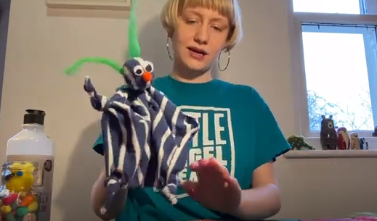 | Watch this video on the Little Angel Theatre YouTube page to see how you can make your own troll puppet. I would love to see any trolls that you make so please send me a picture or video if you have a go at this activity.

Maths Lessons- Monday-Friday
Please click on the links below that will take you straight to the activities on White Rose Home Learning. For each lesson there is:
- A video
- An activity
- An answer Sheet

HOW TO USE THE LESSONS

Just follow these four easy steps…
- Find a calm space where your child can work for about 20-30 minutes.
- Click on the link to the lesson you are going to work on and watch the relevant video.
- Click on the questions link and support your child as they work through the activity.
- Check your child’s answers with them by clicking on the answers link. Correct any mistakes.

JOIN IN THE DAILY MATHS!
Monday  Summer term – Week 5  lesson 1 video - compare length and height | Find Monday’s activity sheets and answers on the school website  https://stignatiuscatholicprimary.co.uk/key-information/online-learning/year-1-home-learning
Tuesday  Summer term – Week 5  lesson 2 - measure length (1) | Find Tuesday’s activity sheets and answers on the school website  https://stignatiuscatholicprimary.co.uk/key-information/online-learning/year-1-home-learning
Wednesday  Summer term – Week 5  lesson 3 - measure length (2) | Find Wednesday’s activity sheets and answers on the school website  https://stignatiuscatholicprimary.co.uk/key-information/online-learning/year-1-home-learning
Thursday  Summer term – Week 5  lesson 4 - introduce mass and weight | Find Thursday’s activity sheets and answers on the school website  https://stignatiuscatholicprimary.co.uk/key-information/online-learning/year-1-home-learning
Friday | Try BBC Bitesize challenges 1 and 2  Friday challenge

English Lessons- Monday- Friday
Below is a series of five lessons we have planned. If you can manage all five then that’s great. If not, choose a few to complete with your child. There are challenges for children who can complete the main activity with ease. If your child finds the main activity a struggle, then don’t worry about completing the challenge.
Monday | This week our English lessons are based on the traditional tale ‘The Three Billy Goats Gruff’. Click this link to watch a great animated version of the story.  https://www.youtube.com/watch?v=f4kdZTnizG4  How many characters are in this story? Can you name them?  Activity:  Draw each character from the story and label them with their name. Don’t forget to use a capital letter at the beginning of each name. | Challenge:  Write a couple of sentences to answer these questions.  Who is your favourite character from ‘The Three Billy Goats Gruff’?  Why do you like him?
Tuesday | Read this description and see if you can guess which character I am describing:  This character has stripy, curly horns. His fur is smooth, soft and grey. He is wearing a shiny bell with a brown ribbon. He has a white, fluffy beard. He is enormous, strong and brave.  Activity:  Choose one of the 4 characters from the story and write a description of him. Try your best to use interesting adjectives. If you send it to me on ClassDojo I will see if I can guess who you are describing.  You will find an ‘adjectives word mat’ below to help you, but you can also think of your own adjectives. | Challenge:  Can you put these adjectives into pairs with a similar meaning?  For example:  Angry Ancient  Old Furious  Big Courageous  Ugly Petite  Fast Colossal  Small Terrified  Brave Rapid  Scared Grotesque
Wednesday | Watch the video again. https://www.youtube.com/watch?v=f4kdZTnizG4  What do the characters say? Can you remember how we show a character is speaking when it is written down? We use speech marks “ ” at the beginning and end of the word/phrase/sentence spoken. E.g. “Who’s that trip-trapping over my bridge?” roared the troll.  Activity:  For each sentence, copy it out and add the speech marks in the right places.  - It’s only me, squeaked Little Billy Goat Gruff.  - I’m going to eat you for my breakfast, lunch and tea, grumbled the troll.  - Oh no, Mr Troll, you wouldn’t want to eat me, said Middle Billy Goat Gruff.  - Who do you think you are? questioned Big Billy Goat Gruff bravely. | Challenge:  Imagine you are on the bridge and the nasty troll is in front of you, threatening to eat you. What would you say to him? Write it down, and don’t forget to use speech marks.  My example:  “How dare you shout at me. Let me past!” demanded Miss Haddon.
Thursday | Stories are more interesting when we write with more specific verbs. For example, instead of ‘took’ we could use ‘stole’, ‘grabbed’, ‘pulled’, or ‘confiscated’. These more specific verbs tell us more about how a character does a certain thing. Watch this video for more information and examples: https://www.youtube.com/watch?v=1vhFQdPjPPU  We can take out the ‘boring’ verb and add a more interesting alternative. Look at my example:  The troll walked towards Big Billy Goat Gruff.  The troll stomped towards Big Billy Goat Gruff.  The word ‘stomped’ gives us the idea that the troll is moving heavily and loudly.  Activity:  For each of these sentences, take out the boring verb and rewrite it with an interesting verb. There is an alternative verbs mat below to help you.  - The Billy Goats Gruff ate the lush, green grass.  - Little Billy Goat Gruff walked onto the bridge.  - The troll went in front of the Billy Goat.  - Middle Billy Goat Gruff ran to the other field.  - The troll stared at Big Billy Goat Gruff and said “STOP!” | Challenge:  Write some alternatives to ‘walked’, one on each piece of paper, and put them in a bowl/bag. Pick one out and walk in this way – can Mum/Dad/older brother or sister guess the verb from your actions?
Friday | At the end of the story the troll was nowhere to be seen and it was safe for everyone to use the bridge. Imagine how happy the Three Billy Goats Gruff were to be in their new field, full of lush, green grass. Maybe some other animals could come and join them in the field, but they might not know how great it is.  Activity:  Can you make a poster to advertise the new field? Remember to write your main message in big letters, draw a picture so the animals can see what is there, and write a few bullet points to explain why you think they should come. | Challenge:  You could also make a ‘Wanted’ poster for the troll. Remember to draw a picture of him and add a detailed description. Is there a reward for catching him?

Adjectives word mat for Tuesday’s lesson:
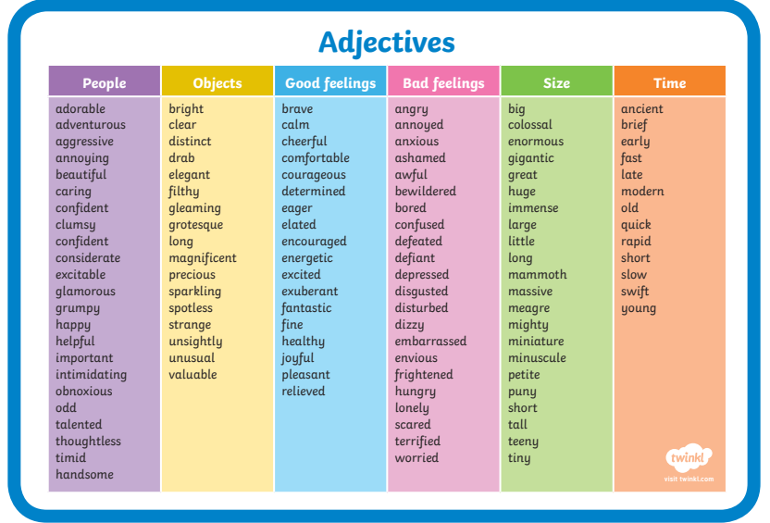

Alternative verbs mat for Thursday’s lesson:
