Home Learning for Year 1

Hello everyone. Below is the home learning weekly timetable for your child. Please check the Year 1 page for additional resources/website links. If you have any questions, please contact us (Miss Haddon or Miss Harte) on ‘Class Dojo’.
Week commencing: Monday 8th June
St Ignatius Home Learning Weekly Timetable
Subject | Resource/Access | Activity
Daily Reading- 30 mins | activelearnprimary.co.uk  (find login details inside the cover of your green book – same as lgfl login with school code: stig)  Free eBooks are also available on oxfordowl.co.uk (you do need to register using your email address and password but it is completely free) | Please continue to read every day with your child. You can find books allocated to your child on active learn. Login to Active Learn and click on ‘My Stuff’ to find your allocated reading books. Don’t forget to look at the inside cover of the book to practise the sounds and words that you will find inside the book.
Daily Phonics | activelearnprimary.co.uk  (find login details inside the cover of your green book – same as lgfl login with school code: stig)  busythings.co.uk  (find login details inside the cover of your green book – same as lgfl login) | Login to Active Learn and click on ‘My Stuff’ to find phonics games you can play.  Key stage 1 > Year 1 setup > English > Phonics programme  Children can select phases 2, 3 &4 or phase 5 to access a variety of games that will help with reading and writing words.
Daily Times Tables | https://www.topmarks.co.uk/maths-games/hit-the-button  (Select ‘Times tables’ and then choose which one you want to practise)  busythings.co.uk  (find login details inside the cover of your green book – same as lgfl login)  https://www.youtube.com/watch?v=1OPTfVcoCO4 | Keep practising your 2, 5 and 10 times tables so you don’t forget them. Focus extra hard on the ones you find difficult to remember.  Key stage 1> Year 2 setup> Mathematics> Multiplication and division> Miner birds:Times tables  Begin to learn your 3 times tables to get ahead!
Twice Weekly Spelling | Weekly spellings:  We are practising the ‘au’ sound.  “Laundry in August, au”  - haul  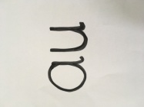  - fault  - jaunt  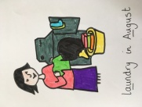  - launch  - author  - August  - laundry  - haunted  - dinosaur  - automatic  Challenge words (year 2 common exception):  class fast | Practise your words using the spelling sheet format:  Read, cover, write, check x3.  Can you put the words in a sentence?
Maths- Daily | https://whiterosemaths.com/homelearning/ | See next page for more details
English- Daily |  | See daily lessons below
Topic | 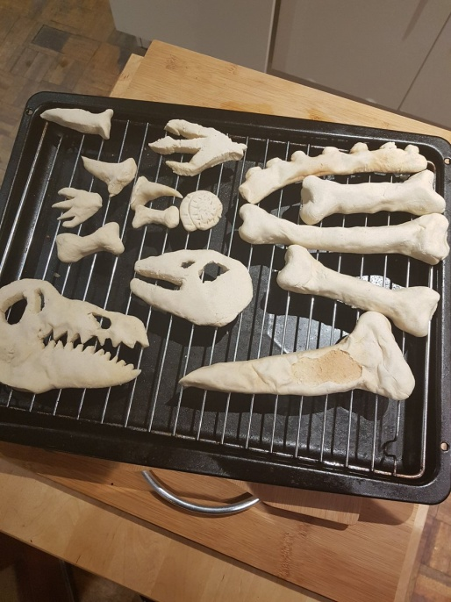 | Have a go at making your own dinosaur bones using salt dough. Make sure you ask an adult to put the dough in the oven and take it out for you.  Recipe:  2 cups flour  1 cup salt  1 cup water  Mix the ingredients together and knead. If the dough is too sticky just add a bit more flour. Shape into bones. Put on a baking tray and ask a grown up to put it in the oven. Bake until the dough goes hard (this can be anywhere between 40 minutes and 2 hours depending on the size of the pieces – keep checking it).  You can then bury them in some soil or sand and have fun digging them up again, you can make a dinosaur skeleton picture or you can just play with them!

Maths Lessons- Monday-Friday
Please click on the links below that will take you straight to the activities on White Rose Home Learning. For each lesson there is:
- A video
- An activity
- An answer Sheet

HOW TO USE THE LESSONS

Just follow these four easy steps…
- Find a calm space where your child can work for about 20-30 minutes.
- Click on the link to the lesson you are going to work on and watch the relevant video.
- Click on the questions link and support your child as they work through the activity.
- Check your child’s answers with them by clicking on the answers link. Correct any mistakes.

JOIN IN THE DAILY MATHS!
Monday  Summer term – Week 7  Video for lesson 1 - count in 2s | Find Monday’s activity sheets and answers on the school website  https://stignatiuscatholicprimary.co.uk/key-information/online-learning/year-1-home-learning
Tuesday  Summer term – Week 7  Video for lesson 2 - count in 5s | Find Tuesday’s activity sheets and answers on the school website  https://stignatiuscatholicprimary.co.uk/key-information/online-learning/year-1-home-learning
Wednesday  Summer term – Week 7  Video for lesson 3 - count in 10s | Find Wednesday’s activity sheets and answers on the school website  https://stignatiuscatholicprimary.co.uk/key-information/online-learning/year-1-home-learning
Thursday  Summer term – Week 7  Video for lesson 4 - add equal groups | Find Thursday’s activity sheets and answers on the school website  https://stignatiuscatholicprimary.co.uk/key-information/online-learning/year-1-home-learning
Friday | Try BBC Bitesize challenges 1 and 2  Friday challenges

English Lessons- Monday- Friday
Below is a series of five lessons we have planned. If you can manage all five then that’s great. If not, choose a few to complete with your child. There are challenges for children who can complete the main activity with ease. If your child finds the main activity a struggle, then don’t worry about completing the challenge.
Monday | Oh no! While the school has been empty, a naughty dinosaur has been in the playground! Look at photograph of dinosaur footprints in the playground (below). Which dinosaur could these belong to? Look at the footprint catalogue (below) to find out. Watch Andy’s Dinosaur Adventures and tell your family what you have learnt about the Stegosaurus.  Andy's Dinosaur Adventures - Stegosaurus  Activity:  Write some facts about the Stegosaurus. Write in the form of bullet points. | Challenge:  Write a couple of sentences to compare Tyrannosaurus Rex and Stegosaurus. What is the same about them?  What is different?
Tuesday | Stegosaurus has very unusual features on its body. Can you remember what some of its features are used for? Tell someone in your family what you remember about the Stegosaurus from Andy’s Dinosaur Adventures. You can watch the video again if you need to be reminded.  Activity:  Colour the outline of the stegosaurus below, or draw your own. Then label the body parts e.g. wide feet, plates that glow red. | Challenge:  Use ‘for’ to explain what each body part is for e.g. spiky tail for hitting dinosaurs that attack it
Wednesday | 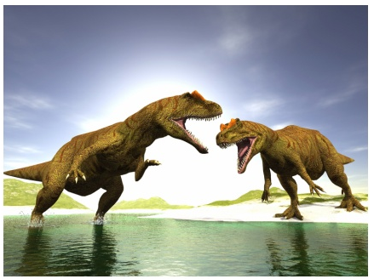  Look at this picture. What can you see? What is happening in the picture? Here are 3 captions. Which one best describes the photograph?  - Allosaurus are very fast runners.  - Two Brachiosaurus eat from a tree.  - Two Allosaurus fight over their homes.  Activity:  Look at the picture of Stegosaurus below and write a caption for it. Remember your capital letter and full stop. Remember to write about what the picture shows. | Challenge:  Find your own dinosaur picture online and write 2 captions; one that describes the picture well and one that doesn’t. Get a grown up in your house to read both captions and see if they can pick the right one.
Thursday | 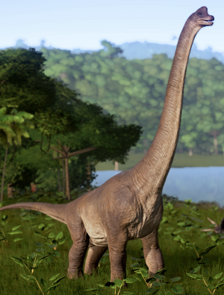  Look at this picture of Brachiosaurus. I think Brachiosaurus compares to a giraffe because it has 4 legs and a long neck to reach leaves from the tops of trees.  Activity:  Look at the pictures of dinosaurs and prehistoric animals below. Which animal might you compare them to that are alive today? For each creature, write down which modern day animal it compares to, using the word ‘because’ to explain why. | Challenge:  Dinosaurs are extinct. What does the word ‘extinct’ mean? Do some research to see if you can find out how the dinosaurs became extinct.
Friday | Read the poem, ‘Dinosaurs’ by Nancy Klein, below and have fun moving like different types of dinosaur. Which is your favourite dinosaur? If you want to find out about more dinosaurs you could watch some more Andy’s Dinosaur adventures by clicking these links:  Diplodocus  Triceratops  Ornithocheirus  You can also look at the Natural History Museum A-Z of dinosaurs (a grown up will need to help you read the information here). A-Z of dinosaurs  Activity:  Draw a detailed picture of your favourite dinosaur and write 3 sentences or more about it. | Challenge:  See if you can make a dinosaur fact sheet for your favourite dinosaur, including a labelled diagram, a picture with matching caption and some information under the subheadings ‘food’ and ‘habitat’.

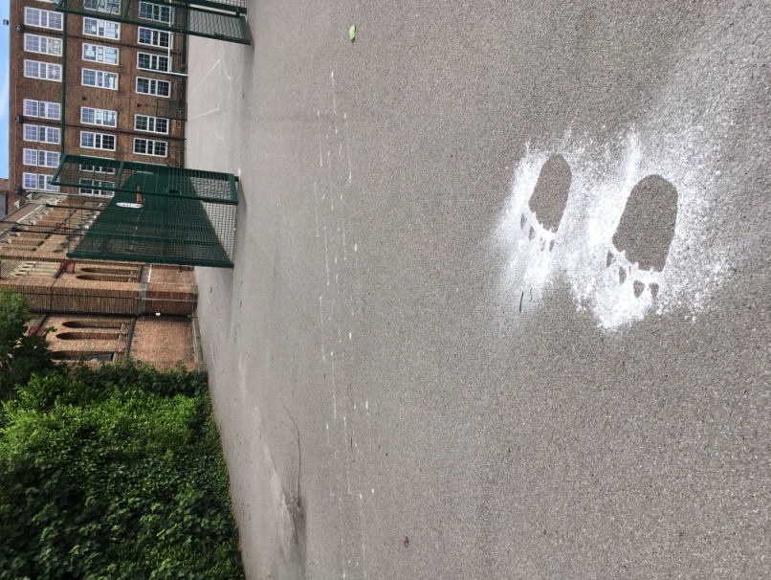
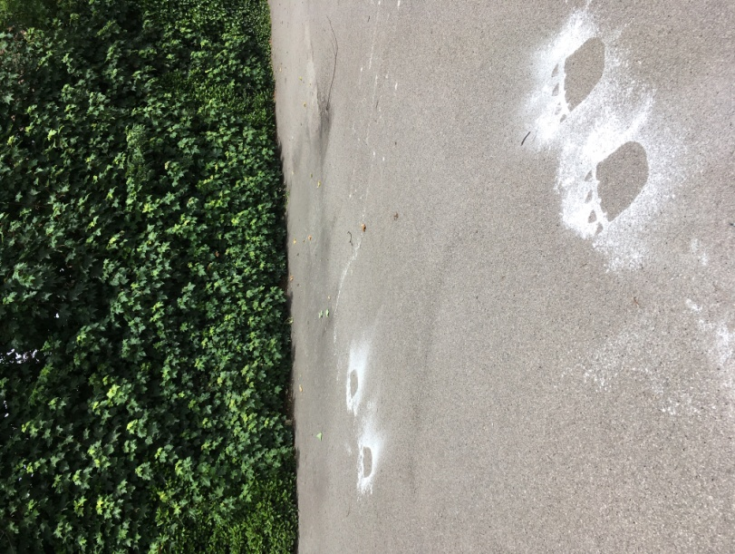
Monday:
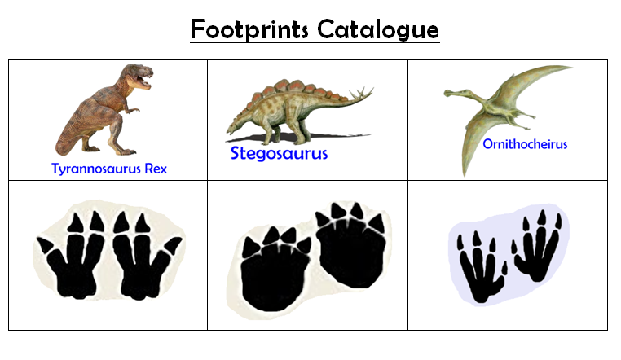

Tuesday:
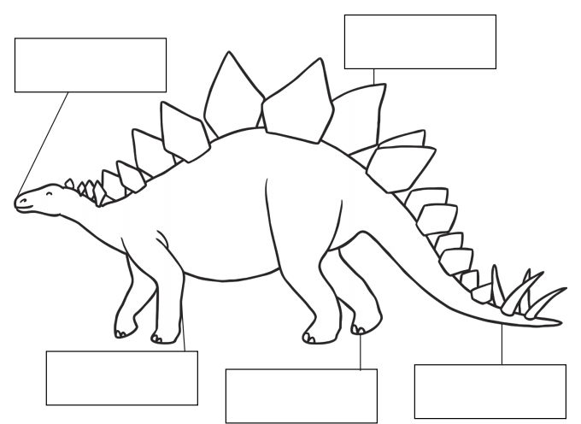

Wednesday:
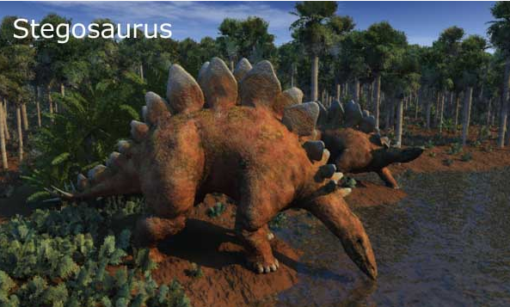

Thursday:
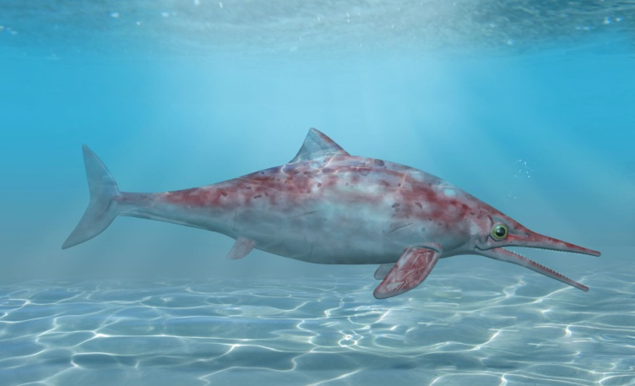  Ichthyosaurus | 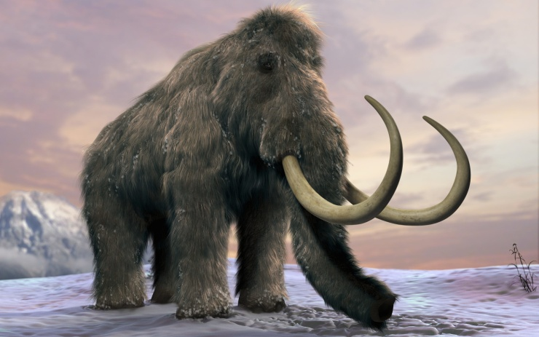  Woolly Mammoth
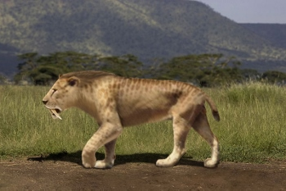  Sabre Tooth Tiger | 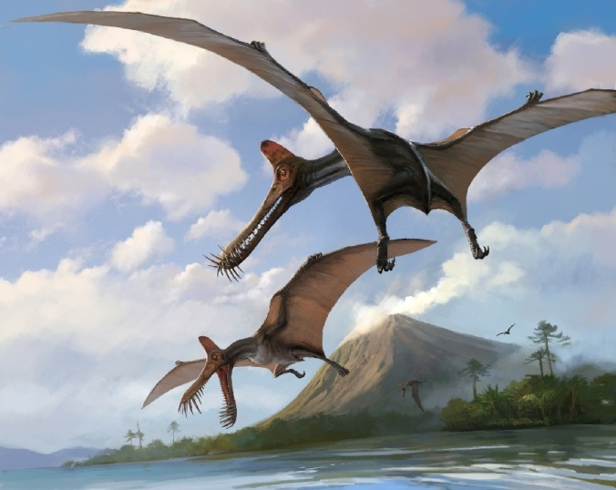  Ornithocheirus

Friday:
