St Ignatius' Milestones
Year 2 C L A S S

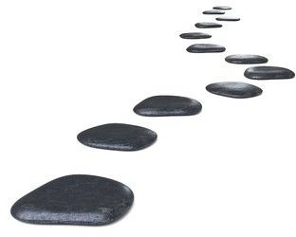
Take part in a local area walk
Design/Make a sandwich Create an obstacle course
Visit a museum
Learn a song by heart
Make up a class dance

Learn to tie shoe laces

Share a memory from the past

Visit a war memorial

