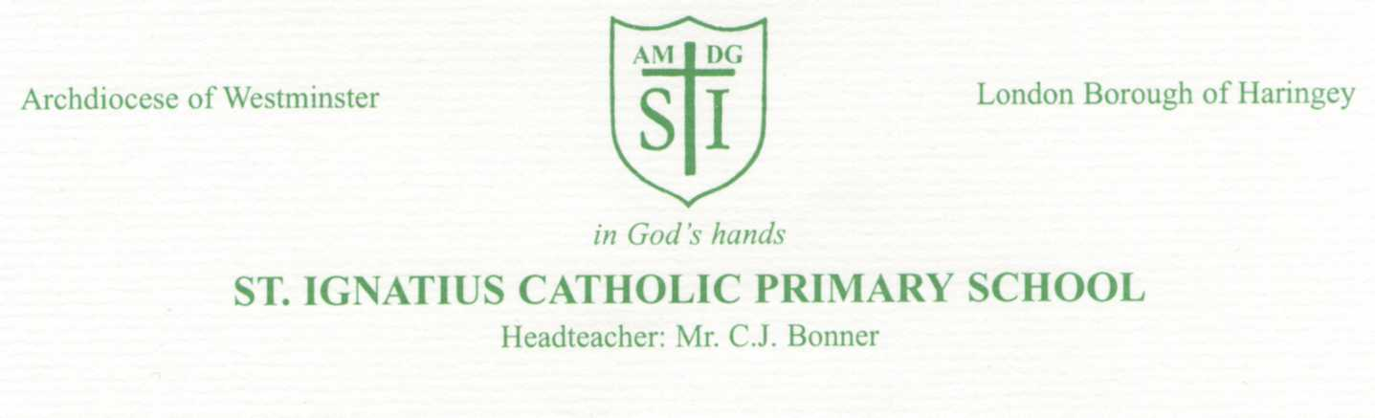

Thursday 20th October 2022

Dear Parents/Guardians,

We will be running a workshop for parents of children in Year 2 on Wednesday 9th November at 3:30pm in the school hall. The aim of the workshop is to give parents information about the teaching of reading, writing and maths in Year 2. As you may already know, the children in Year 2 will take part in the end of key stage assessments next summer.

This workshop will help you to understand how best to support your child at home and with their homework, and give you a sense of the expectations at the end of Year 2. We will also explain the importance of reading at home and give you an overview of how we teach it in school.

It is very important that ALL parents attend, so we hope to see as many of you there as possible. You will bring your child along to the workshop as we will be modelling some of the concepts/learning that takes place in class and so you will work together with your child to complete some of the activities.

We will also have some resources that you can use at home in order to support the learning that is taking place in school. We will provide a resource pack for each child which you can collect at the workshop.

Strong school/home partnerships are key to pupils achieving well and making progress, so we look forward to seeing you all there.

We will be happy to chat to you regarding any queries you may have. Look forward to seeing you soon.

Yours sincerely

Miss Taylor

