Home Learning for Year 2
Below is the expected home learning weekly timetable for your child. Please check the year group page for additional resources/website links. If you have any questions please contact the class teacher on ‘Class Dojo’.
Week commencing: Monday 20th April
St Ignatius Home Learning Weekly Timetable
Allocated time | Resource/Activity | Access
Daily Reading- 30 mins | Individual reading books  Read the eBook, ‘Fe! Fi! Fo! Fum!. | https://www.twinkl.co.uk/resource/t-l-53902-fee-fi-fo-fum-ebook
Daily Spelling/Phonics | Practice 10 common exception words:  Eye  Fast  Father  Find  Floor  Gold  Grass  Great  Half  Hold  You could practice these spelling words in Sum Dog challenge games. | Practise writing these words and then use the correct spelling of the word in a sentence. For example: I can find half of ten.  Your log in details are in your homework books. Please contact us on Dojo message if you are finding it difficult to log in.
Daily Times Tables | Continue practicing the 2, 5 and 10 multiplication tables. Write them down for example, 1 x 2 = 2. Then ask someone to test you on them out of order. | Try this nrich game as a challenge!  https://nrich.maths.org/14242
Daily Sumdog- 30 mins | - Fraction Challenge  - 2D Shape and Measuring Challenge  Challenges have been set up on Sumdog.  Maths - Problem of the Week | https://www.sumdog.com/user/sign_in  Username and password included in home learning pack  See Maths challenge on the year group page.
Twice Weekly Grammar | Practice full stops using this game. Skip the advert and drag the snails where you would like to add a full stop.  Access ‘my stuff grammar & spelling bug conjunctions’ | https://www.roythezebra.com/reading-games/full-stop-1.html  https://www.activelearnprimary.co.uk/login?c=0  Use your active learn login  School code: stig
Maths- Daily | White Rose- Maths | https://whiterosemaths.com/homelearning/  See next page for more details!
English- Daily | We are starting our new English topic.  It is about chocolate!  ‘Does Chocolate Grow on Trees?’ | See daily lesson below!
Topic | Have you created your own habitat during the Easter holidays?  Take a picture and send it on Dojo!  Choose one habitat and explain why the animals that live there suit that type of habitat.  You could  - write it in your homework books  - create a poster of the habitat | There will be a PowerPoint which teaches you about habitats and the different types of habitats.  Different habitats:  https://www.bbc.co.uk/bitesize/topics/zx882hv
Maths Lessons- Monday-Friday
Please click on the links below that will take you straight to the activities on White Rose Home Learning. For each lesson there is a
- Video
- Activity
- Answer Sheet

HOW TO USE THE LESSONS

Just follow these four easy steps…
- Click on the set of lessons for your child’s year group.
- Watch the video (either on your own or with your child).
- Find a calm space where your child can work for about 20-30 minutes.
- Use the video guidance to support your child as they work through a lesson.

JOIN IN THE DAILY MATHS!
Lesson 1 (Monday) – 20.4.20  Finding ¾  Video:  https://whiterosemaths.com/homelearning/year-2/  Challenge- See Problem of the Week | Day 1 Activity Link  https://wrm-13b48.kxcdn.com/wp-content/uploads/2020/homelearning/year-2/Lesson-1-Y2-Spring-Block-4-WO11-Find-three-quarters-2019.pdf | Answers  https://wrm-13b48.kxcdn.com/wp-content/uploads/2020/homelearning/year-2/Lesson-1-Y2-Spring-Block-4-ANS11-Find-three-quarters-2019.pdf
Lesson 2 (Tuesday)- 21.4.20  Counting in fractions  Video:  https://whiterosemaths.com/homelearning/year-2/  Challenge- See Problem of the Week | Day 2 Activity Link  https://wrm-13b48.kxcdn.com/wp-content/uploads/2020/homelearning/year-2/Lesson-2-Y2-Spring-Block-4-WO12-Count-in-fractions-2019.pdf | Answers  https://wrm-13b48.kxcdn.com/wp-content/uploads/2020/homelearning/year-2/Lesson-2-Y2-Spring-Block-4-ANS12-Count-in-fractions-2019.pdf
Lesson 3 (Wednesday)- 22.4.20  Measure length (cm)  Video:  https://whiterosemaths.com/homelearning/year-2/  Challenge- See Problem of the Week | Day 3 Activity Link  https://wrm-13b48.kxcdn.com/wp-content/uploads/2020/homelearning/year-2/Lesson-3-Y2-Spring-Block-5-WO1-Measure-length-cm-2019.pdf | Answers  https://wrm-13b48.kxcdn.com/wp-content/uploads/2020/homelearning/year-2/Lesson-3-Y2-Spring-Block-5-ANS1-Measure-length-cm-2019.pdf
Lesson 4 (Thursday) – 23.4.20  Measure length (m)  Video:  https://whiterosemaths.com/homelearning/year-2/  Challenge- See Problem of the Week | Day 4 Activity Link  https://wrm-13b48.kxcdn.com/wp-content/uploads/2020/homelearning/year-2/Lesson-4-Y2-Spring-Block-5-WO2-Measure-length-m-2019.pdf | Answers  https://wrm-13b48.kxcdn.com/wp-content/uploads/2020/homelearning/year-2/Lesson-4-Y2-Spring-Block-5-ANS2-Measure-length-m-2019.pdf
Lesson 5 (Friday) – 24.4.20  Comparing lengths  Video:  https://whiterosemaths.com/homelearning/year-2/  Challenge- See Problem of the Week | Day 5 Activity Link  https://wrm-13b48.kxcdn.com/wp-content/uploads/2020/homelearning/year-2/Lesson-5-Y2-Spring-Block-5-WO3-Compare-lengths-2019.pdf | Answers  https://wrm-13b48.kxcdn.com/wp-content/uploads/2020/homelearning/year-2/Lesson-5-Y2-Spring-Block-5-ANS3-Compare-lengths-2019.pdf
English Lessons- Monday- Friday
Monday | Have a think about the questions below. Either answer them in your head, with a family member or in your books.  - Do you like chocolate? Think about the types of chocolates you have seen or eaten.  - What colours were they?  - What shapes were they?  - Where do you think chocolate comes from?  - How do you think we might find the answer to this?  - What information might we need to find this answer?  On active learn ‘My stuff word smith Growing chocolate.  Read growing chocolate and see if you can answer these questions now. | Challenge:  True or false:  ‘chocolate melts when it is warm’  ‘All chocolate is brown’  ‘everyone likes chocolate’  ‘you can drink chocolate’  ‘you can use chocolate in cooking’  ‘eating lots of chocolate is good for you’  Which statement is an opinion?
Tuesday | On active learn ‘My stuff word smith Growing chocolate.  Look at screens 4 – 6 of ‘Growing chocolate’ e-book.  Making chocolate seems quite complex!  We will be using a flow chart to show how cocoa mass is turned into chocolate.  On active learn ‘my stuff wordsmith flow chart and put the statements in the right order.  Here are the statements if you cannot access the flow chart on active learn. You can put them in order in your homework book.  - The chocolate mix is conched to make it smooth.  - Cocoa butter and cocoa mass are separated.  - The chocolate mix is refined to get rid of lumps.  - The chocolate mix is tempered to make it shiny.  - The beans are crushed into cocoa mass.  - The cocoa mass is pressed in a machine.  These are not in the right order. You have to put them in the right order.  Here is an example of a flow chart:  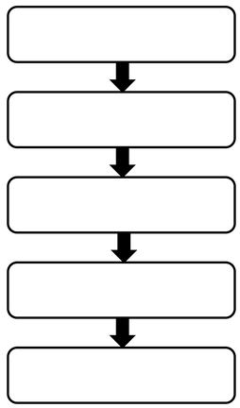 | Challenge:  Have a look for unfamiliar words in the e-book and use a dictionary to find the definition of those words.  You can use this online dictionary.  https://kids.wordsmyth.net/we/  You can create a glossary page in the back of your homework books with the word and its definition.  For example:  Process – to change something into something else.
Wednesday | Today you are going to describe chocolate. Think of some adjectives that you could use to describe chocolate.  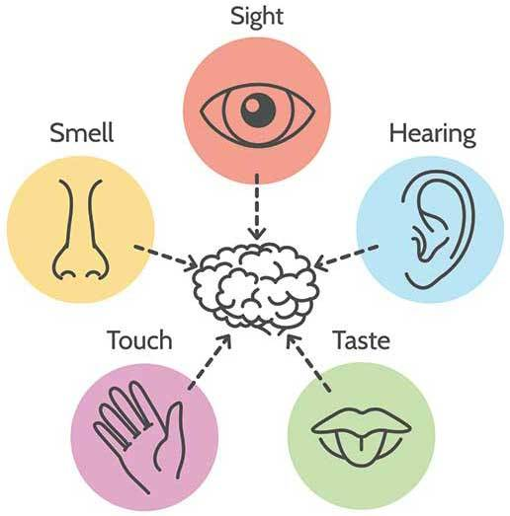  Use your 5 senses to find words to describe chocolate.  For example:  Sight: dark brown  Hearing: snap!  Taste: delicious  Touch: smooth  Smell: bitter  Now use these words in sentences. For example:  Lindt chocolate has a dark brown colour. When you break it in half it makes a snappy sound.  Continue it using all your adjectives you wrote. | Challenge:  Can you use expanded noun phrases in your sentences.  For example:  Galaxy is a tasty chocolate!
Thursday | Today you will be doing some research!  Our e-book on screen 2 stated that cocoa trees grow in tropical countries.  Your job today is to find out why?  Here are some questions I would like you to answer.  - What kind of weather do cocoa trees need to grow in?  - Why do cocoa trees need that type of weather?  - Which countries do cocoa trees grow in?  - Can you find which continent these countries are in?  - How is the chocolate sent over to the UK for us to eat?  You can write the questions and answers in your homework books.  Use these websites to help you find the answers or google the questions yourselves!  https://www.coolkidfacts.com/cocoa-bean-facts/  https://makechocolatefair.org/issues/cocoa-production-nutshell | Challenge:  What other interesting facts can you find about chocolate?  Create a poster including all the chocolate facts you have learnt and teach your family at home!
Friday | Big write:  “THE TOWN… IT’S… IT’S… STARTING TO COLLAPSE AND FLOAT AWAY!” screamed Milly, as she stared in shock at the quickly disappearing town of Willow.  “What are we going to do?” questioned Matt, with a worried expression, frozen to the spot, helpless.  Finish the story. Remember to answer these questions:  - Who are the characters? What are their names and what do they look like. Remember to use adjectives and expanded noun phrases.  - What does the town look like?  - Why is the town collapsing?  - Think about how the characters sort out the problem in the story  - How does it end? | Challenge:  - Use 5 common exception words in your big write.  - Use quotation marks when the characters are talking.

