Home Learning for Year 2
Below is the expected home learning weekly timetable for your child. Your child may also have an additional task set from their class teacher- please look on the year group page for more information. The timetable will be updated weekly.
Week commencing: 30.3.20
St Ignatius Home Learning Weekly Timetable
Allocated time | Resource | Access
30 minutes | YouTube-  Joe Wicks posts a P.E lesson for children learning from home every morning. You can watch these live at 0900 or access them later in the day. | https://www.youtube.com/watch?v=6v-a_dpwhro
30 minutes Daily Reading | Individual reading books you have from home or School. | https://www.activelearnprimary.co.uk/resources#wordsmith  Re-read from the beginning and then complete ‘Maximus and the Beanstalk’ on Activlearn.  Read the first chapter of the eBook ‘The Little Red Riding Hood Collection.’ What are the features that tell you this story is a fairy tale?  https://www.twinkl.co.uk/resource/t2-e-41548-twist-the-text-the-little-red-riding-hood-collection-ebook
Daily Spelling/Phonics |  | https://www.activelearnprimary.co.uk/resources#spag  Revise suffixes.  Play the ‘More Suffixes’ game.  Challenge: Can you explain how a suffix can change a word’s class? For example, ‘kind’ is an adjective, ‘kindly’ is an adverb.  Revise these 10 common exception words for Year 2. Try to use them in written sentences.  after behind  again both  any break  bath busy  beautiful because  Challenge: Can you use 2 of the spelling words in a sentence? For example, ‘I went to see the beautiful picture again.’
Daily Times Tables | TopMarks game: see link! | https://www.topmarks.co.uk/times-tables/coconut-multiples  5 x table  Practise writing it.  For example, 1 x 5 = 5.
Twice Weekly Grammar | Revise how to use apostrophes using the Activlearn website by  Playing the ‘More Apostrophes’ game.  Write sentences using words that use apostrophes because they have a letter missing or to show possession. For example: Don’t take Sam’s dog. Use homework books. | https://www.activelearnprimary.co.uk/resources#spag
Maths | Revise fractions using the White Rose website lessons 3 and 4.  Revise symmetry  Try to match the shapes and patterns to their symmetrical other half. | https://whiterosemaths.com/homelearning/year-2/  https://www.topmarks.co.uk/symmetry/symmetry-matching
Writing | Use the first story writing frame on the Twinkl website to write a new fairy tale. A hard copy is available.  L.O: To write a fairy tale.  S.C:  - I can use characters from a fairy tale.  - I can use a fairy tale setting.  - I can write dialogue for my characters. | https://www.twinkl.co.uk/resource/t-l-8624-story-settings-description-writing-frames  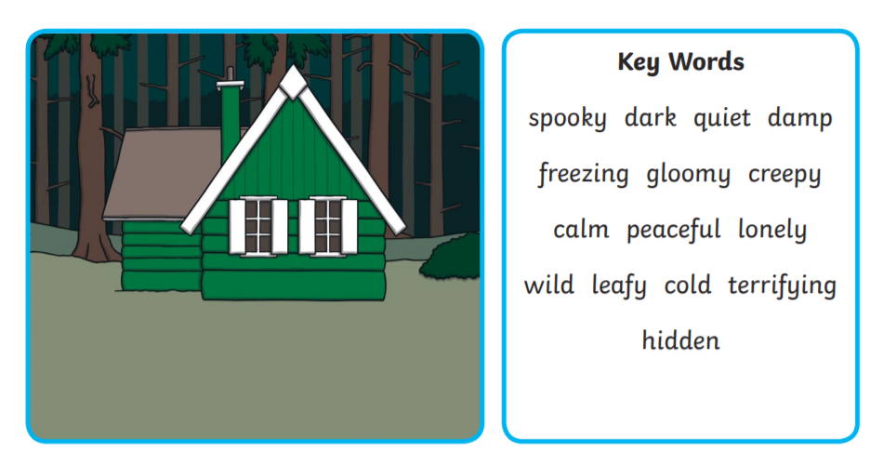
Art/Design and Technology | Use the net of a cube to design your own Easter basket. | https://www.twinkl.co.uk/resource/t-c-254499-easter-themed-basket-craft

