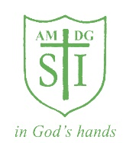

St Ignatius' Milestones
Year 3

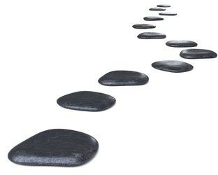
Write a story for EYFS

Write in hieroglyphics

Visit a museum

Do Pedestrian Training
Make a Greek Feast

Design and make a toy

Learn and perform a song in Spanish

Take part in a poetry competition

