St Ignatius's Milestones
Year 5
Go on a residential trip Be a reading buddy

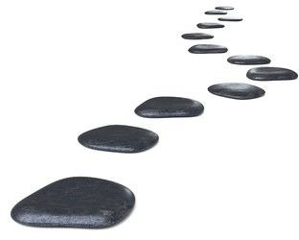
Learn a prayer in another language
Make a bag
Make biscuits

Make the solar system
Create a poster about Online Safety

Attend a class mass

Take part in Bike-ability Training

