Year 5 and 6
Prayer Booklet
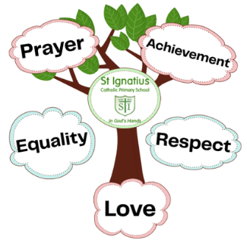

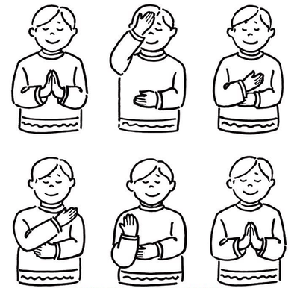
Sign of the Cross
In the name of the Father, and of the son,
and of the Holy Spirit, Amen.


Morning Prayer
Father in Heaven you love me, you ’re with me night and day.
I want to love you always in all I do and say.
I’ll try to please you Father, bless me through this day.
Amen

Grace before meals
Bless us, O Lord, and these your gifts which we are about to receive from your bounty. Through Christ our Lord. Amen.

Grace after meals
We give you thanks, Almighty God, for all your benefits, who live and reign, world without end. Amen.


Home time Prayer
Now the busy day is done, Father bless us everyone. Keep me safely through the night, until we see the morning light. Amen


The Lord’s Prayer
Our Father who art in heaven, hallowed be thy name. Thy kingdom come. Thy will be done on earth, as it is in heaven. Give us this day our daily bread, and forgive us our trespasses, as we forgive those who trespass against us, and lead us not into temptation, but deliver us from evil. Amen.


Glory Be
Glory be to the Father and to the Son and to the Holy Spirit, as it was in the beginning is now, and ever shall be world without end. Amen.


Hail Mary
Hail, Mary, full of grace, the Lord is with thee. Blessed art thou among women and blessed is the fruit of thy womb, Jesus. Holy Mary, Mother of God, pray for us sinners, now and at the hour of our death. Amen.


Angel of God
Angel of God, my guardian dear, to whom God’s love commits me here, ever this day be at my side, to light and guard, to rule and guide. Amen.

Our School Prayer
Lord Jesus,
Help us to recognise that we are all made in God’s image.
Help us to celebrate our achievements.
Help us to show respect to everybody that we meet.
Teach us to love others, as you have loved us.
Saint Ignatius of Loyola, pray for us.
Amen.
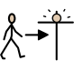
The Apostles’ Creed
I believe in God.
The Father almighty Creator of heaven and earth, And in Jesus Christ, his only Son, our Lord,
(At the words that follow, up to and including the Virgin Mary, all bow)
Who was conceived by the Holy Spirit,
Born of the Virgin Mary.
Suffered under Pontius Pilate,
Was crucified, died and was buried,
he descended into hell;
on the third day he rose again from the dead;
he ascended into heaven,
and is seated at the right hand of God the Father almighty; from there he will come to judge the living and the dead.
I believe in the Holy Spirit,
the holy catholic Church,
the communion of saints,
the forgiveness of sins,
the resurrection of the body,
and life everlasting.
Amen.


Act of Contrition
O my God, because you are so good, I am very sorry that I have sinned against you, and with the help of your grace I will not sin again.

Come, Holy Spirit
V. Come, Holy Spirit, fill the hearts of your faithful.
R. And kindle in them the fire of your love.
V. Send forth your Spirit and they shall be created.
R. And you will renew the face of the earth.
Let us pray
O God, who by the light of the Holy Spirit, did instruct the hearts of your faithful, grant that by that same Holy Spirit, we may be truly wise, and ever rejoice in your consolation, Through Christ our Lord. Amen.

Prayer of St Richard of Chichester
Thanks be to you, my Lord Jesus Christ, for all the benefits which you have given me, for all the pains and insults which you have borne for me.
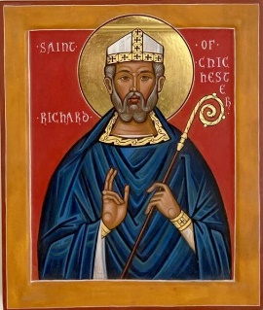
O most merciful Redeemer, friend and brother, may I know you more clearly, love you more dearly, and follow you more nearly, day by day. Amen.


Morning offering
O Jesus,
Through the most pure heart of Mary,
I offer you all my prayers,
Thoughts, works and sufferings of this day
For all the intentions of your most Sacred heart.
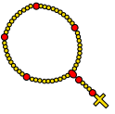
The Rosary
The Rosary is said using the Hail Mary, the Our Father and the Glory Be. For each mystery or decade, you would recite one Our Father, ten Hail Marys and the Glory Be.
The Joyful Mysteries (Recited on Mondays and Saturdays)
The Annunciation (Luke 1:26-38)
The Visitation (Luke 1: 39-45)
The Nativity (Luke 2: 1-7)
The Presentation in the Temple (Luke 2: 22-35)
The Finding in the Temple (Luke 2: 41-52)
The Mysteries of Light (Recited on Thursdays)
The Baptism of Jesus (Matthew 3:13-17)
The Wedding of Cana (John 2:1-12)
The Sorrowful Mysteries (Recited on Tuesdays and Fridays)
The Agony in the Garden (Mark 14:32-42)
The Scourging at the Pillar (Matthew 27: 15-26)
The Crowning with Thorns (Matthew 27: 27-31)
The Carrying of the Cross (John 19: 15-17, Luke 23: 27-32)
The Crucifixion (Luke 23: 33 - 38, 44- 46)
The Glorious Mysteries (Recited on Wednesdays and Sundays)
The Resurrection (Matthew 28: 1-8)
The Ascension (Acts 1: 6-11)
The Descent of the Holy Spirit (Acts 2: 1-12)
The Assumption (1 Thessalonians 4: 13-19)
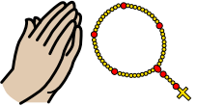
The Coronation of Mary Queen of Heaven and Earth (Revelation 12:1, 14: 1-5, Isaiah 6: 1-3)
Prayer concluding the Rosary
Hail Holy Queen Hail, Holy Queen, Mother of Mercy, Hail our life, our sweetness and our hope! To thee do we cry, poor banished children of Eve. To thee do we send up our sighs, Mourning and weeping in this valley of tears! Turn, then, most gracious Advocate, Thine eyes of mercy towards us, And after this, our exile, Show unto us the blessed fruit of thy womb, Jesus. O clement, O loving, O sweet Virgin Mary.
Leader: Pray for us, O holy Mother of God.
Response: That we may be made worthy of the promises of Christ.
Let us pray.
O God, whose only begotten Son, By his life, death and resurrection, Has purchased for us the rewards of eternal life, Grant, we beseech thee, That meditating on these mysteries Of the most holy Rosary of the Blessed Virgin Mary, We may imitate what they contain And obtain what they may promise, Through the same Christ our Lord. Amen.


The Magnificat
My soul proclaims the greatness of the Lord,
and my spirit rejoices in God my Saviour,
for he has looked upon his handmaid in her lowliness;
for behold, from this day forward, all generations will call me blessed.
For the Almighty has done great things for me, and holy is his name.
His mercy is from age to age for those who fear him.
He has made known the strength of his arm,
and has scattered the proud in their conceit of heart.
He has cast down the mighty from their thrones and has exalted those who are lowly.
He has filled the hungry with good things, and has sent the rich away empty.
He has helped his servant Israel, mindful of his mercy, even as he promised to our fathers, to Abraham and his descendants for ever.
Glory be to the Father and to the Son and to the Holy Spirit,
as it was in the beginning,
is now, and ever shall be,
world without end.
Amen.


Act of Faith
My God, I believe in you,
And all that your Church teaches,
Because you have said it,
And your word is true.

Act of Hope
My God, I hope in you,
For grace and for glory,
Because of your promises,
Your mercy and your power.

Act of Love
My God, because you are so good,
I love you will all my heart,
And for your sake,
I love your neighbour as myself.

Spontaneous Prayer
As well as learning school and traditional prayers, we teach our children the importance of spontaneous prayer as well. These are the moments that we may want to connect with God to express thanks, joy, sorrow or call for help. These moments are just as important as our daily prayers and allow children to develop some agency in the creation of prayer and their relationship with God.


Below are some suggestions for when spontaneous prayer may be suitable at home:

- To express thanks for something.

- To express joy about something.

- To pray for someone in need.

- To pray for support and guidance.

-To pray for forgiveness after making a mistake.
- To pray for courage when scared.

- To pray for understanding when confused.
- Any time you wish to communicate with God.

You may remind your child as well that sometimes prayer is something shared with others and said out loud. Other times it is something private, said in one’s mind.

