St Ignatius's Milestones
Year 6
Take part in a structured debate Visit a zoo

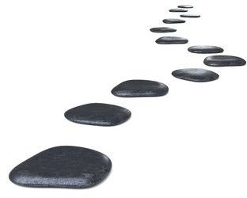
Teach a younger child some key maths skills
Learn how to construct an email
Make a smoothie

Make the solar system
Independently access the news

Build a bridge

Create an animation
Take part in a Year 6 Production

