COVID 19 - Return to School Home-School Agreement

A three way partnership of: School Parent Child

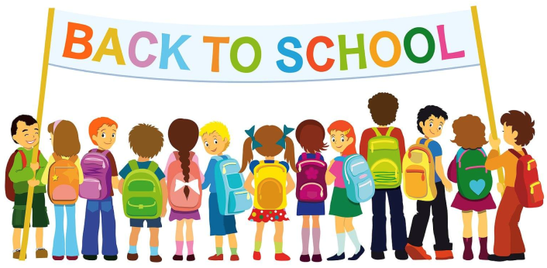
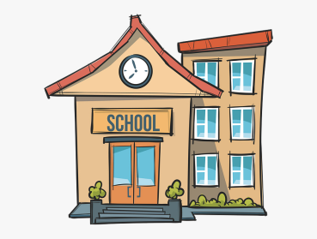 | 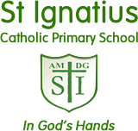 | 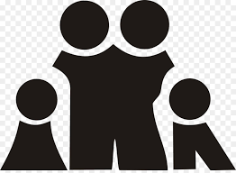

School – We will do our best to:

- Provide an environment which has been risk assessed in response to the COVID-19 infection

- Adhere to the social distancing rules as set out by the government as much as we reasonably can

- Provide a curriculum that meets the needs of your child’s well-being, mental health and academic needs;

- Contact you if your child displays symptoms of COVID-19;

- Inform you if staff or children in your child’s ‘pod’ show symptoms of COVID-19 as this will mean you will all need to self-isolate for at least 14 days or until the test comes back negative

- Continue our clear and consistent approach to rewards and sanctions for children as set out in the Behaviour Policy as well the expectations outlined in this agreement

- Communicate between home and school through newsletters, text, email and the school website.

Parent – I know,understand and agree that:

- the school will do its utmost to protect the health and safety of my child, but as stated in government guidance, complete social distancing measures of my young children cannot be guaranteed
- If my child, or anyone in my household, shows symptoms of COVID-19, my child will not be sent to school; we will self-isolate for 14 days as a family; will get tested and will let the school know as soon as possible via telephone

- If my child, or another child in their pod, shows symptoms of COVID-19 at school, I will collect my child from school immediately

- I will follow social distancing rules, on my commute and when dropping my child off and picking them up,
- I will strictly keep to the school drop off and collection timings for my child

- My child will not bring any items into school with them or take items home from school

- My child will have their temperature taken during the school day if they feel or present as unwell

- I will need to remind my child about social distancing rules but accept they are difficult to follow and that my child may not always do this successfully
- My child will need to use good hygiene, particularly in relation to washing their hands and using a tissue / cover their mouth when coughing / sneezing.

- I will not be allowed into the school without a pre-arranged appointment (made via telephone or email)

- I need to support all staff in their efforts to create ‘as safe as possible’ an environment

- I need to provide up to date telephone numbers and email so that I can be easily contacted
- I need to read all letters, messages, emails that are sent home
- I understand that my child must adhere to all school expectations in order to keep the school community as safe as possible.
I understand that failure to do so, will mean that my child cannot safely remain at school during the re-opening phase.

Child – I will do my best to:

- Keep to the social distancing rules in class and in the playground;
- Tell an adult if I feel unwell
- Not bring things into school from home or take things home from school
- Only use the equipment provided to me by school and no other
- Not mix with any other children in other pods in the school
- Only enter and exit the school building from the designated entrances
- Follow good respiratory hygiene: coughing and sneezing into elbow or tissue (catch it-bin it-kill it)
- Follow good hand hygiene – use soap and water for 20 seconds or hand sanitiser
- Behave well at all times to maintain the safety of myself and others
- Follow these expectations and know that if I don’t, I may be sent home.

