Next week is children’s mental health week.
7th-13th February is children’s mental health week. The theme this year is ‘Growing together’, encouraging children (and adults) to consider how they have grown emotionally, and how they can help others to grow too.
Dress to Express Day- Friday 11th February
The staff and your child/children will show their support by coming to school on Friday 11th February wearing their own clothes to express who they are. What will their outfit say about them? Does it tell everybody who they hope to be when they are older? Maybe they can wear their favourite colour/s or an outfit that makes them feel good about themselves. What will you wear to show your support on the day?
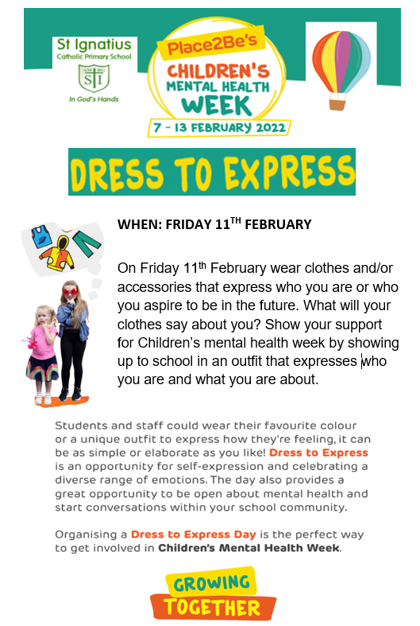
All children will be learning the song Reach (for the stars) and will be singing and signing the song. Look out for posts on your child’s dojo story throughout next week. If you have any questions please do not hesitate to speak to your child’s class teacher.

