**ST IGNATIUS CATHOLIC PRIMARY 22nd March 2016**

**Newsletter**

**‘To live by our PEARL values’ - Prayer, Equality, Achievement, Respect, Love**

Email: [admin@st-igs.haringey.sch.uk](mailto:admin@st-igs.haringey.sch.uk) Website : [www.stignatiuscatholicprimary.co.uk](http://www.stignatiuscatholicprimary.co.uk)

**Dates for your diary**

|  |  |  |
| --- | --- | --- |
| **Date** | **Who?** | **What** |
| 23.03.16  9.30am | Y1 –Y6 | Stations of the Cross  ( School hall ) |
| 24.03.16 | All | Inset Day  FLCs  3:30 |
| 11.04.16 | All | Inset Day  School closed |
| 12.04.16 | All | Pupils return to school for Summer Term |
| W/B  25.04.16 | All | Book Fair this week |
| 22.04.16  9am | All | Coffee morning with Family Support focus |

Dear Parents and Carers,

Last week began with an ‘eggciting’ discovery in the school grounds. The children found a giant egg which has been a great source of excitement and curiosity. Throughout the week the children were involved in lots of writing activities using the egg as a stimulus.

We were also very lucky to be part of a 3 day project with the Royal Academy of Music. The children in Year 5 had the opportunity to work collaboratively with these very talented music specialists and produced their own musical pieces. The progress they made in such a short time has been extraordinary.

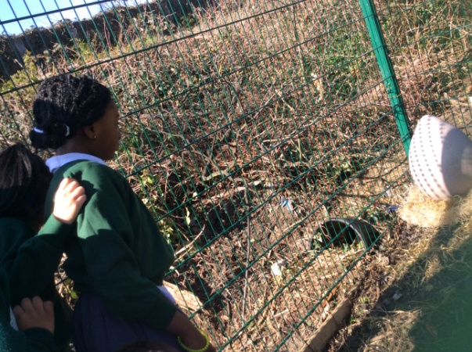

**Lenten Reflection**

We pray that as we approach the end of the Holy Season of Lent we will all emerge,

“transformed in the newness of your mind,

that you may discern what is the good and acceptable and perfect will of God” (Romans 12:2)

We wish you all a happy and holy Easter holiday

**Stations of the Cross.**

Mr Rutherford’s class will be leading this Lenten reflection at 9.30am on Wednesday 23rd March.

Parents are welcome to attend.

**Easter Fair**

Thank you to all the children and adults who attended last week’s Easter Fair. This enjoyable event was very successful and raised £430. A special thank you to all parents and staff who helped.

**Family Learning Conferences**

These meetings will take place on Thursday 23rd March. The children do not attend school on this day but we ask that they accompany their parents/carers to their appointment. We look forward to welcoming you to share in your child’s successes and achievements.

**CAFOD Collection**

Thank you to all of you who supported the non uniform day which raised funds for CAFOD’s ‘Big Splash’ Lenten appeal.

**Mrs Feild**

Mrs Feild will be leaving at the end of term to take up a new post. We thank her for all the work she has done with us and send her our best wishes for the future.

**Emmanuel – Caretaker**

Emmanuel has been redeployed by our cleaning company and Abdel has taken over this role.

**Parent Concerns**

All of our staff try to ensure that all the children have consistently positive learning experiences in school. However if you have any concerns at all, we ask that you speak with your child’s class teacher in the first instance. If you would like to take a matter further, please raise it with Mr Bonner, Ms Curran or Ms Taylor who can be contacted via the school office. We also have our parent governors who would be happy to support you in addressing any concerns you may have.

Karen Gold has been appointed as a **parent governor** and joins Miren Belinchon in this role. **Streetz Ahead Performance**

On Sunday 13th March the children from the Streetz ahead dance classes performed at the Haringey sixth form centre. The children had worked extremely hard to learn their routines and the show was fabulous.Well done children, you made us very proud.

**Lunch Menu**

This week is Week 3 of the Spring menu. Please see the school website for details.

**House Points**

The winning team this week was **Asia**

Congratulations !!

**Achievement Awards**

|  |  |  |  |
| --- | --- | --- | --- |
| Year 1 | Jeremy Manasse | Year 4 | Jorge |
| Year 2 | Carla Nayomi | Year 5 | Joan Faith |
| Year 3 | Summer Fredherick | Year 6 | Osa Benedicte |

**Special Recognition Awards**



Abi (6M) Michelle ( 4c)

**General reminders**

* School starts at 8:55 am. Please ensure that your child is in the line at this time.
* Please sign and date the reading record daily.
* There are some parents still letting their children get out of their cars at or on the zebra crossing. Please ensure that you do not do this – It is very dangerous.
* School re opens after the Easter break on Tuesday 12th April 2016