Wellbeing Wednesday

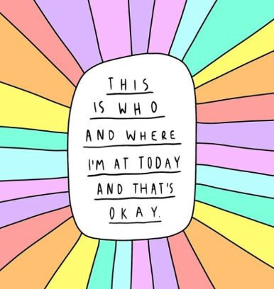
Every day is different. Things happen that might make us feel happy, sad, excited, worried, tired, angry, calm, proud, or a different way altogether. However you feel today, let’s think about it. Thinking about it can sometimes help us to change it or be thankful for it.
How do you feel today?

Write or draw something in your life that makes you happy:
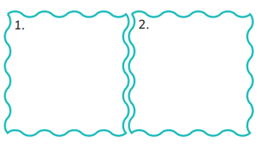
Write or draw 2 things that you would like to do today:

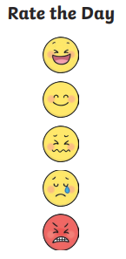
At the end of the day:
Write or draw the best thing that happened today:

