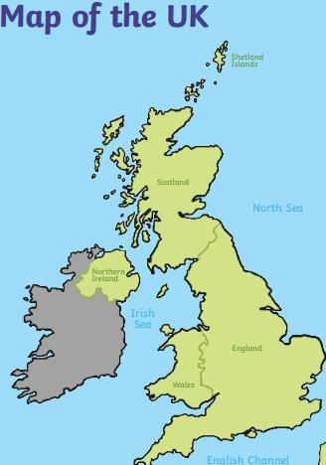
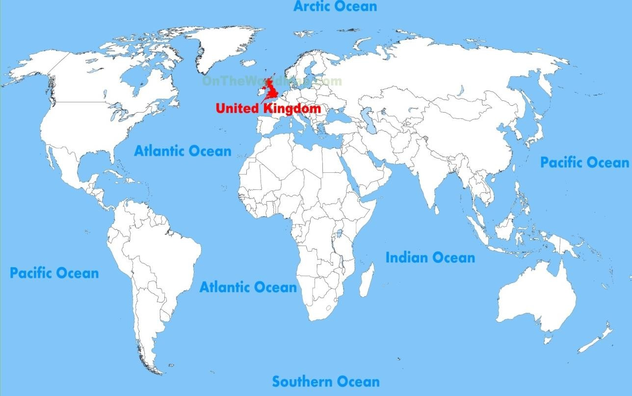

Celtic Sea

By the end of Year 1 you will need to:
- be able to locate the United Kingdom on a map of the world.
- know the names of the four countries that make up the United Kingdom and the names of the surrounding seas.

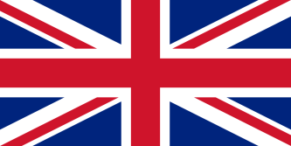
What should I already know?
Key vocabulary
- City
Definition
A large town that usually has a cathedral.
- Country
A large area of land where people
live under the same Government.
- Sea
The salt water covering most of the
Earth.
- Island
An area of land that is surrounded
by water on all sides.
- British Isles
Great Britain, Ireland and all nearby
islands.
- United Kingdom
England, Scotland, Wales and
Northern Ireland.
- Coast
The land next to the ocean.
- Capital city
The main city in a country, usually
where the Government is located.
- I live in Tottenham which is in London, the capital city of England.

- The country I live in is called England which is part of the United Kingdom.

I need to know:
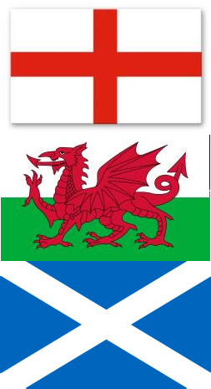
- The United Kingdom is made up of four countries.

Country | Flag | Capital city
England |  | London
Wales |  | Cardiff
Scotland |  | Edinburgh
Northern Ireland | 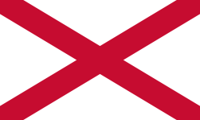 | Belfast
- The flag of the United Kingdom is made up of each of the four flags above and is called the Union Jack.

- There are four seas that surround the United Kingdom:
- The North Sea
- The Irish Sea
- Celtic Sea
- English Channel

