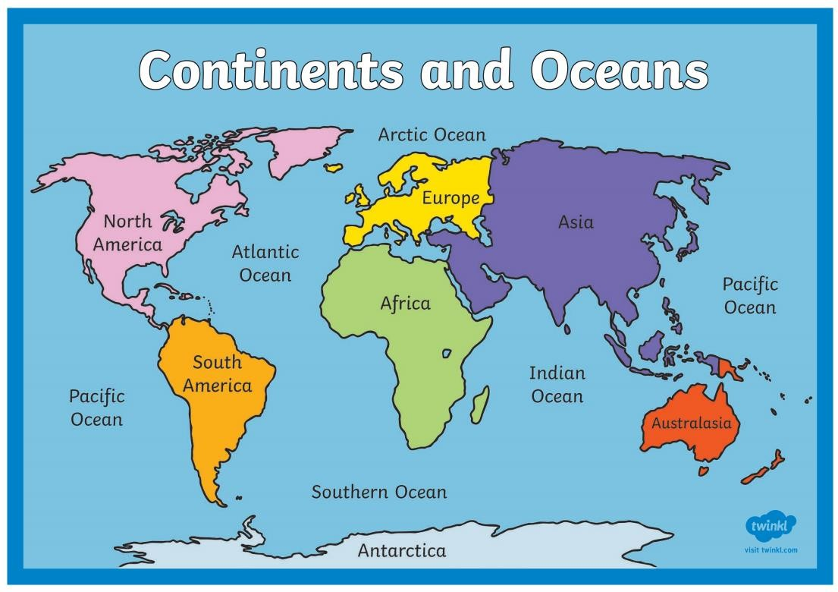
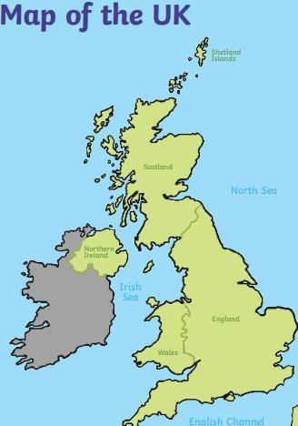

Celtic Sea

By the end of Year 2 you will need to:
- be able to name and locate the world’s 7 continents and 5 oceans.
- use simple compass directions (North, South, East and West) to describe the location of features and routes on a map.

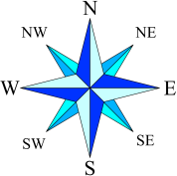
I need to know:
Key vocabulary
- City
Definition
A large town that usually has a cathedral.
- Country
A large area of land where people
live under the same Government.
- British Isles
Great Britain, Ireland and all nearby
islands.
- Continent
A group of countries on one large
expanse of land.
- United Kingdom
England, Scotland, Wales and
Northern Ireland.
- Coast
The land next to the ocean.
- Capital city
The main city in a country, usually
where the Government is located.
- Compass
An instrument used to show North.
- Environment
A particular geographical area.
What should I already know?
- That the United Kingdom is made up of four countries;
England, Wales, Scotland and Northern Ireland.
- The United Kingdom is surrounded by four seas; The North Sea, The Irish Sea, The Celtic Sea and the English Channel.
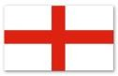
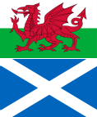
- The United Kingdom is made up of four countries and surrounded by four seas

Country | Flag | Capital city | Seas
England |  | London | The North Sea The Irish Sea The Celtic Sea  The English Channel
Wales |  | Cardiff
Scotland |  | Edinburgh
Northern Ireland |  | Belfast

  - The world is made up of seven continents and 5 oceans.

Continents | Oceans
Europe | Arctic Ocean
Africa | Atlantic Ocean
Asia | Pacific Ocean
Australasia | Indian Ocean
North America | Southern Ocean
South America
Antarctica

- The four main points of the compass are North, East, South and West.

