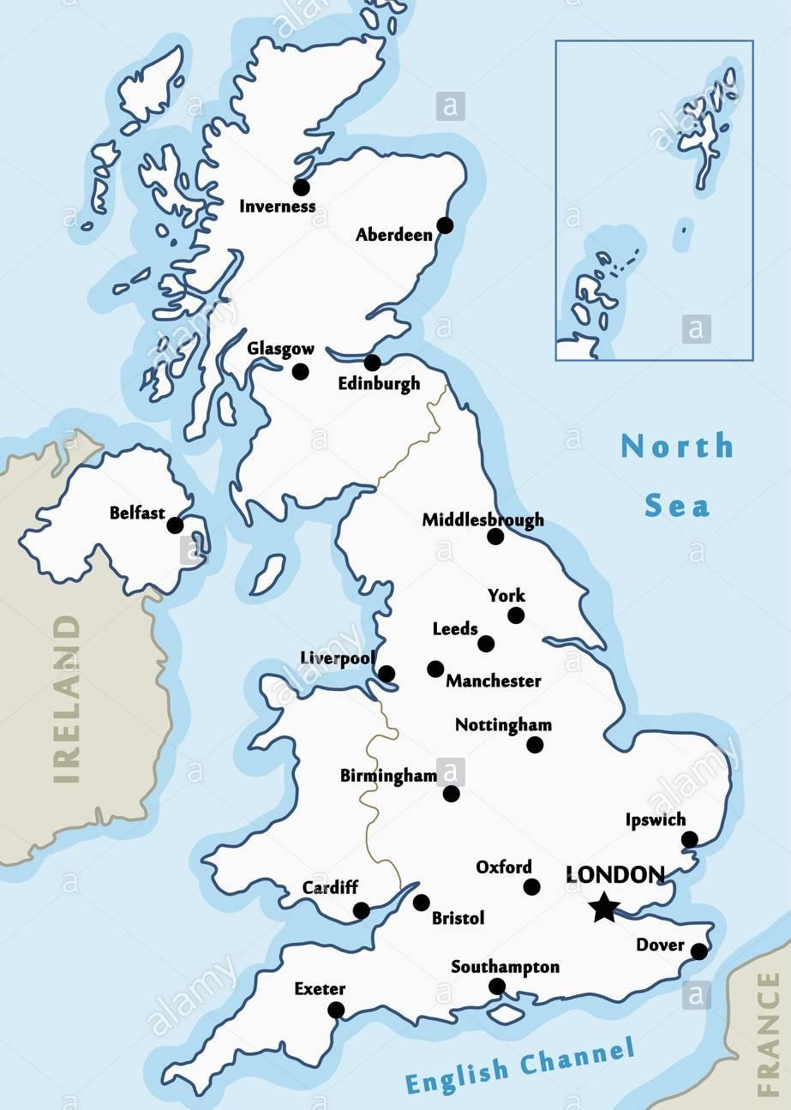

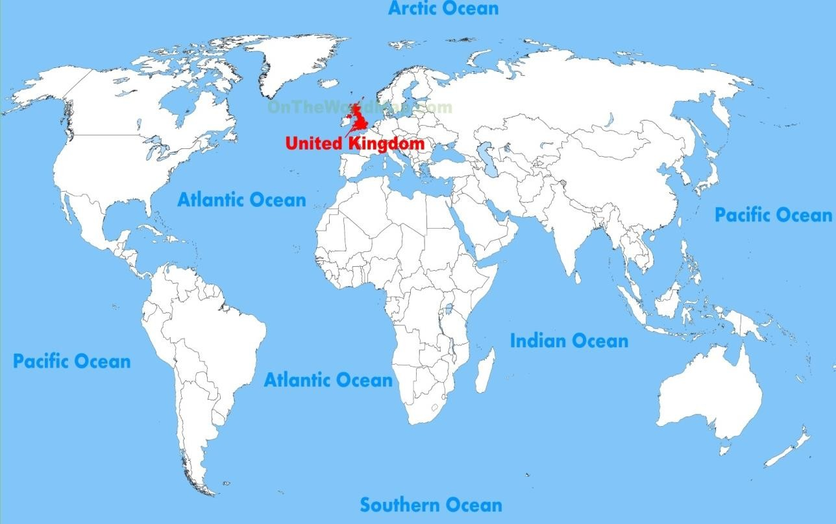
Celtic Sea
By the end of Year 3 you will need to:
- To know countries and major cities of the UK and the geographical regions e.g north west, midlands etc.

What should I already know?  - The 7 world continents and 5 world oceans.  - To understand that the UK is made up of 4 countries. |  | I need to know:  The regions of England
Key vocabulary
City: A large town that usually has a cathedral.
Country: A large area of land where people live under the same Government.
British Isles: Great Britain, Ireland and all nearby islands.
United Kingdom: England, Scotland, Wales and Northern Ireland.
Coast: The land next to the ocean.
Capital city: The main city in a country, usually where the Government is located.
Region: A large area of land that is different from other areas of land
Continent: very large landmasses found on Earth.
