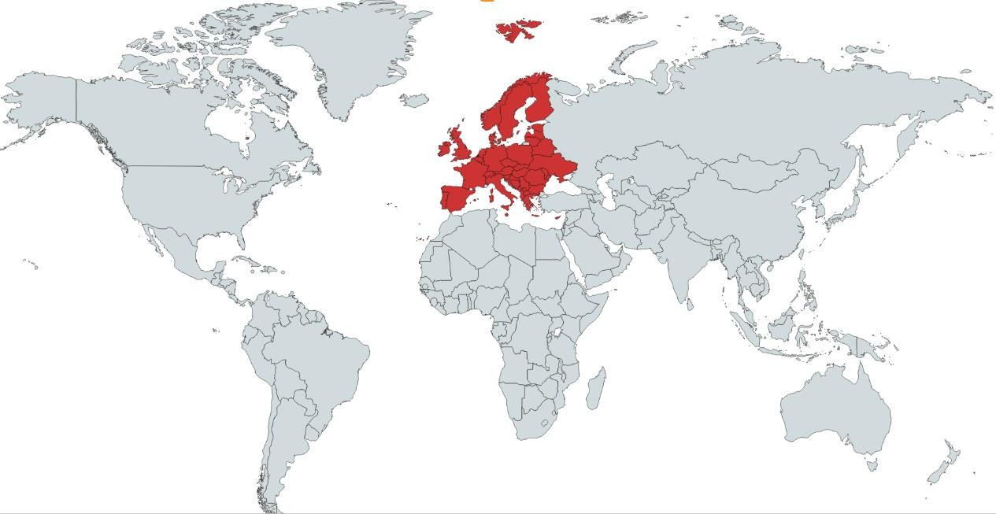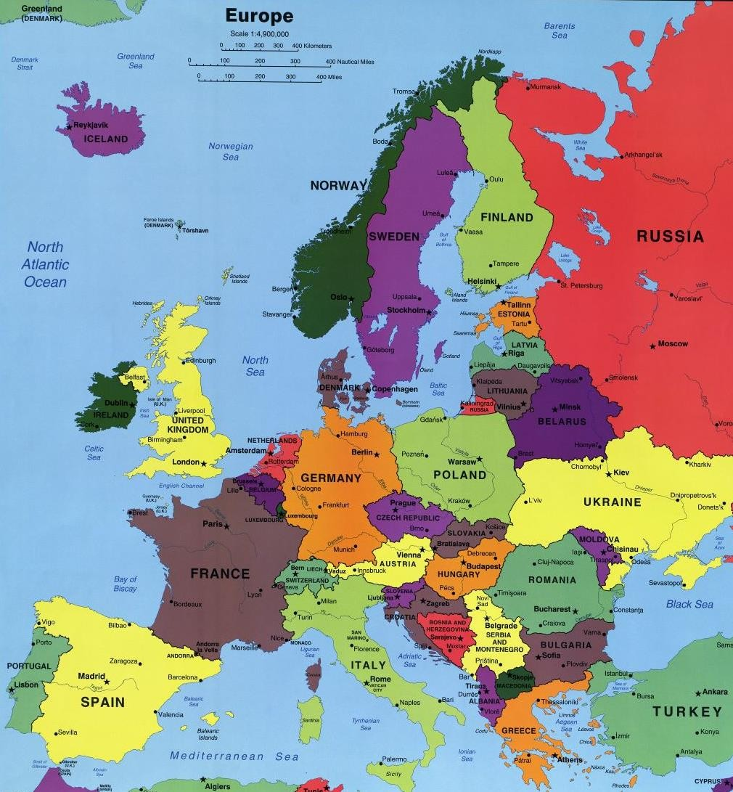
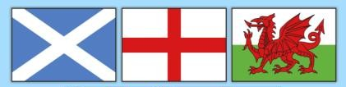
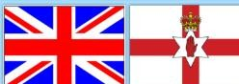
By the end of Year 4 you will need to:
- Name and locate European countries and their capital cities.
- Name different environmental regions (ie) desert, tundra, mountains and rainforest
Countries of the UK and the capital cities: England – London
Wales – Cardiff Scotland – Edinburgh Northern Ireland- Belfast
Hamlet Village Town City County Country Continent

I need to know:

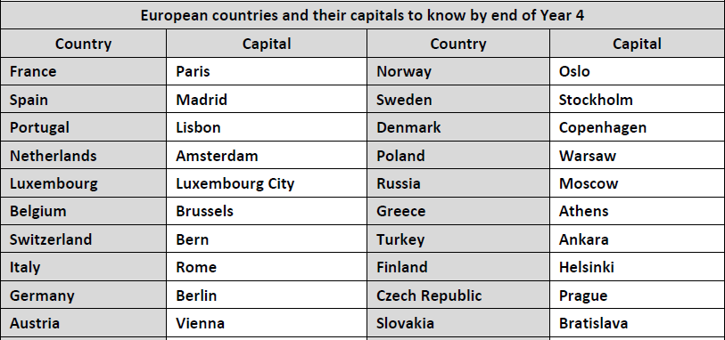

What should I already know?
The country I live in is called England which is part of the United Kingdom which is part of Europe.
Countries and major cities of the UK and geographical regions.
Key vocabulary with definition
City- A large town that usually has a cathedral.

Country- A large area of land where people live under the same
Government.

British Isles-Great Britain, Ireland and all nearby islands.

United Kingdom -England, Scotland, Wales and Northern Ireland.

Capital city- The main city in a country, usually where the Government is located.
Environmental region- An area that is defined by it’s physical or natural surroundings.
Desert- A barren, dry, sandy region with little or no plant life.

Tundra- A huge plain in the arctic regions where trees do not grow.

Mountains- A land mass with great height and steep sides that is higher than a hill.
Rainforest- A dense evergreen forest, with high rainfall, mostly found in tropical areas.
 |  |  | Feature | Examples
 |  |  | Rivers | Volga – longest river in Europe,  Russia  Thames – London, England Seine – Paris, France  Rhine – runs through Germany, France and Netherlands | 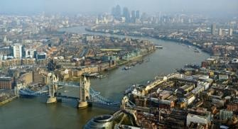
 |  |  | Mountains | Ben Nevis – Highest montain in  the UK – Scotland.  Snowdon – Highest mountain in Wales  Scafell Pike – Highest mountian in England.  Ural mountain – form the boundary between Europe and Asia.  Alps – The highest mountain range in Europe.  Pyrenese – form the natural border between France and Spain | 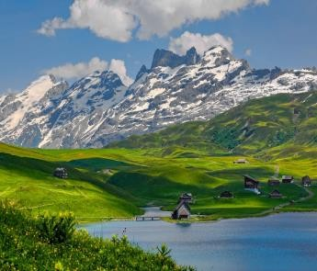
 |  |  | Seas | Atlantic Ocean – separates Europe  from America  Mediterranean sea – separates Europe from Africa  English Channel – Separates UK from Europe | 