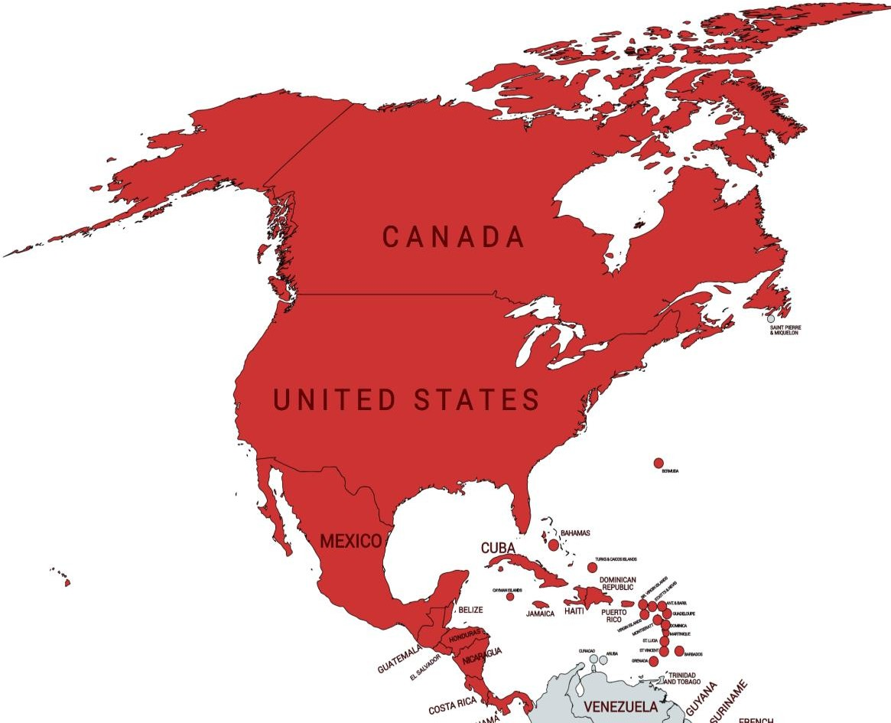
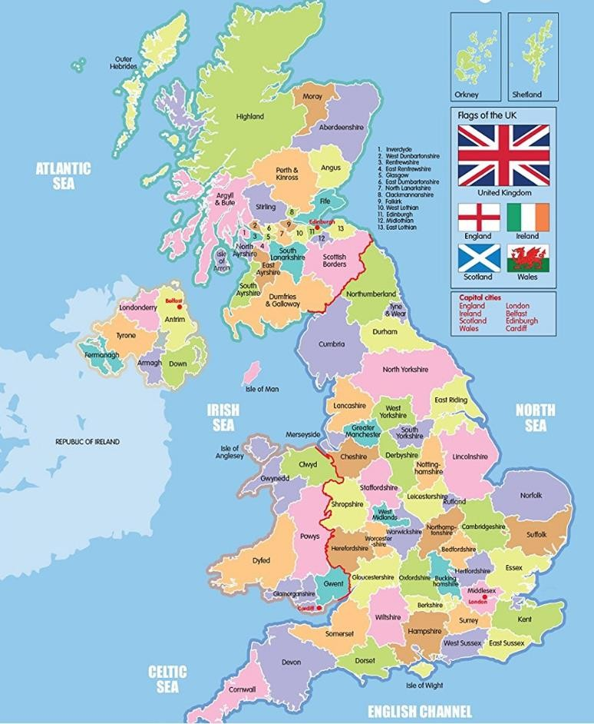

By the end of Year 5 you will need to:

- To know the countries in North & Central America (capital cities & environmental regions)
- To know the UK counties

What should I already know?  - To know that we live in Tottenham which is in London, the capital city of England.  - The names and location of most European countries and their capital cities. |  | I need to know:
 |  |  | Country | Flag | Capital city
 |  |  | United States of America | 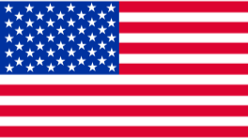 | Washington DC
 |  |  | Canada | 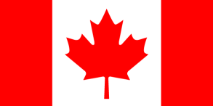 | Ottawa
Key vocabulary
Latitude: angular distance is measured from the equator.

Longitude: The lines running vertically around the Earth.

Equator: an imaginary circle around Earth. It divides the Earth into two equal parts: the Northern Hemisphere and the Southern Hemisphere
Tropic of Cancer: the parallel of latitude that is north of the equator

Tropic of Capricorn: the parallel of latitude that is south of the equator
Environmental region: areas that are broadly divided by physical characteristics such as rainforest and desert.
Timezones: A region of the globe that observes a uniform standard time
County: a geographical region of a country

Desert: is a landscape form or region that receives very little rain
 |  |  | Mexico | 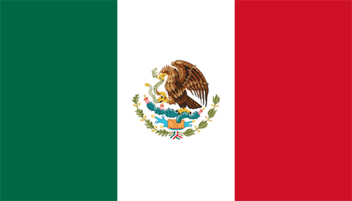 | Mexico City
 |  |  | Cuba | 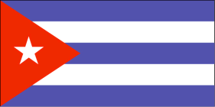 | Havana
 |  |  | Costa Rica | 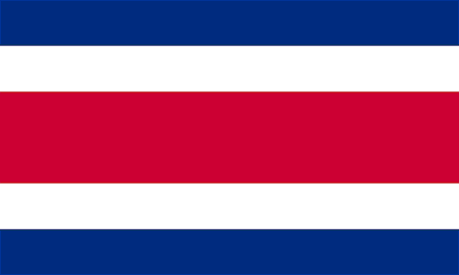 | San José
There are two oceans surrounding North & Central America: Atlantic Ocean and Pacific Ocean.
There are two seas surrounding Central America: Gulf of Mexico and Caribbean Sea.

