Knowledge Organiser

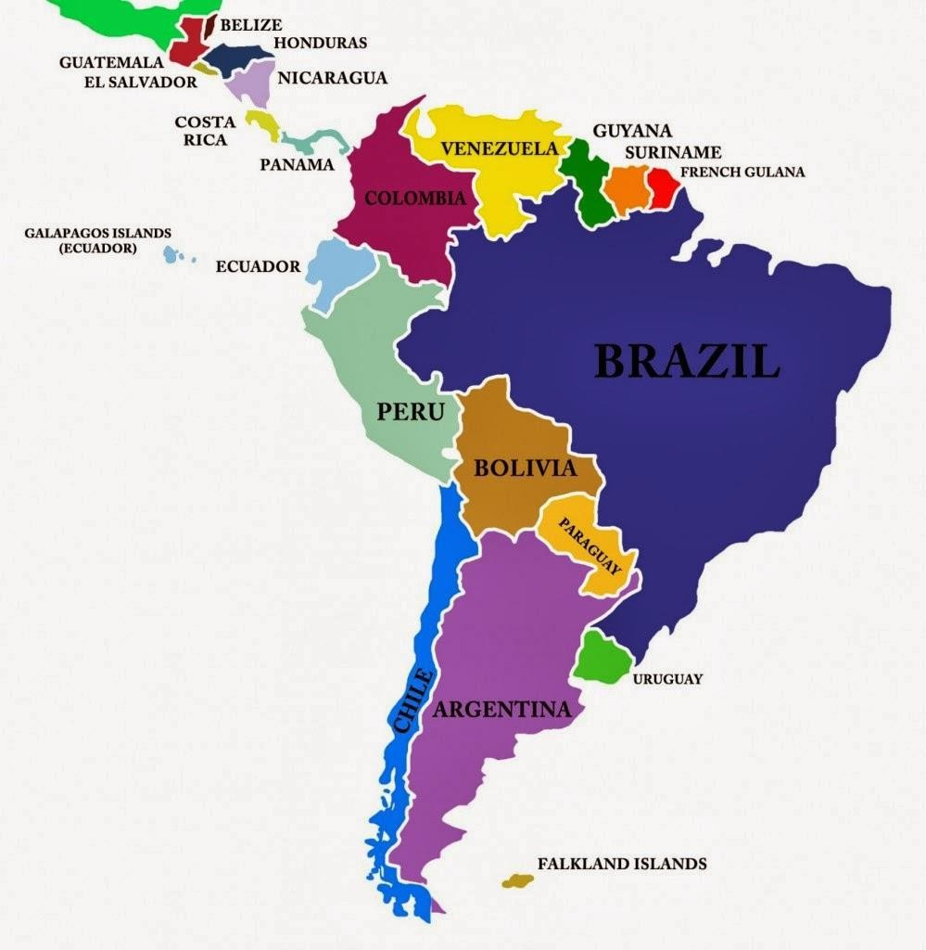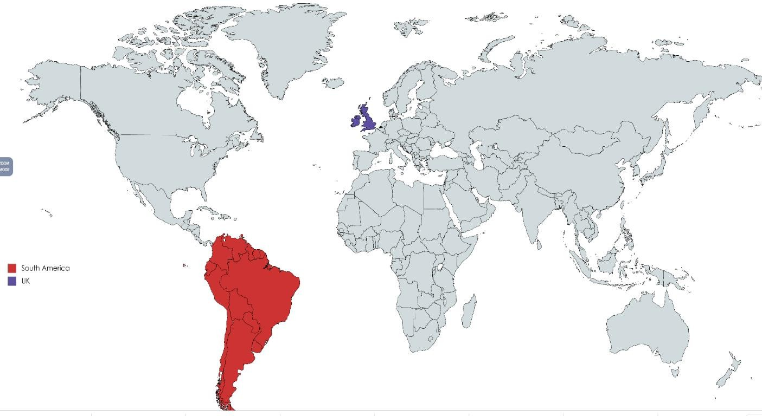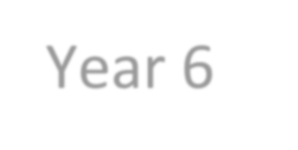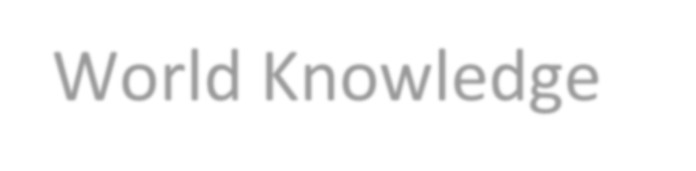Year 6 World Knowledge
By the end of Year 6 you will need to:
- Be able to locate the world’s countries using maps to focus
on South America.
- The names of the countries in South America including capital cities and environmental regions.

What should I already know?
- The country I live in is called England which is part of the United Kingdom.
- The UK is in Europe.
- The 7 continents and five oceans.

Key vocabulary Definition
Amazon Basin | The area drained by the River Amazon and all its  tributaries
Amazon River | The longest river in South America. It flows through  Peru, Bolivia, Venezuela, Colombia, Ecuador and Brazil
Compass Points | Points on a magnetic compass marking the four main directions: North, South, East, West, and intermediate  directions.
Continent | Very large land mass with no standard definition: Europe, Africa, Antarctica, Asia, Australasia, North America or  South America
Latitude | Imaginary horizontal line used to show NSS position on  the Earth’s surface
Longitude | Imaginary vertical line used to show E-W position on the  Earth’s surface
Mountain | large landform, often with a peak, rising high above the  surrounding area
Mountain Range | A chain of mountains
Physical Feature | Naturally occurring, e.g. rivers, mountains, lakes
River | Natural watercourse flowing downhill towards a river,  ocean or lake
Slum | A densely populated and run down area of a city, usually  associated with poverty
Source | The original point where a river begins
Tributary | A river or stream that flows into a larger river
Village | Place where people live, smaller than a town
Rainforest | A luxuriant, dense forest rich in biodiversity, found  typically in tropical areas with consistently heavy rainfall.

I need to know:

South America is the fourth largest continent in size. With a population of over 400 million.
Countries | There are 12 countries in South America (see list on the right) and 3 dependencies with a total of more than 385 million people living on the continent.
Largest Country | Brazil. The country is covering more than half the continent's landmass.
Largest City | Sao Paolo in Brazil. With more than 20 million inhabitants (2014) Sao Paulo is also one of the 10 biggest cities in the world
Smallest Country | Suriname. The country is one of the 10 most sparsely populated countries in the world
Biggest Island | Tierra del Fuego (Spanish meaning: Land of Fire), at the southern tip of Argentina and Chile
Longest River | Amazon River (6,437metres/4,000miles). The Amazon is not only the second longest river in the world after the Nile, but also the Amazon carries more water than the world's other 10 biggest rivers combined!
Highest Mountain | Aconcagua in Argentina. The mountain (6,961metres/22,837ft) is located in the Andes  mountain range.

https://www.kids-world-travel-guide.com/south-america-facts.html

