Theme/Term | Autumn 1 |  |  |  | Autumn 2
Writing Root /  Spelling Seed Text | 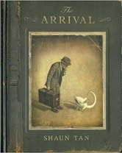  The Arrival  Shaun Tan  Theme-Migration/Movement | 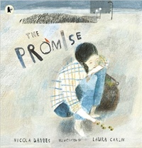  The Promise  Nicola Davies  Theme- Evolution +  Inheritance |  |  | The Invention of Hugo Cabret  Brian Selznick  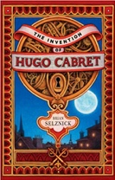  Theme- Enterprise/  Activism | Rain Player  David Wisniewski  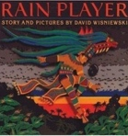  Theme- Fate vs. free will
Length | 17 sessions, 3+ weeks | 15 sessions, 3 weeks |  |  | 17 sessions, 3+ weeks | 15 sessions, 3 weeks
Outcomes | Extended own version narratives  Letters, lists of rules, character descriptions, diaries, short playscripts, short reports, guides | Narrative poem sequels  Promises, extended thought bubbles, diary entries, letters in role, figurative captions, summary poems |  |  | Biographies  Diaries, journalistic writing, flashback narratives, speeches, discussions, letters, film critiques | Analytical essays  Instructions, posters, missing scenes, diaries, debates
Theme/Term | Spring 1 |  |  |  | Spring 2
Writing Root /  Spelling Seed Text | 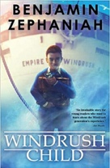  Windrush Child  Benjamin Zephaniah  Theme-Migration/Movement |  | The Hidden Forest  Jeannie Baker  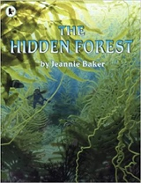  Theme- Evolution +Inheritance |  | Can We Save the Tiger?  Martin Jenkins  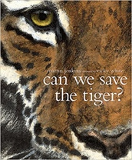  Theme- Evolution +Inheritance | The Last Wild  Piers Torday  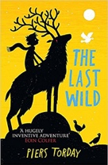  Theme- Utopia vs dystopia
Length | 15 sessions, 3 weeks |  | 16 sessions, 3+ weeks |  | 15 sessions, 3 weeks | 16 sessions, 3+ weeks
Outcomes | Persuasive pitch to the local council  Thought bubble, informal letter, poem, diary entry, advice, informal letter |  | Balanced discussions  Research notes, non-chronological reports in the form of a letter to a character |  | Discussion texts  Letters, explanations, persuasive posters, & speeches, simple poems | Own version dystopian narratives  Posters, retellings, formal reports, character descriptions, diaries, formal letters
Theme/Term | Summer 1 |  |  |  | Summer 2
Writing Root /  Spelling Seed Text | 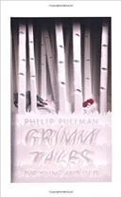  Grimm Tales for Young and Old  Phillip Pullman  Theme- Fate vs. free will |  |  | Romeo and Juliet  William Shakespeare  Theme- Fate vs. free will | Night Mail  W H Auden  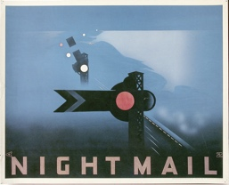  Theme- crossing borders | 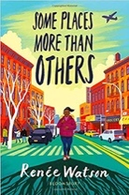  Some Places More Than Others  Renee Watson  Theme- crossing borders
Length | 15 sessions, 3 weeks |  |  | 15+ sessions,3+weeks | 15 sessions, 3 weeks | 15 session, 3 weeks
Outcomes | Own version traditional tales  Retellings, character studies, monologues |  |  | Playscripts  Diaries, letters, character descriptions, balanced arguments | Poetry  Letters, diaries, information leaflets, instruction | The Suitcase Project  A transition project to represent children including maps, recipes, poems, photos and a biography

