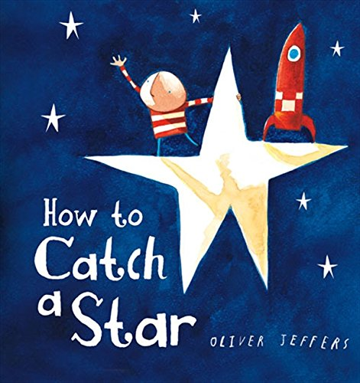
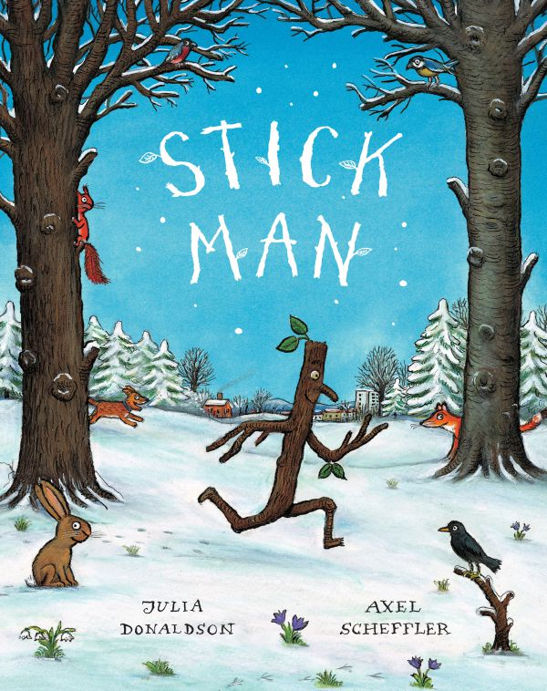
The World ~ Seasonal Changes

- Observe seasonal changes in our local environment as we move from autumn to winter
- Shadows
- Children to find out about nocturnal animals and hibernation
- Remembrance Day
- Bonfire Night
Books we will be sharing together to help us with our learning.

- What’s in the Witch’s Kitchen?
- The Hairy Toe
- Stick Man
- Darkness Slipped In
- How to Catch a Star
- The Gingerbread Man
- The Christmas Story
- Non-Fiction text - nocturnal animals

Autumn 2
Foundation Stage
Darkness

Creative Activities
- Firework art ~ printing, glitter trails, pastels and chalk
- Exploring texture and shape with clay
- Painting using different techniques
- Observational art work – pumpkins/ poppies
- Creating our very own Stick Man
- Imaginative play
- Creating night time creatures using junk modelling
- Christmas craft
- Artist - Bridget Riley and Yayoi Kusama
- TOPPs Music Sessions

People and communities ~ Visits and Visitors
- Owl visit
- Hedgehog visit
- Christmas Crafts
- Baby visit
- Sainsbury’s Shopping
- Nativity Play

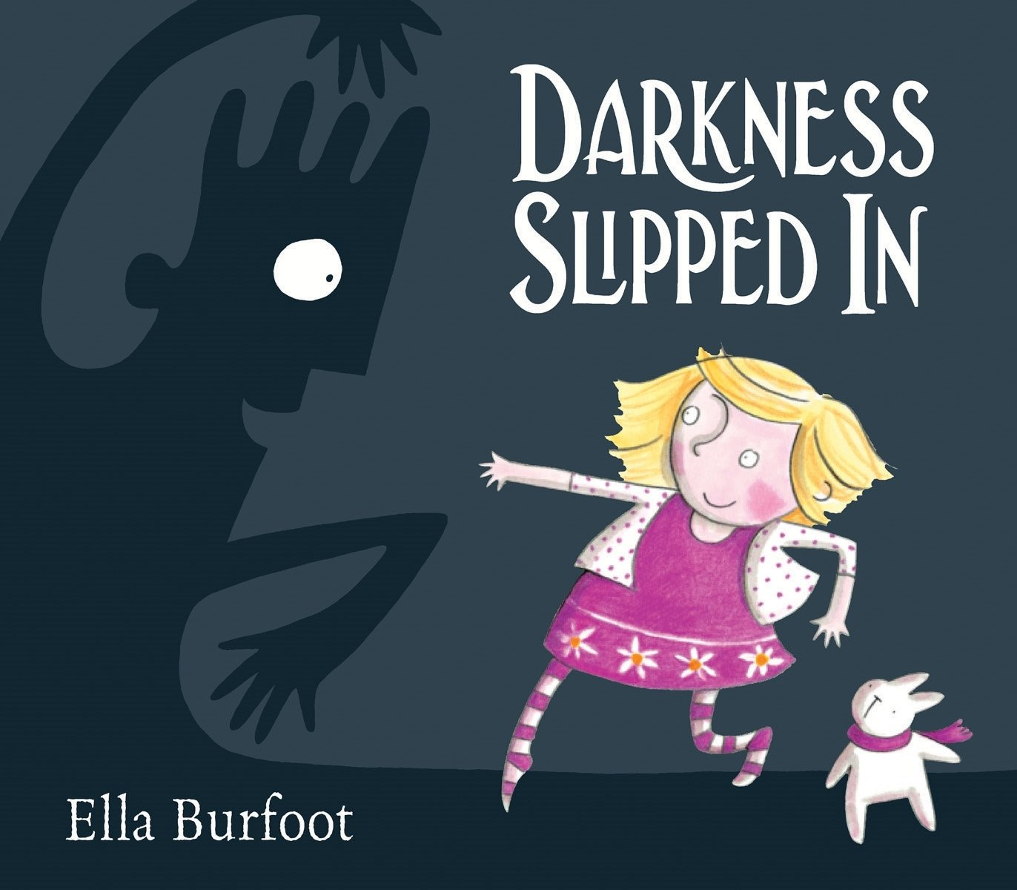
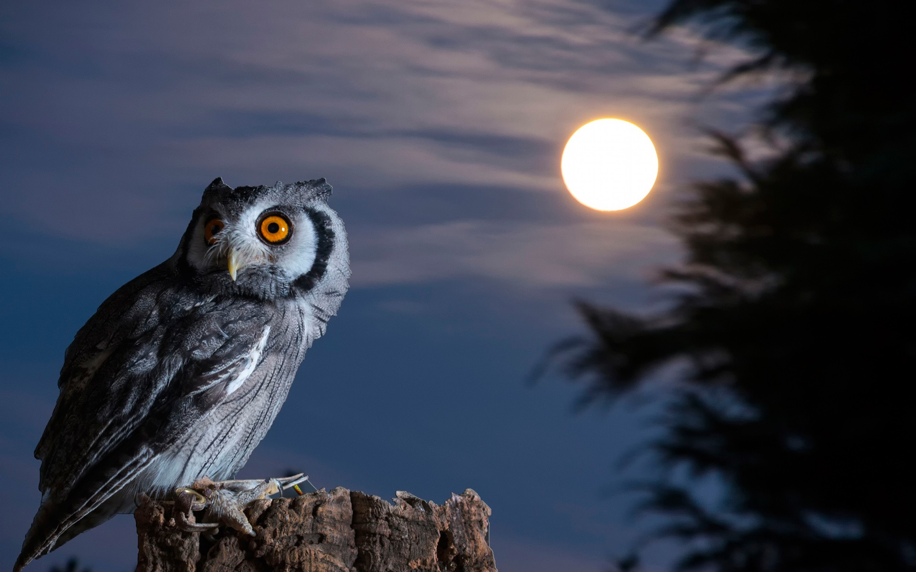
Outdoors
- Provide the children with open ended resources for them to explore, create and investigate with.
These may include: wooden blocks, crates, den making materials, outdoor mud kitchen, sand and water, mark making equipment and areas to discover.

RE ~ Christmas
- I am special
- Sharing the Christmas story
- Gifts and gift bringers
- The Nativity Story

PE
- Fundamental skills - gross and fine motor skills
- Coordination, balance, spatial awareness

