The World ~ Seasonal Changes

- Talk about dark nights and things that come out at night
- Observe seasonal changes in our local environment
- Children to find out about nocturnal animals and animals that hibernate.
- Remembrance Day
Maths Activities

- Counting to 10 forward and backward
- Noticing / sorting – using descriptive language
- Subitise 1 to 5 – instant recognition
- Part/whole – what do you see and how do you see it?
- Patterns and pattern making
- Singing number rhymes
- Using 5 Frames
- Learn about size, position and order

Reading and writing activities
- Reading a variety of story and non- fiction books
- Opportunities to develop fine motor skills
- Singing a range of songs and rhymes
- Opportunities to mark make independently
- Drawing Club
- Speaking and listening opportunities in small and large groups
- Continue to learn the sounds our letters make
- Oral blend/segment and begin to blend and segment CVC words
- Forming letters correctly
- Reading books
- Lending Library open

Autumn 2
Foundation Stage

Creative Activities
- Firework art ~ wax resist, glitter trails and pastels
- Creating our own masterpieces with paint
- Modelling with clay
- Painting using different techniques
- Observational art work – pumpkins/poppies
- Making our very own Stick Man
- Imaginative play
- Creating night time creatures using junk modelling
- Christmas art and craft

Books we will be sharing together to help us with our learning.

- Owl Babies
- Cave Baby
- Stick Man
- Darkness Slipped In
- How to Catch a Star
- The Gingerbread Man
- The Christmas Story

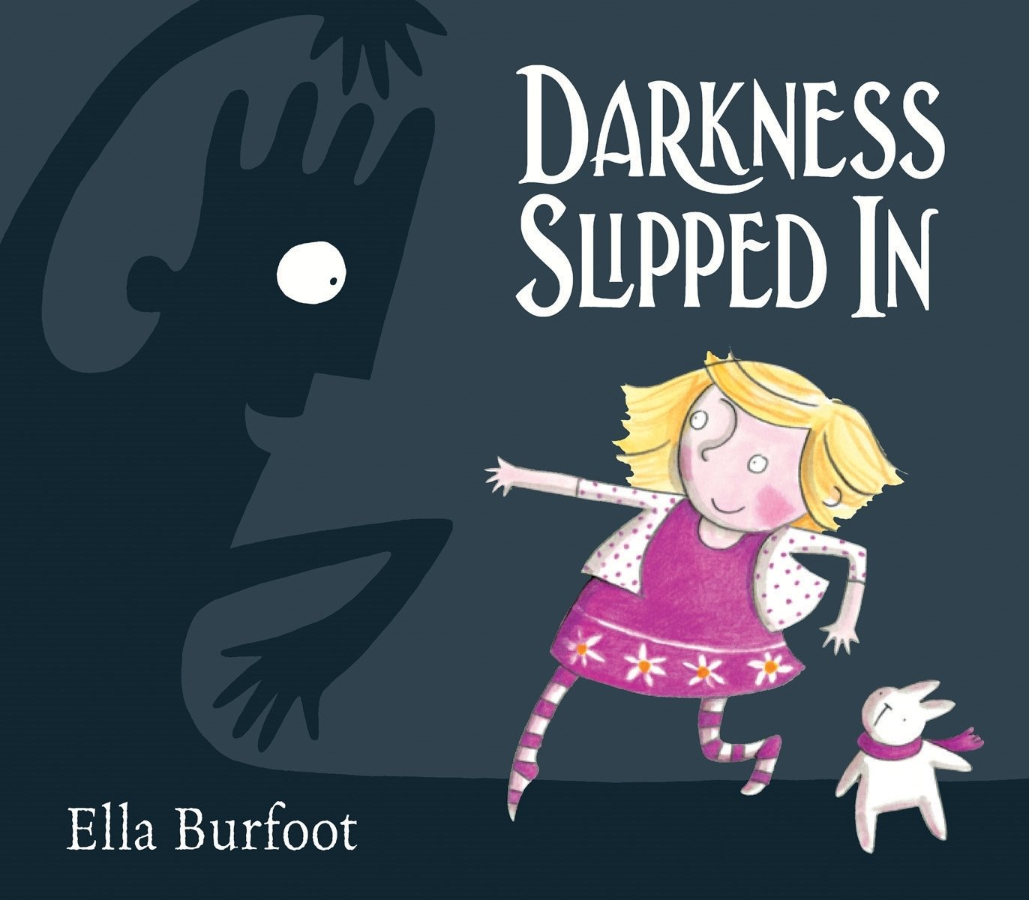
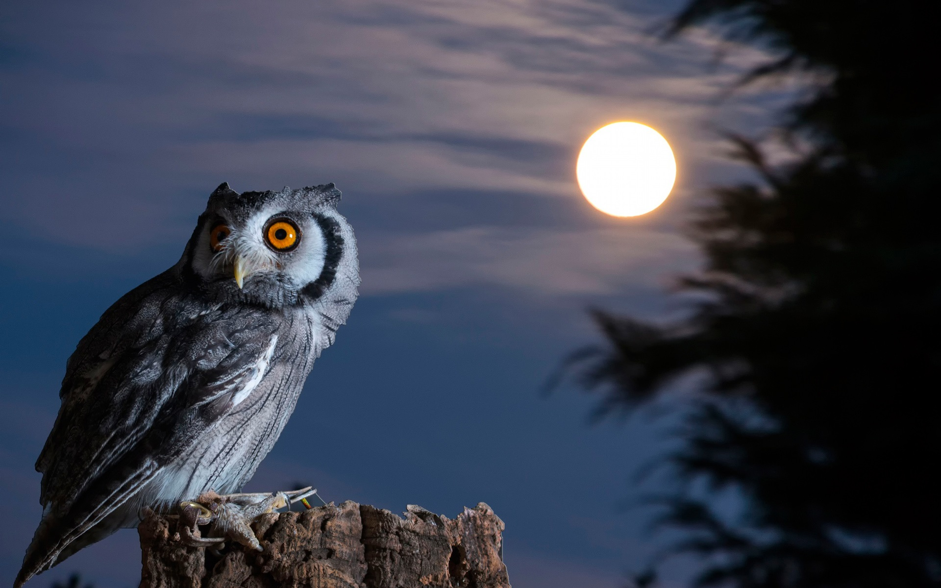

Outdoors
- Provide the children with open ended resources for them to explore, create and investigate with.
These may include: wooden blocks, crates, den making materials, outdoor mud kitchen, sand and water, mark making equipment and areas to discover.

RE ~ Christmas
- I am special
- Sharing the Christmas story
- Gifts and gift bringers
- Perform the Nativity Story

People and communities ~ Visits and Visitors
- Owl Man
- Christmas Craft
- Nativity Play

