**Christmas Workshop**

**for Reception families**



**Join the Family Learning team for fun Christmas crafts and activities with a maths theme**

* **Find out what your child learns at school**
* **Work with your child and help their learning**
* **Discover more about Family Learning**
* **Meet other parents**
* **Children join in second part of the session**

**Thursday 5th December 9.00-11.00**

**at St John’s C of E Primary**

**Book your place by filling in the form at**

[**https://bit.ly/FLCHR24**](https://bit.ly/FLCHR24)

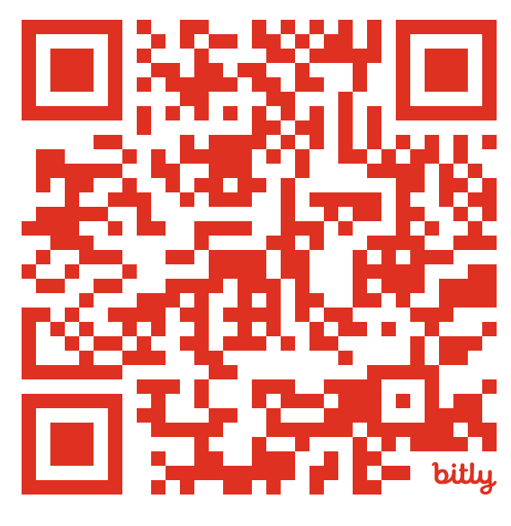

**Due to health and safety we are unable to accommodate younger siblings in the session**