**Class 3 – Summer Term 2**

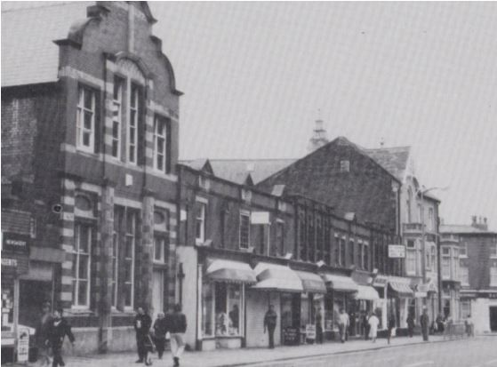

**Local History of Blackpool**

**English**

**READING**

**Research**

Blackpool Attractions

Significant people: Henry Banks, William Henry Cocker and John Bickerstaffe

**WRITING**

**Persuasive Writing**

Creating a leaflet for Blackpool.

**Persuasive Writing**

A persuasive piece recommending someone for a blue plaque (this will form a letter/video).

Learning Question

**Which significant people from Blackpool should be given a blue plaque and why?**

History

Local History

To find out about the history of Blackpool from photographs and maps.

To find out about the history of our school.

To find out the significance of blue plaques.

To find out who has been given a blue plaque and why.

To think about which people might be given a blue plaque.

To decide on criteria for selection of people who might receive a plaque.

To locate blue plaques in Blackpool town centre by following a map

**Science**

**Light**

**Exploring if everything can make a shadow.**

**Forces and Magnets**

**Investigating that some forces needed contact and some can act at a distance.**

**Compare how things move on different surfaces**

**RE**

**Non-Christian Unit**

Does everybody follow the same rules? Why? Why not?

**Does everybody follow the same rules?**

**Does everybody follow the same rules? Does**

**D.T.**

**Structures**

Making a frame for a blue plaque.