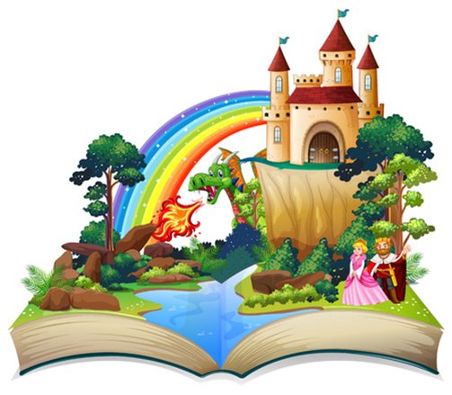
Twisted Tales course
for Year 3 families

Plan, write and create a story with your child using IT

✓ Find out what English your child learns at school
✓ Support your child’s learning by working together
✓ Use a tablet to make an animated story/film

Children join in last part of every session

Free 5 week course
Starts Thursday 23rd April 9am-11am
at St John’s C of E Primary

Due to health and safety we are unable to accommodate younger siblings in the session
Book your place by filling in the form at
 https://bit.ly/FLTT26

