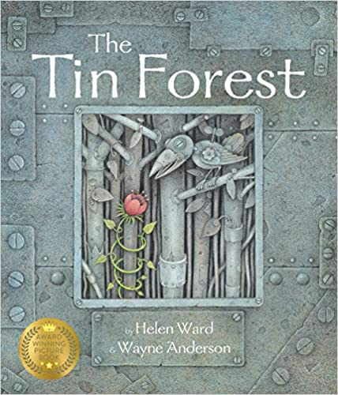
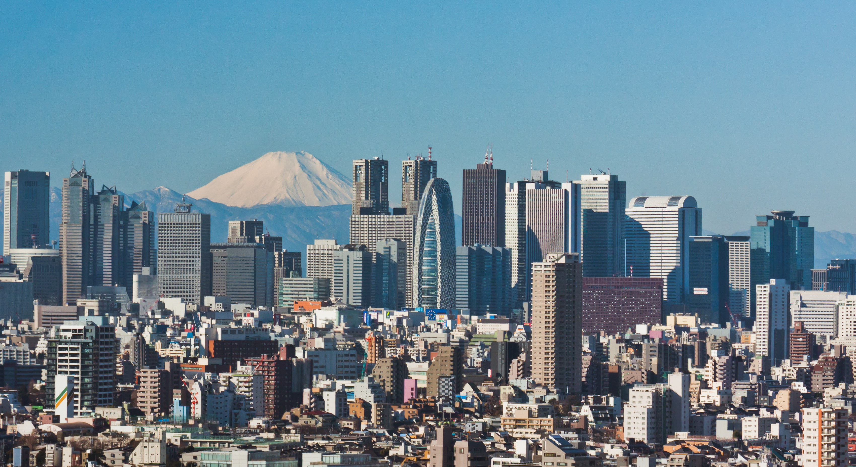
Geography
What factors influence where settlements develop?
Use population density maps to find out where in the world people live/don’t live and why.
Exploring why cities are getting larger and larger – push and pull factors.
Exploring why people migrate, learning about voluntary migration and forced migration.
Who are refugees? Why are they refugees? What happens to refugees?
What can we do to help refugees?

English
Read and analyse a modern fable,
The Tin Forest by Helen Ward and Wayne Anderson
Write our own modern fables.
Read and analyse explanation texts.
Watch and analyse The Ocean Maker.
Write an explanation text for a machine that can create rain.

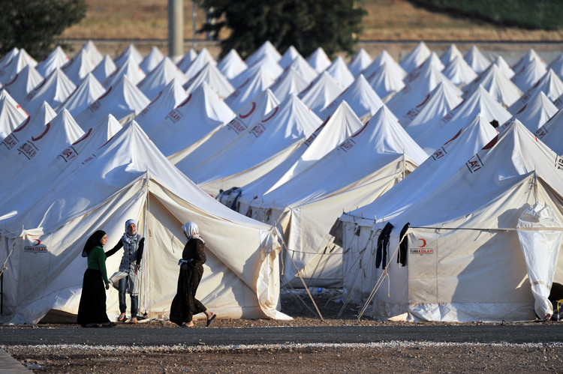
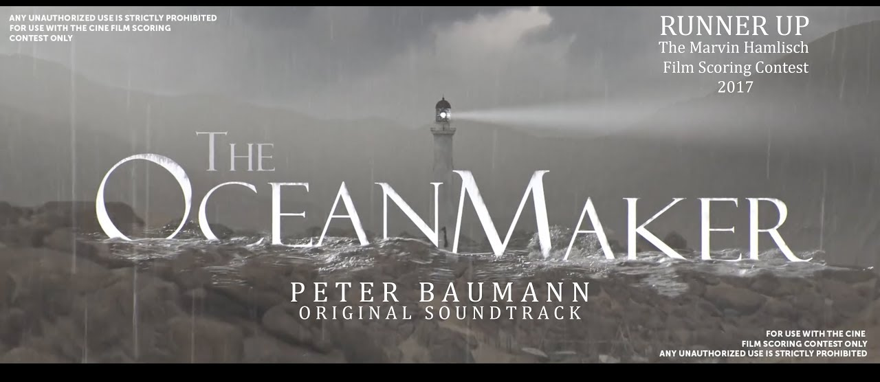

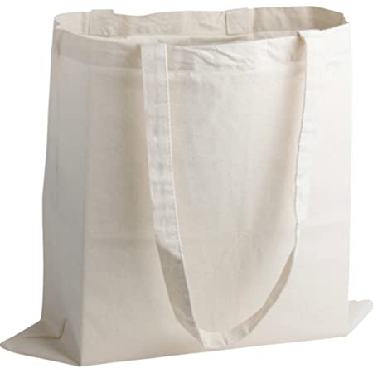
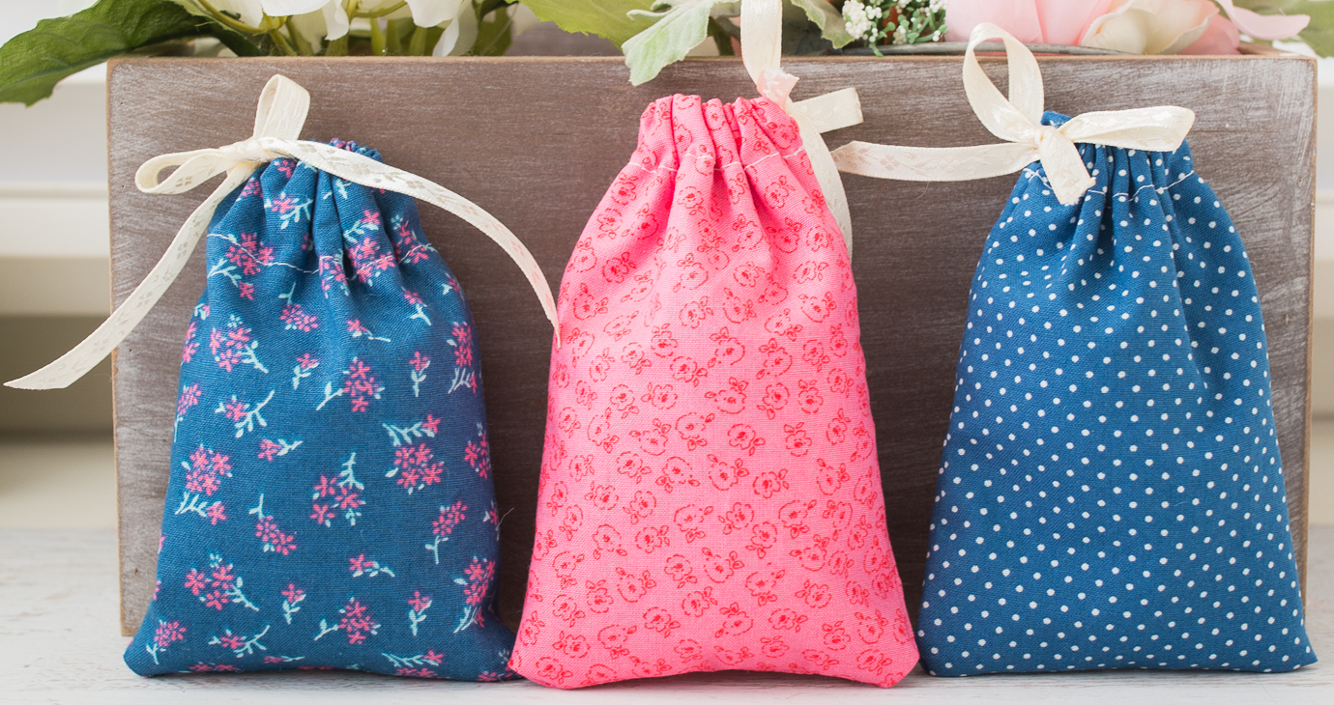
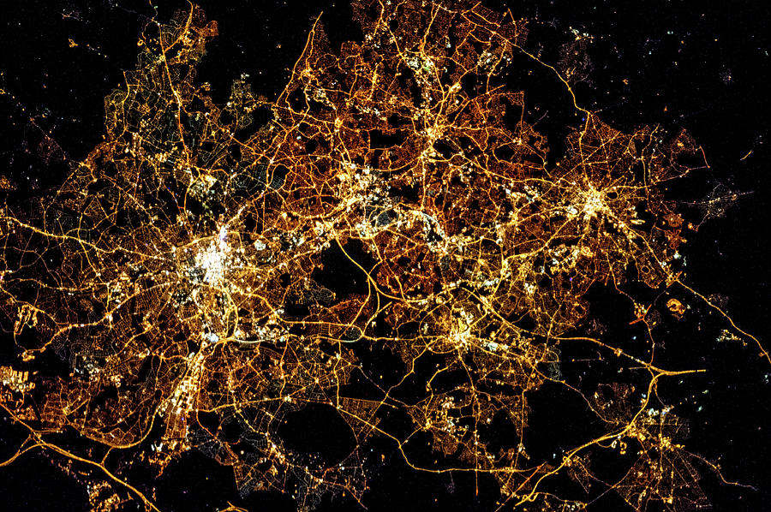
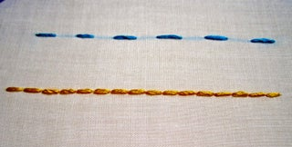

Why do people live where they live?
Summer 2
Class 4

Design Technology
Textile bag for refugee child
Discuss needs of user and analyse existing bags.
Make a pattern and paper prototype of their bag.
Explore the properties of different fabrics.
Practice running stitch, back stitch and blanket stitch.
Make and evaluate their bags.

