Why do people live where they live?
settlement  a place where people establish a community  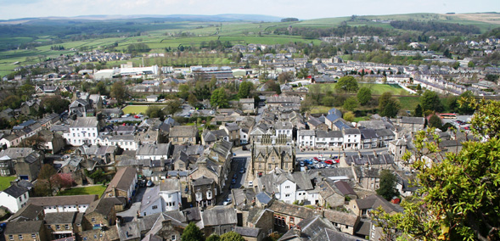 | community  a group of people living in the same place  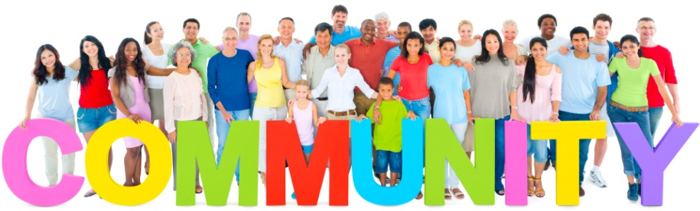 | hamlet  a settlement smaller than a village, without a church, less than 100 people
village  a settlement larger than a hamlet but smaller than a town, located in a rural area, population of 100 – 1000 people  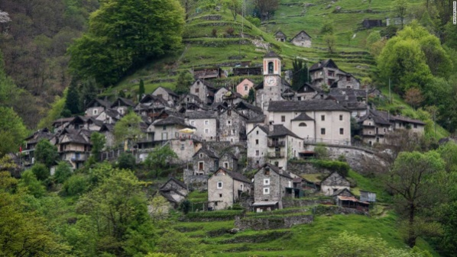 | town  A built-up area with a local government, that is larger than a village and generally smaller than a city, population of 1000 – 100,000 people.  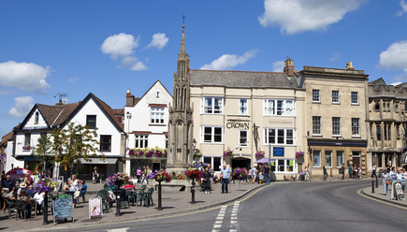 | city  larger than a town, usually containing a cathedral, population of 100,000 to 10 million people.  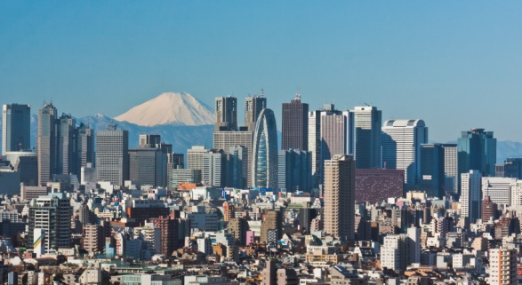
megacity  a city with more than 10 million people  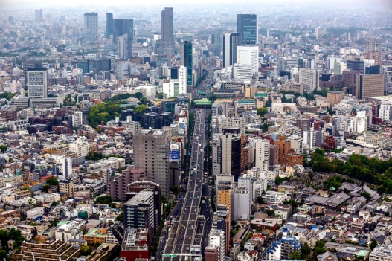 | population  all the people who live in a particular place  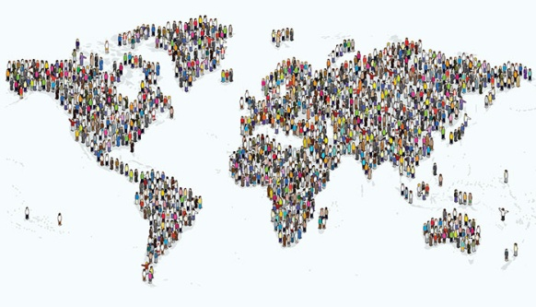 | migration  movement of people to a new area or country  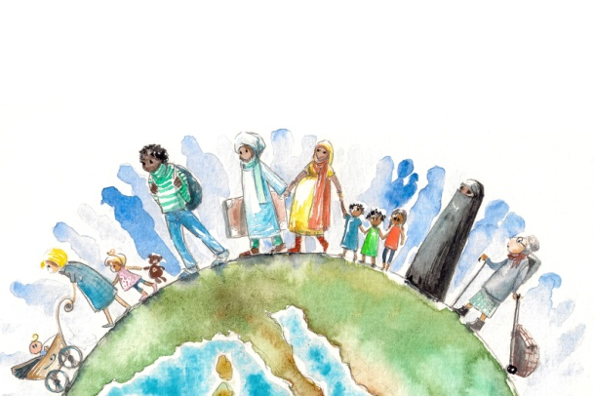
migrant  a person who moves from one place to another, especially in order to find work or better living conditions | immigrant  a person wh comes to live permanently in a foreign country  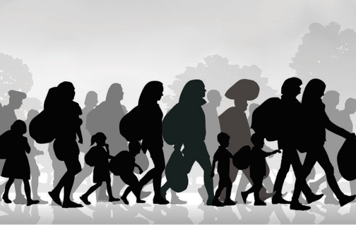 | refugee  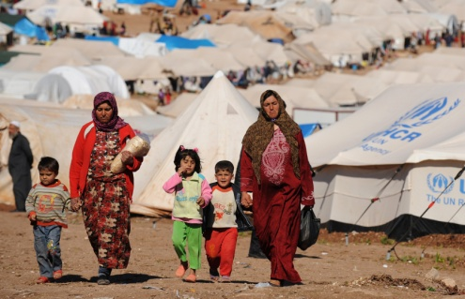  a person who has been forced to leave their country to escape war, persecution or a natural disaster

