**English**

**Text: ‘**The Mouse Hole Cat’ By Antonia Barber

Setting Description

Write a story based on a theme

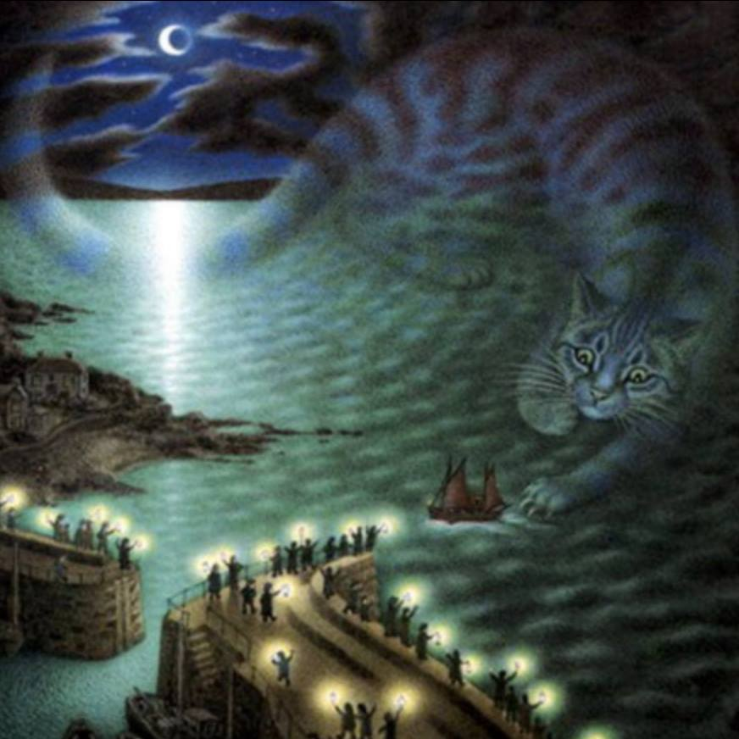

***Class Novel:***

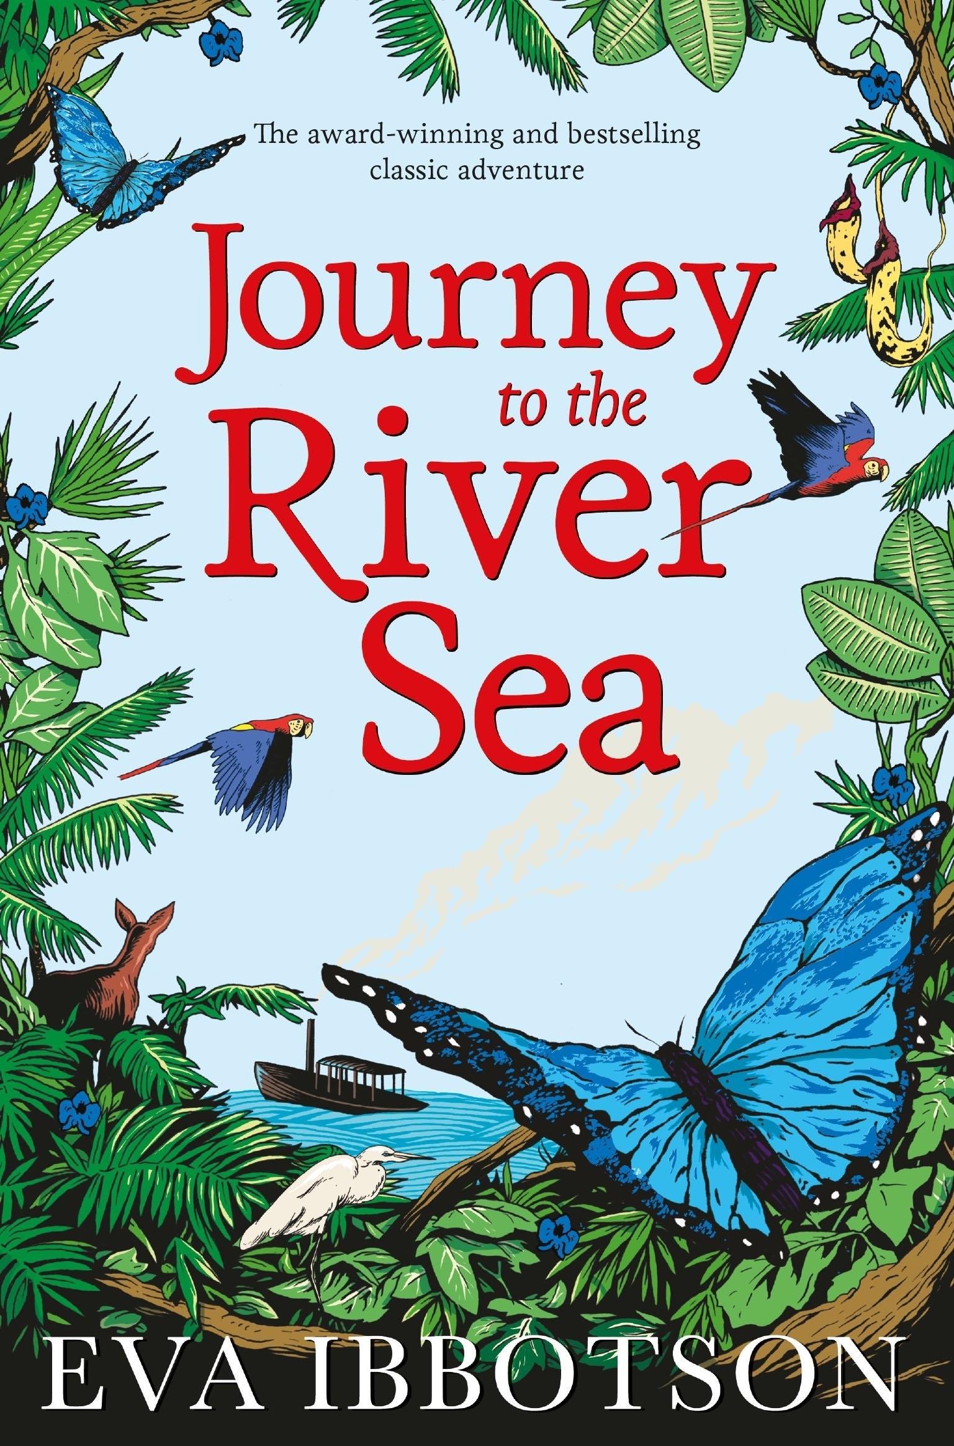 ‘Journey to the river sea’ by Eva Ibbotson

**Class 5 - Summer Term 2**

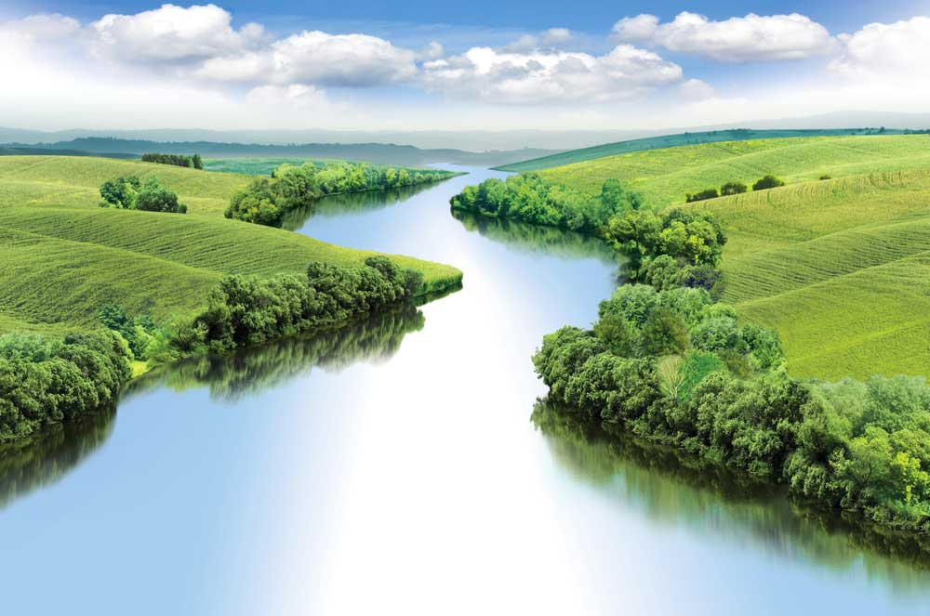

**Rivers**

***Learning Question***

Why are rivers so dynamic?

**Geography**

To be able to describe what a river is and explain where rivers begin and end.

Describe the 3 stages of a river: upper course

middle course

lower course

Explore the different features created at each stage and explain why they are created.

Describe what happens when a river floods and how it effects people’s lives.

The Water Cycle

Understand how rivers fits into the Water Cycle.

**DT**

**Building Bridges**

To investigate the design of different bridges.

Design a bridge and select suitable construction materials.

Construct a bridge.

Evaluate the bridge thinking about the design and construction.

**Geography Fieldwork Skills**

Exploring a river – visit to Cuerden Valley.

**Science Fieldwork Visit:**

Stanah Country Park