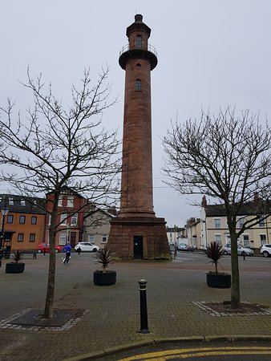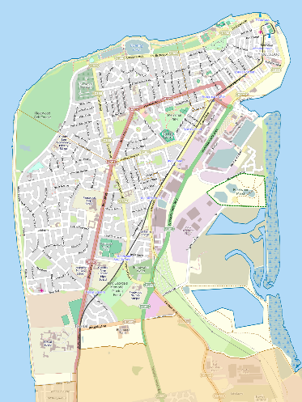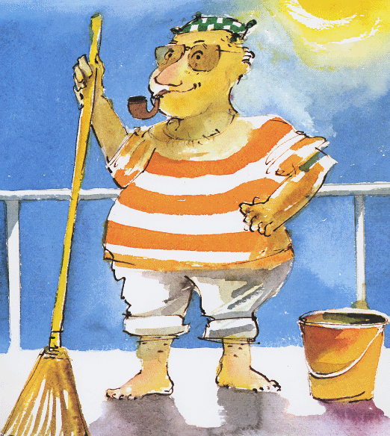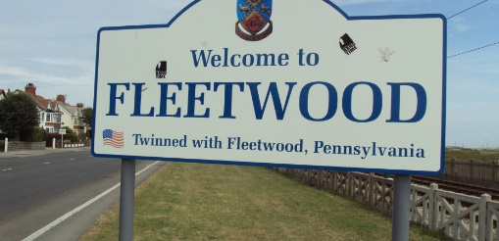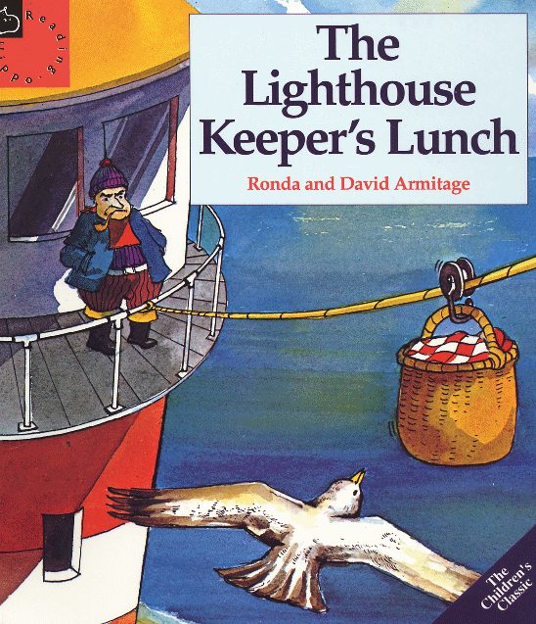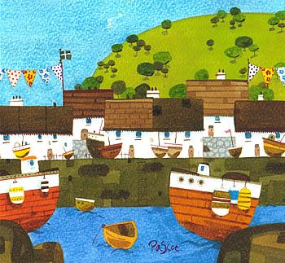

**Art**

Natalie Pascoe – Painting seaside scenes

**English**

* Looking at stories with familiar settings, and work by same author i.e. The Lighthouse Keeper books by David and Ronda Armitage
* Story sequencing - Sandwich books
* Write story based on Mr Grinling
* Letter writing - write a letter to Mr Grinling.

## **Geography**

* Where is Fleetwood?
* What is the physical geography of Fleetwood like?
* What is the Human geography of Fleetwood like?
* Field trip to Fleetwood
* Compare Fleetwood and Blackpool

# **Class 2**

**Summer 2**

***What would it be like to go on holiday to Fleetwood?***