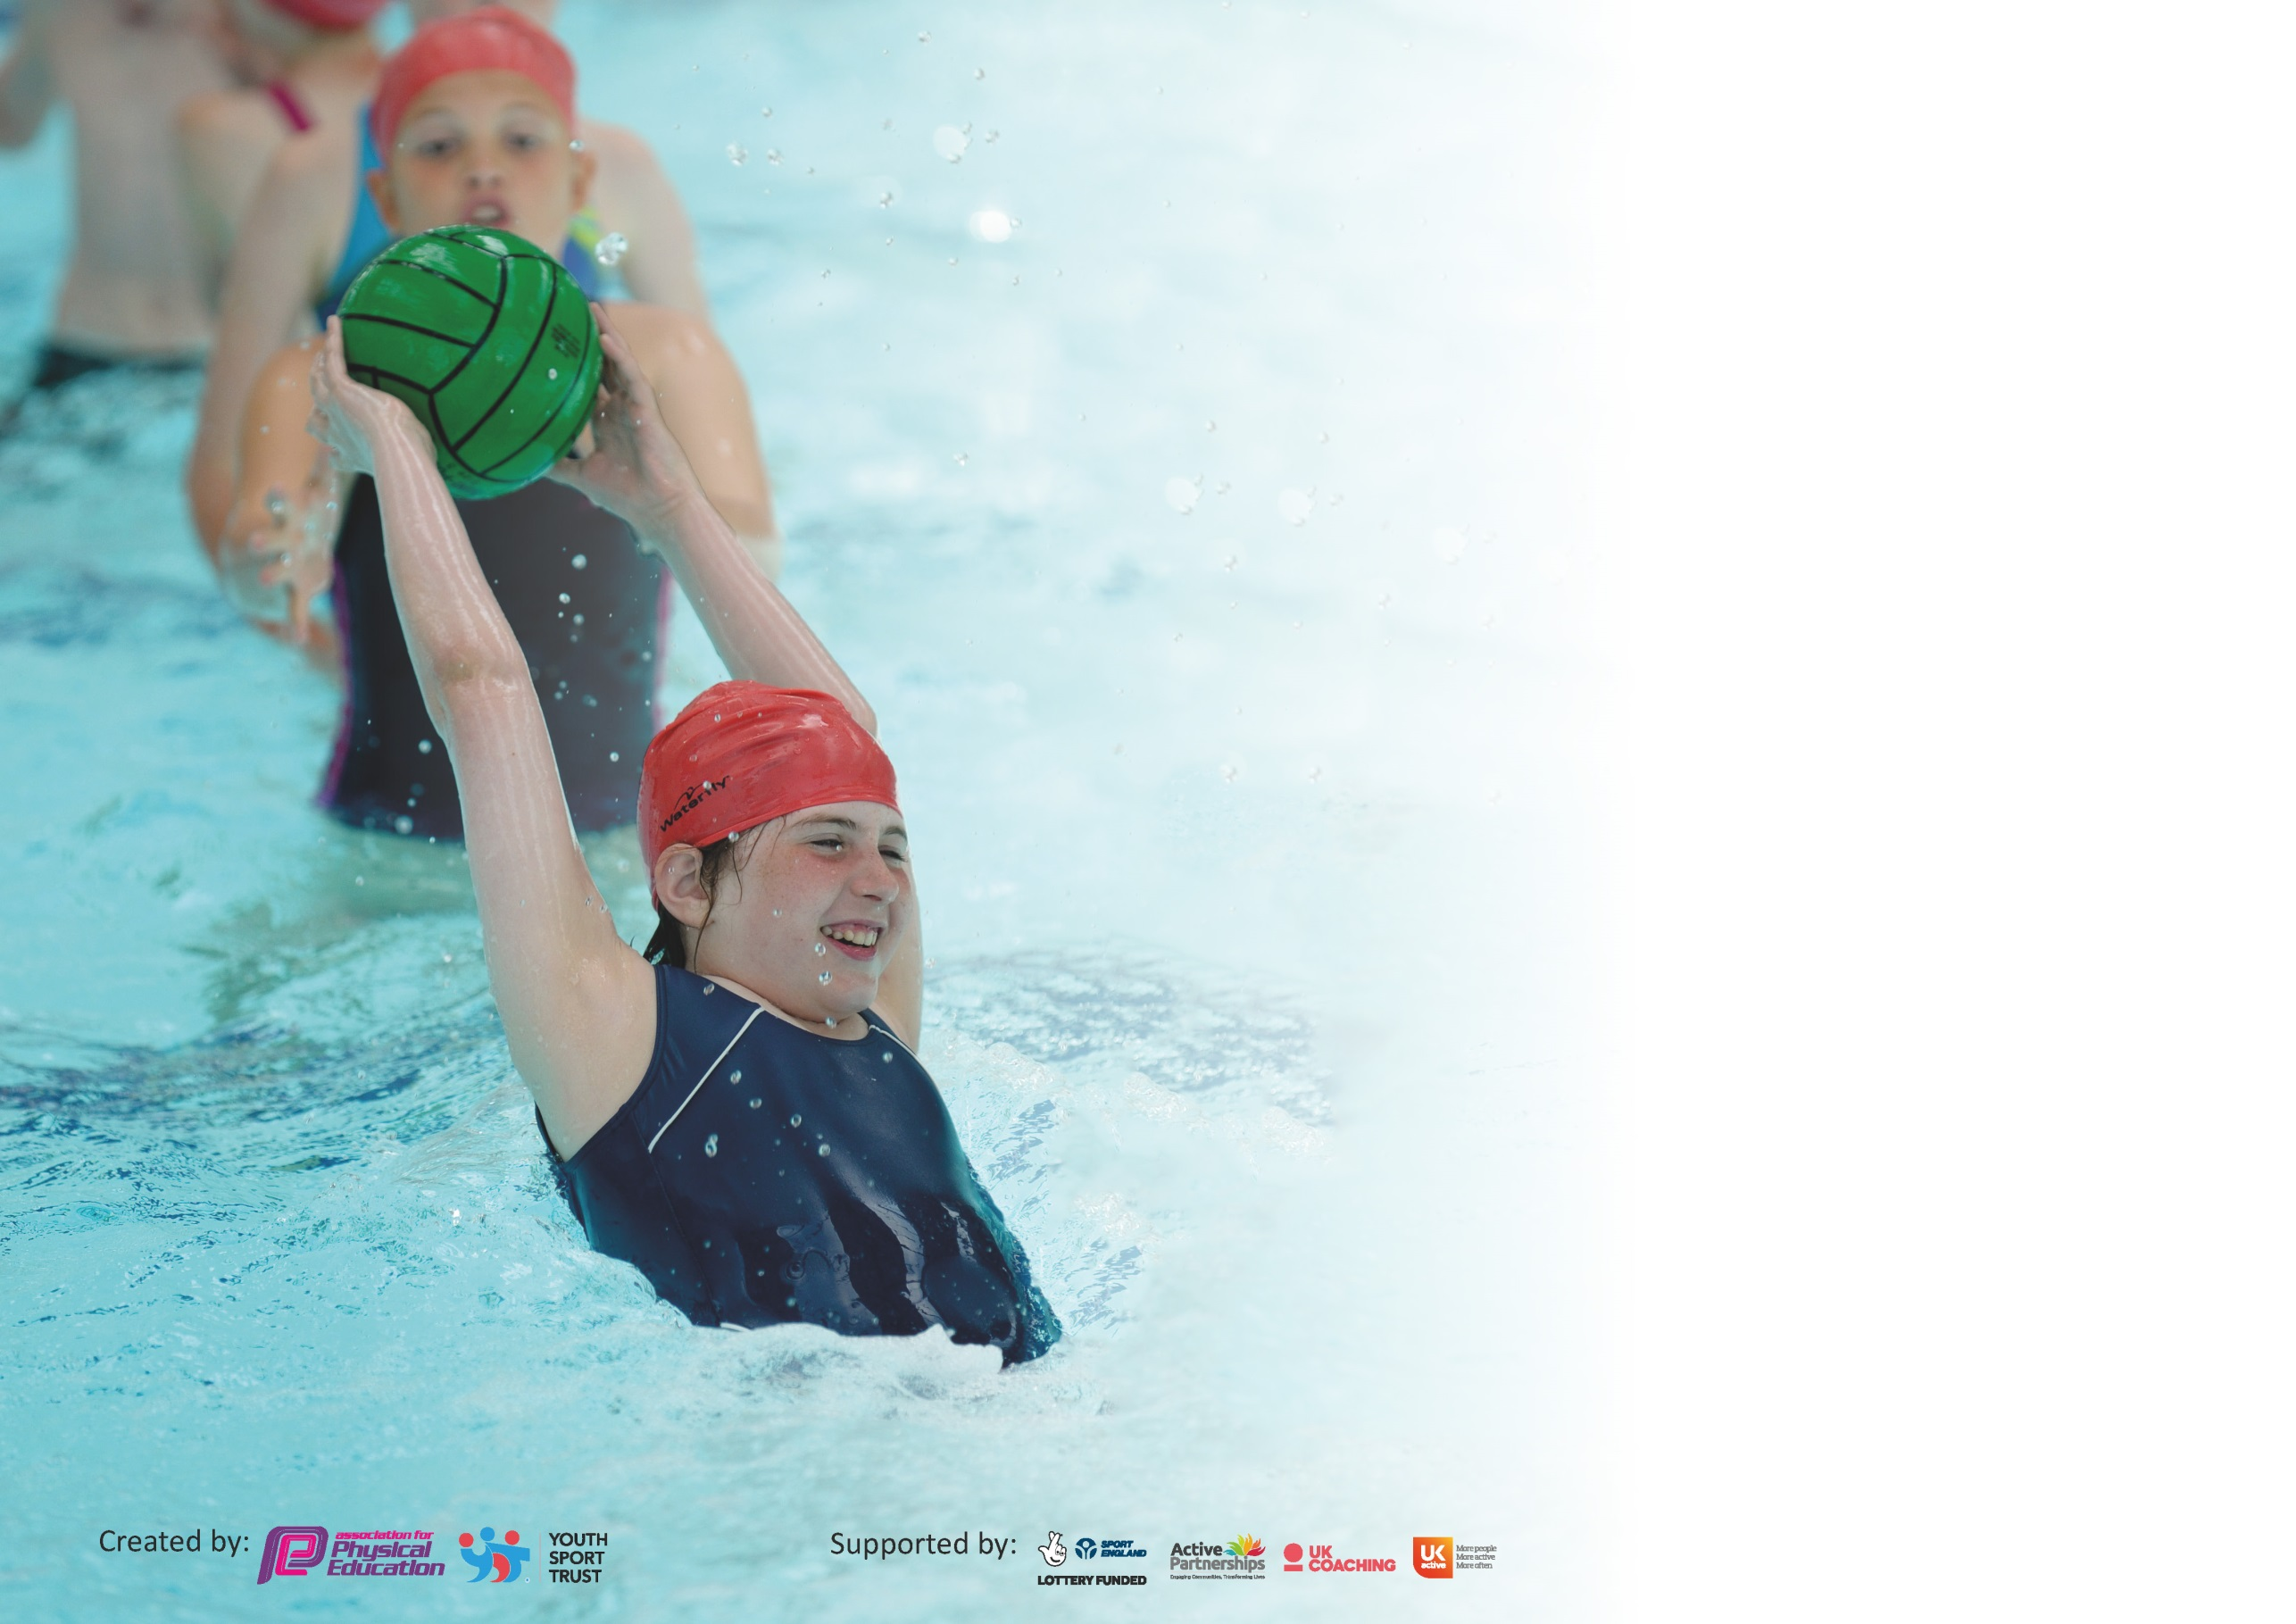

It is important that your grant is used effectively and based on school need. The Education Inspection Framework (Ofsted 2019 p64) makes clear there will be a focus on ‘whether leaders and those responsible for governors all understand their respective roles and perform these in a way that enhances the effectiveness of the school’.

Under the Quality of Education criteria (p41) inspectors consider the extent to which schools can articulate their curriculum (INTENT), construct their curriculum (IMPLEMENTATION) and demonstrate the outcomes which result (IMPACT).

To assist schools with common transferable language this template has been developed to utilise the same three headings which should make your plans easily transferable between working documents.

Schools must use the funding to make additional and sustainable improvements to the quality of Physical Education, School Sport and Physical Activity (PESSPA) they offer. This means that you should
use the Primary PE and Sport Premium to:

- Develop or add to the PESSPA activities that your school already offer
- Build capacity and capability within the school to ensure that improvements made now will benefit pupils joining the school in future years

Please visit gov.uk for the revised DfE guidance including the 5 key indicators across which schools should demonstrate an improvement. This document will help you to review your provision and to report your spend. DfE encourages schools to use this template as an effective way of meeting the reporting requirements of the Primary PE and Sport Premium.

We recommend you start by reflecting on the impact of current provision and reviewing the previous spend.

Schools are required to publish details of how they spend this funding as well as on the impact it has on pupils’ PE and sport participation and attainment by the end of the summer term or by 31st July 2020 at the latest.

We recommend regularly updating the table and publishing it on your website throughout the year. This evidences your ongoing self-evaluation of how you are using the funding to secure maximum, sustainable impact. Final copy must be posted on your website by the end of the academic year and no later than the 31st July 2020. To see an example of how to complete the table please click HERE.

Support for review and reflection - considering the 5 key indicators from DfE, what development needs are a priority for your setting and your pupils now and why? Use the space below to reflect on previous spend and key achievements and areas for development.

Key achievements to date until July 2020: (March 2020 due to Covid19) | Areas for further improvement and baseline evidence of need:
Engagement in PE and Sport across the school.  Extra-curricular activities i.e. breakfast clubs, after school clubs and lunchtime activities.  Cross Curricular Links – Science, Maths, Geography, Music, History, PSHE. | Professional development for staff.  Build upon provision for active lunchtimes.  Further develop leadership opportunities.

Meeting national curriculum requirements for swimming and water safety.
What percentage of your current Year 6 cohort swim competently, confidently and proficiently over a distance of at least 25 metres?  N.B. Even though your pupils may swim in another year please report on their attainment on leaving  primary school at the end of the summer term 2020. | 80%
What percentage of your current Year 6 cohort use a range of strokes effectively [for example, front crawl, backstroke and breaststroke]? | 70%
What percentage of your current Year 6 cohort perform safe self-rescue in different water-based situations? | 100%
Schools can choose to use the Primary PE and Sport Premium to provide additional provision for swimming but this must be for activity over and above the national curriculum requirements. Have you used it in this way? | Yes

Action Plan and Budget Tracking
Capture your intended annual spend against the 5 key indicators. Clarify the success criteria and evidence of impact that you intend to measure to evaluate for pupils today and for the future.

Academic Year: 2019/20 | Total fund allocated: £17, 780  5.5% carried over due to Covid19 | Date Updated: July 2020
Key indicator 1: The engagement of all pupils in regular physical activity – Chief Medical Officer guidelines recommend that primary school pupils undertake at least 30 minutes of physical activity a day in school |  |  |  | Percentage of total allocation:
 |  |  |  | %
Intent | Implementation |  | Impact | 30%
Your school focus should be clear what you want the pupils to know and be able to do and about  what they need to learn and to  consolidate through practice: | Make sure your actions to achieve are linked to your intentions: | Funding allocated: | Evidence of impact: what do pupils now know and what can they now do? What has changed?: | Sustainability and suggested next steps:
Developed active lunchtimes:  Coaches from Blackpool Sports Team, Alan Williams (specialist coach) and three members of staff as dedicated play leaders.  Leaderships opportunities for children – PALs and Prefects.  Extra-Curricular activities – offer a range of opportunities.  Specialist Coaches to support staff development and to offer a variety of activities. | Blackpool Sports Team supplied coaches each lunchtime – rotated across all age groups during the week. Additional lunchtime activities two days a week from Alan Williams.  Extra-curricular – breakfast clubs, after school clubs offered a range of sports to different age groups.  Specialist coaches enhanced provision e.g. balance bikes, badminton, dance. | £4350  Coaches  Resources  £1000 | Lunchtimes – significantly more children are engaged in activities.  Extra-curricular clubs all had the maximum children attending.  Staff Play Leaders began to develop activities for wet lunchtimes e.g. dance club. | Further develop leadership opportunities for children – training programmes delivered by external organisations leading to children receiving a leadership award.  Further develop provision at lunchtime to maximise opportunities.
Key indicator 2: The profile of PESSPA being raised across the school as a tool for whole school improvement |  |  |  | Percentage of total allocation:
 |  |  |  | 19.5%
Intent | Implementation |  | Impact
Your school focus should be clear what you want the pupils to know and be able to do and about  what they need to learn and to  consolidate through practice: | Make sure your actions to achieve are linked to your intentions: | Funding allocated: | Evidence of impact: what do pupils now know and what can they now do? What has changed?: | Sustainability and suggested next steps:
Sports Leaders (Year 6) promote physical activity within school and on the website. Play Leaders (Year 5) work alongside KS1 at lunchtimes developing active play.  Both these initiatives aim to ensure the older children act as role models for the younger children to promote all aspects of physical activity.  Display board in the Hall to showcase PE and Sport activities, achievements and Sports Person of the Term from each class. Activities also shared on the school website.  Swimming identified as a key skill to promote and support the children’s lessons. | Class 6 and Class 5 are encouraged to make an application to take on the roles to elevate the role and demonstrate its importance.  Sports Person of the Term for each class are awarded in assemblies and their pictures are displayed.  Achievements and success celebrated on the school website.  Additional swimming instructors employed to support children’s development. | Swimming instructors  £1749  Alan Williams  £1740  Leadership development | Changes in terms of aspiration and recognition that success can be achieved in various forms e.g. determination, participation, teamwork.  Children who take up leadership positions learn important skills and act as roles models for other children.  Current Year 6 73% were non-swimmers at the start of their lessons and 80% reached the national requirement and 100% achieved their water safety certificates. | Continue to promotes PE and Sport across a range of platforms.  Further develop leadership roles in terms of formal training and additional roles.

Key indicator 3: Increased confidence, knowledge and skills of all staff in teaching PE and sport |  |  |  | Percentage of total allocation:
 |  |  |  | %
Intent | Implementation |  | Impact | 30%
Your school focus should be clear | Make sure your actions to | Funding | Evidence of impact: what do | Sustainability and suggested
what you want the pupils to know | achieve are linked to your | allocated: | pupils now know and what | next steps:
and be able to do and about | intentions: |  | can they now do? What has
what they need to learn and to |  |  | changed?:
consolidate through practice:
Support provide from the PE lead, access to training from Blackpool Borough Sports Council, staff working with specialist coaches in school (observations, team teaching).  Use of staff meeting time to share vision for school PE and Sport and to maximise physical activity opportunities.  Play Leaders and Welfare staff training to enhance lunchtime provision. | Specialist coach worked two days per week in school, rotated around different classes during the year.  PE lead led staff training.  Regular informal discussions with staff to provide support.  Staff meeting time to share good practice in PE lessons, promoting an ethos of activity and learning not just playing.  Local training accessed for active lunchtimes to support all lunchtime staff. PE Lead half termly meeting with all lunchtime staff. | Alan Williams and Blackpool Sports Team support staff development.  £5250  £120 | Working alongside specialist coaches; staff have the opportunity to share planning and team teach to develop skills and build confidence.  PE lessons focused on “learning not playing”  Structure of lessons to maximise activity time.  Developed confidence of lunchtime staff and the range of activities they can offer. | Access ongoing training for lunchtime staff.  Identify training needs for all staff. Liaise with Blackpool Sports Team for training provision.
Key indicator 4: Broader experience of a range of sports and activities offered to all pupils |  |  |  | Percentage of total allocation:
 |  |  |  | %
Intent | Implementation |  | Impact | 15%
Your school focus should be clear | Make sure your actions to | Funding | Evidence of impact: what do | Sustainability and suggested
what you want the pupils to know | achieve are linked to your | allocated: | pupils now know and what | next steps:
and be able to do and about | intentions: |  | can they now do? What has
what they need to learn and to |  |  | changed?:
consolidate through practice:
Participated in a range of festivals and provided coaching for children to experience new activities.  Provide cross curricular opportunities e.g. Science – effect of exercise on the body, Geography – orienteering. Additional extra-curricular activities.  Active lunchtimes – play leaders, specialist coaches. | Extra-curricular opportunities – breakfast clubs and after school clubs, new sports offered e.g. table tennis, badminton.  Emphasis on active lunchtimes; use of play leaders, specialist coaches.  Attended festivals e.g. Bollywood Dance, Strictly Come Dancing, Glow in the Dark Football, Orienteering.  Active lunchtimes - three members of staff are lunchtime play leaders, at lunchtimes specialist coaches lead activities, playground leaders from Class 5 work with KS1 and Class 6 prefects with Reception. | Specialist coaches used to enhance opportunities  £2700 | Pupils introduced to new activities to enable them to develop new skills and apply existing skills e.g. table tennis, badminton clubs.  Traditional activities continue to be offered as extra-curricular clubs e.g. boys and girls football, athletics.  Wide range of activities have ensured increased participation as children across all year groups have had the opportunity to try new activities. | Further develop extra-curricular provision.  Additional specialist coaches used to further enhance the variety of opportunities.

Key indicator 5: Increased participation in competitive sport |  |  |  | Percentage of total allocation:
 |  |  |  | 0%
Intent | Implementation |  | Impact
Your school focus should be clear | Make sure your actions to | Funding | Evidence of impact: what do | Sustainability and suggested
what you want the pupils to know | achieve are linked to your | allocated: | pupils now know and what | next steps:
and be able to do and about | intentions: |  | can they now do? What has
what they need to learn and to |  |  | changed?:
consolidate through practice:
Level 2 competitions attended in boys and girls football, orienteering, dance, indoor athletics.  Level 1 competitions hosted in school e.g. football, indoor athletics, dodgeball.  This area was curtailed due to Covid 19. | Opportunities to develop skills within lessons and at extra-curricular clubs leading into competitions.  Children from different classes involved e.g. Class 2 (indoor athletics, glow in the dark football, Class 4 (orienteering, dance) Class 3 (dance). | £0  Impact of other funding previously accounted for. | Children can access physical activity in school and then apply these skills in competitive situations.  Children from KS1 participated in Level 2 competitions.  Children competing in a broad range of competitions. | Continue to access Level 2 competitions.  Further develop Level 1 competition linked to revised house points system.

