
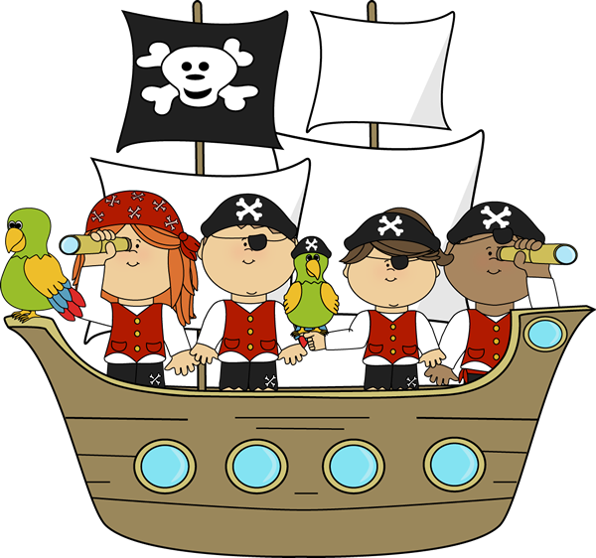
Fun with Phonics course
for KS1 families

Take part in fun activities with your child based on a pirate theme
✓ Find out what your child learns at school
✓ Support your child’s learning by working together
✓ Make resources to use at home

Children join in last part of every session

Free 4 week course
Starting Thursday 5th March 9am-11am
St John’s Primary School

Book your place by filling in the form at
https://bit.ly/FLPhonics26

Due to health and safety we are unable to accommodate younger siblings in the session

